ECEN 325

Lab 8: BJT Amplifier Configurations

Section 506

04/03/2020

Jason Gilman

TA: Mandela

**Calculations**

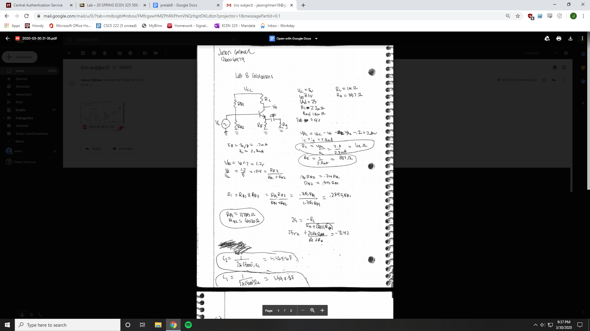

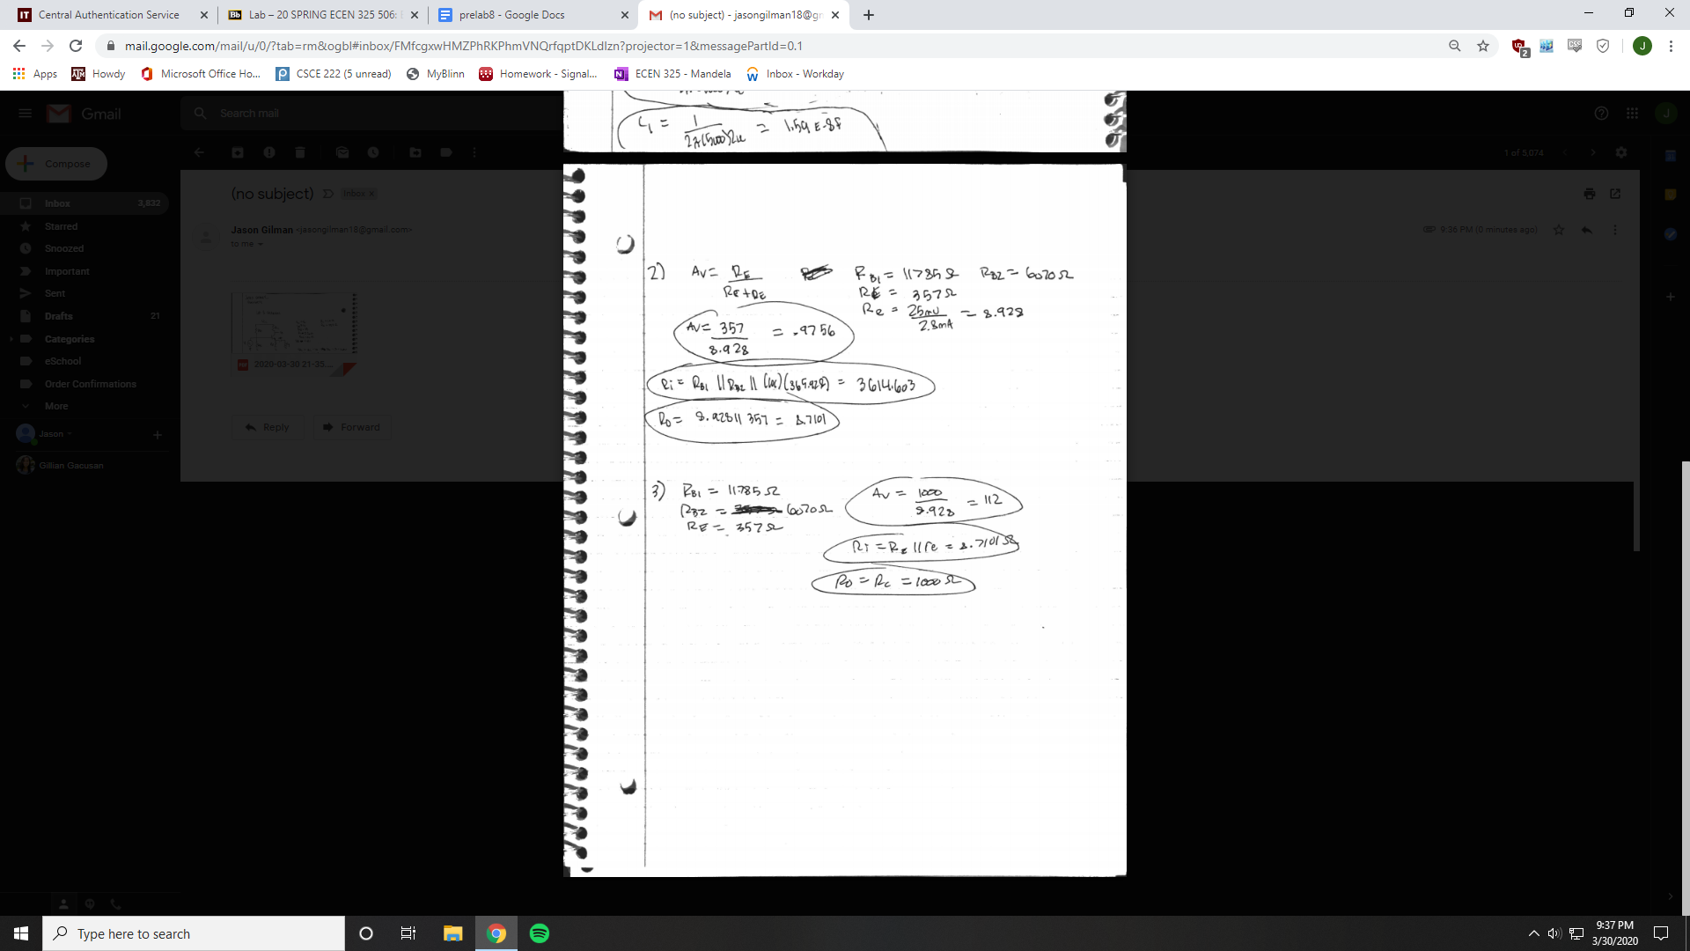

**Simulations**

NPN Common-Emitter

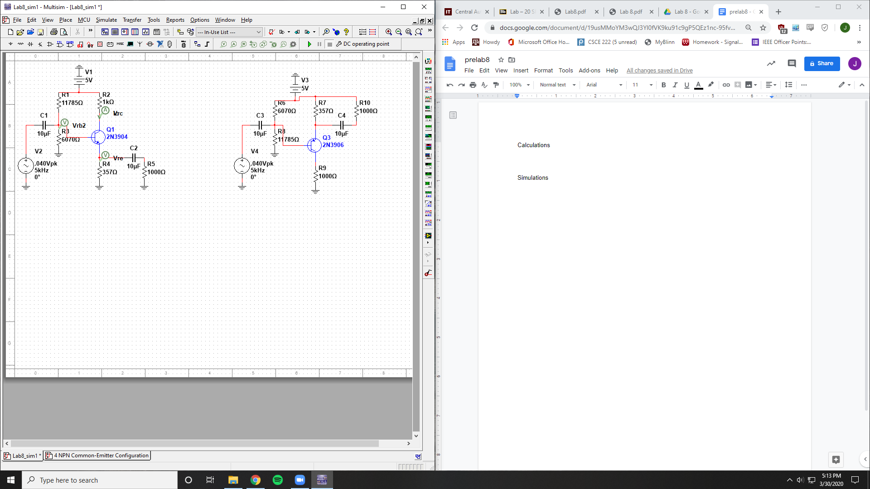

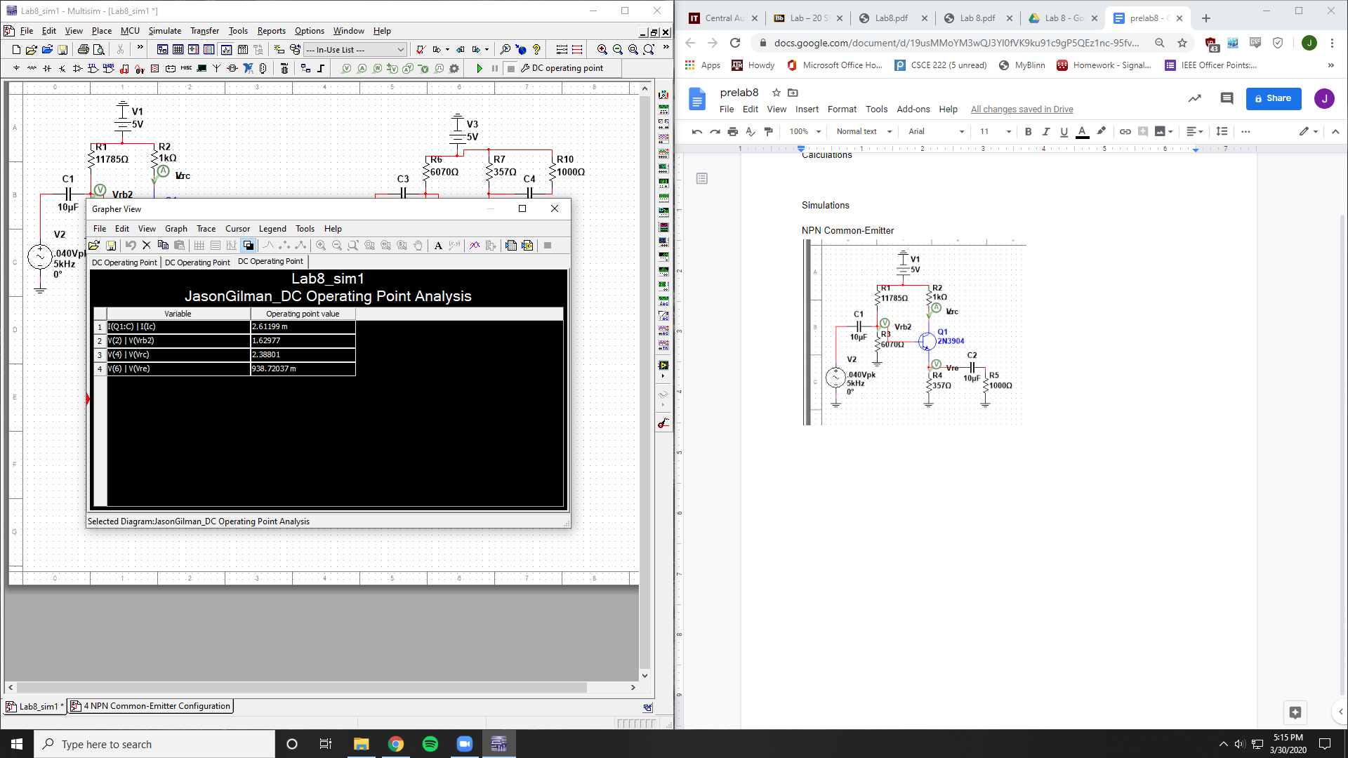

Ic = 2.61199 mA

Vrb2 = 1.62977 V

Vrc = 2.38801 V

Vre = 938.72037 mV

Vo = 2.38801 V

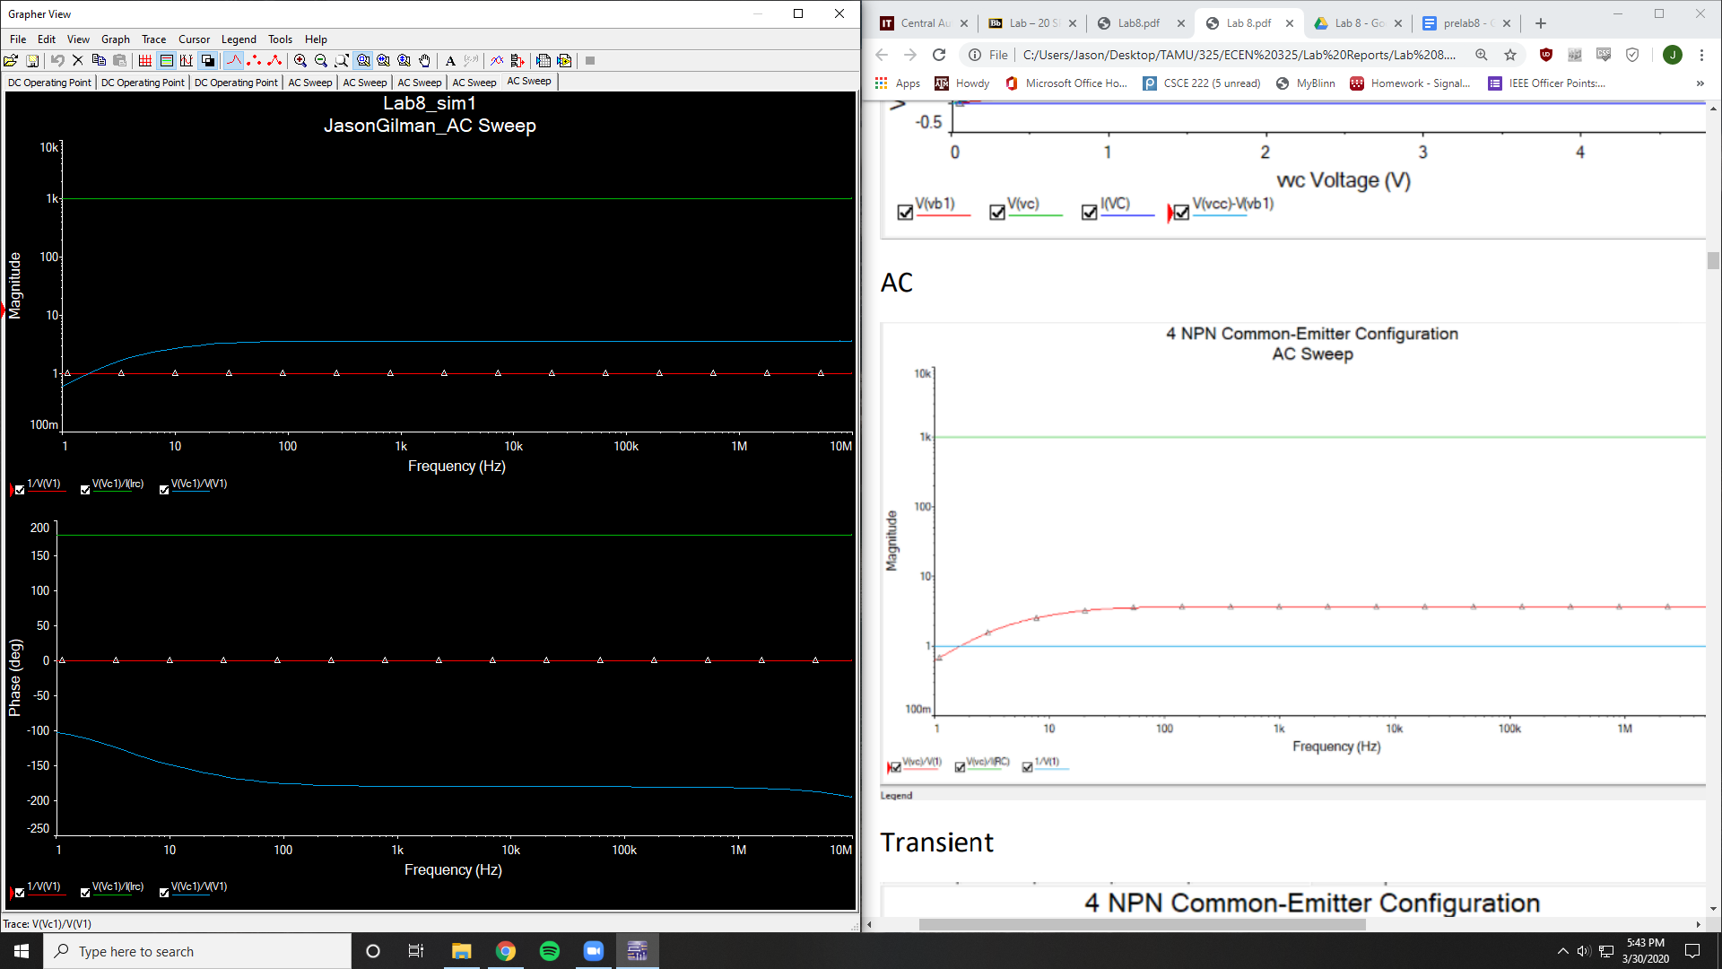

Av = 2.89

Ri = 1

Ro = 1000

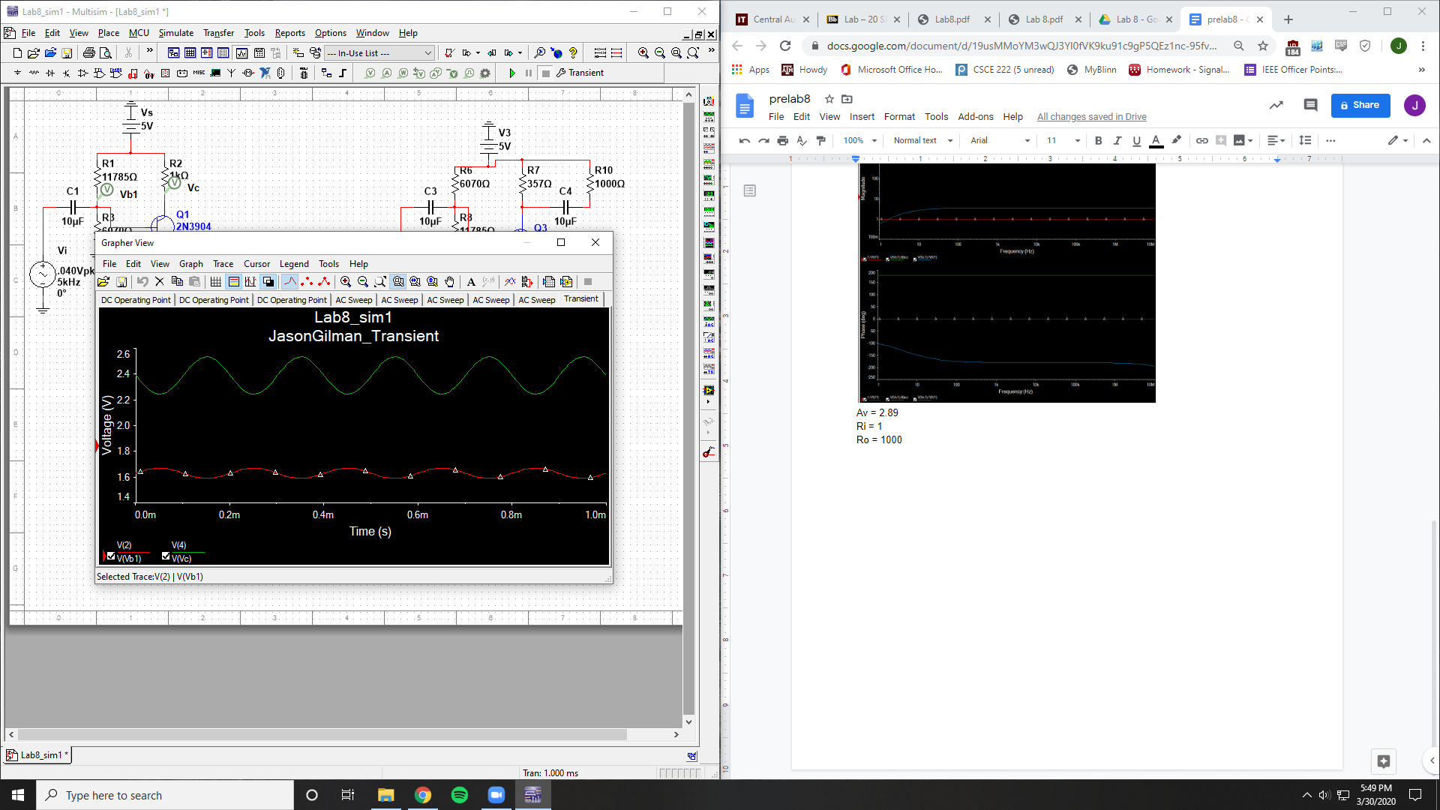

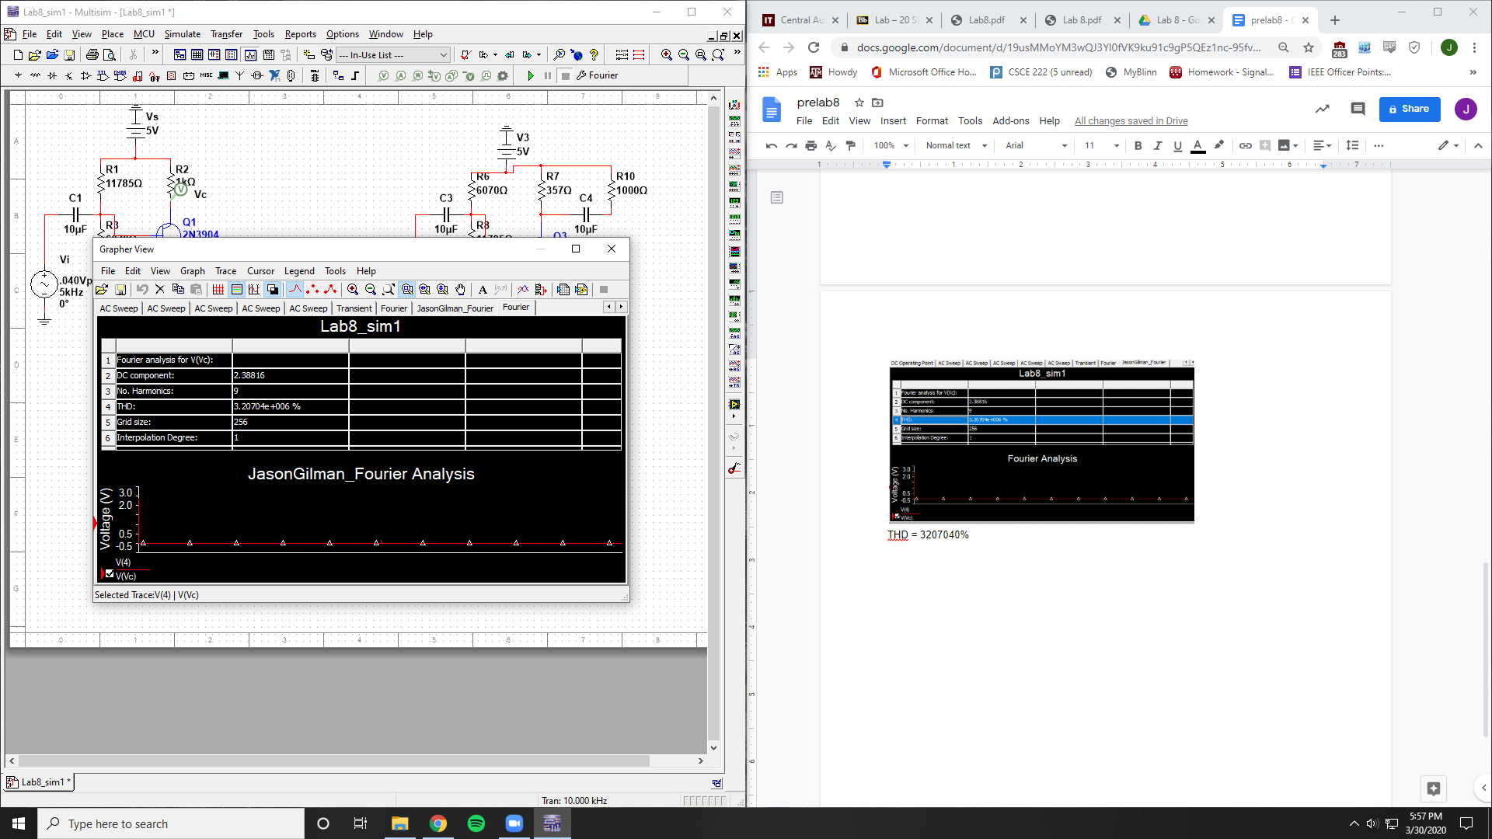

THD = 3207040%

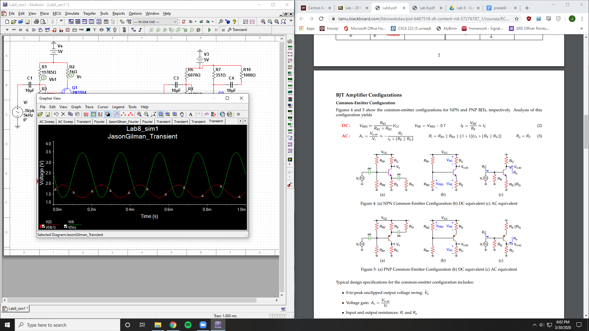

Clipping occuring at .3 V

PNP Common-Emitter

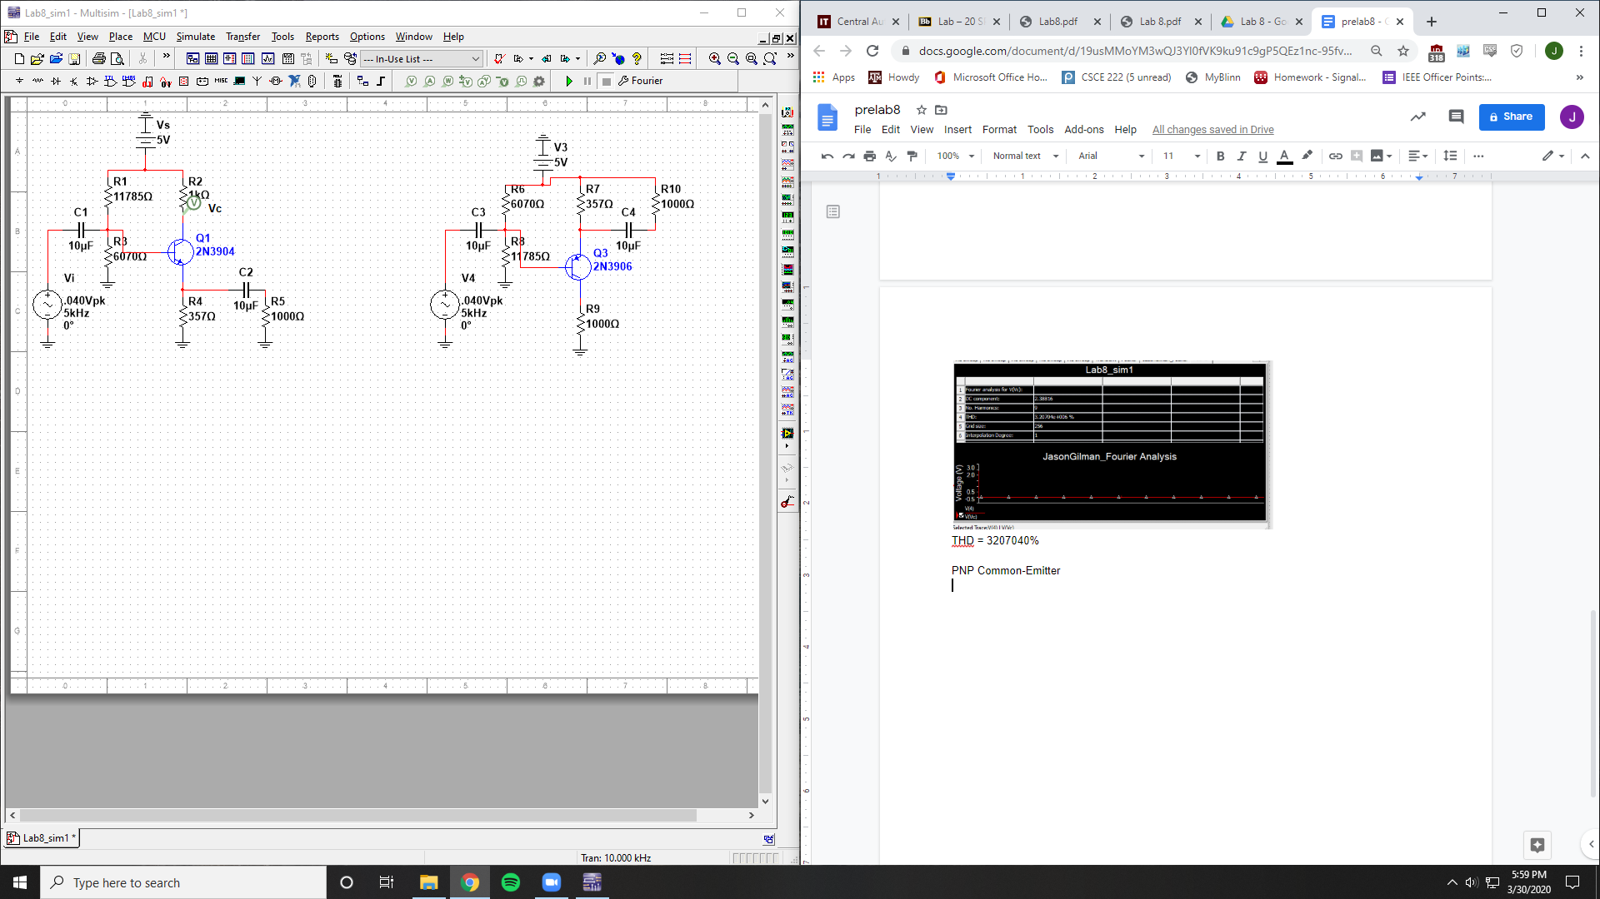

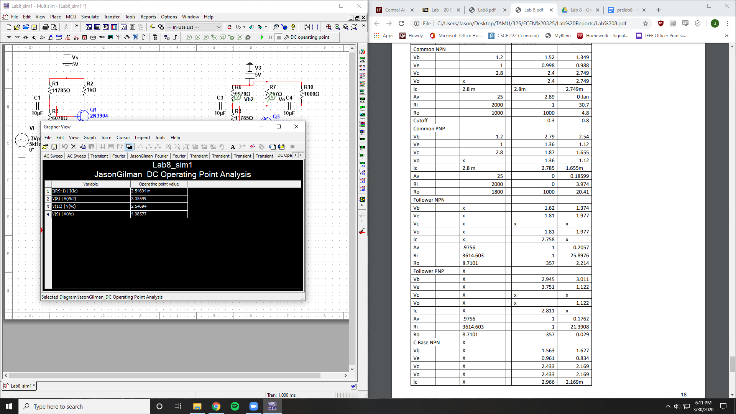

Ic = 2.54 mA

Vrb2 = 3.35599 V

Vrc = 2.54694 V

Vre = 4.08577 V

Vo = 2.54694 V

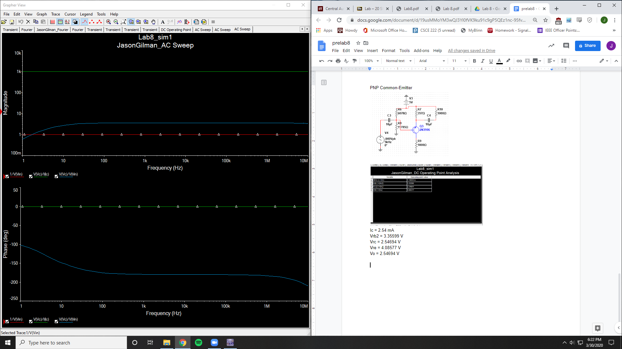

Av = 2.89

Ri = 1

Ro = 1000

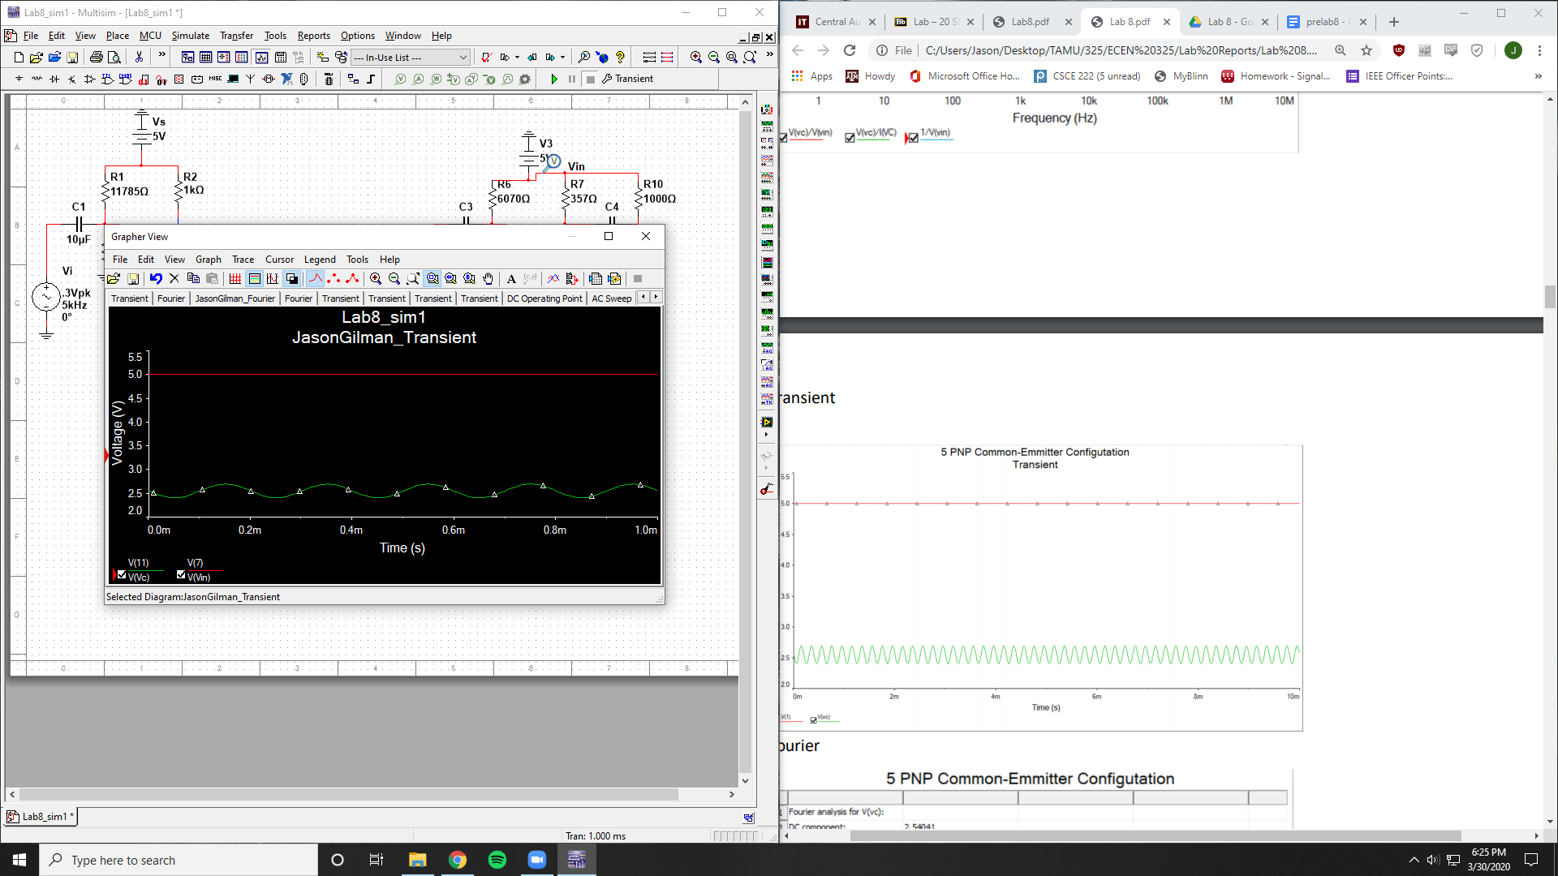

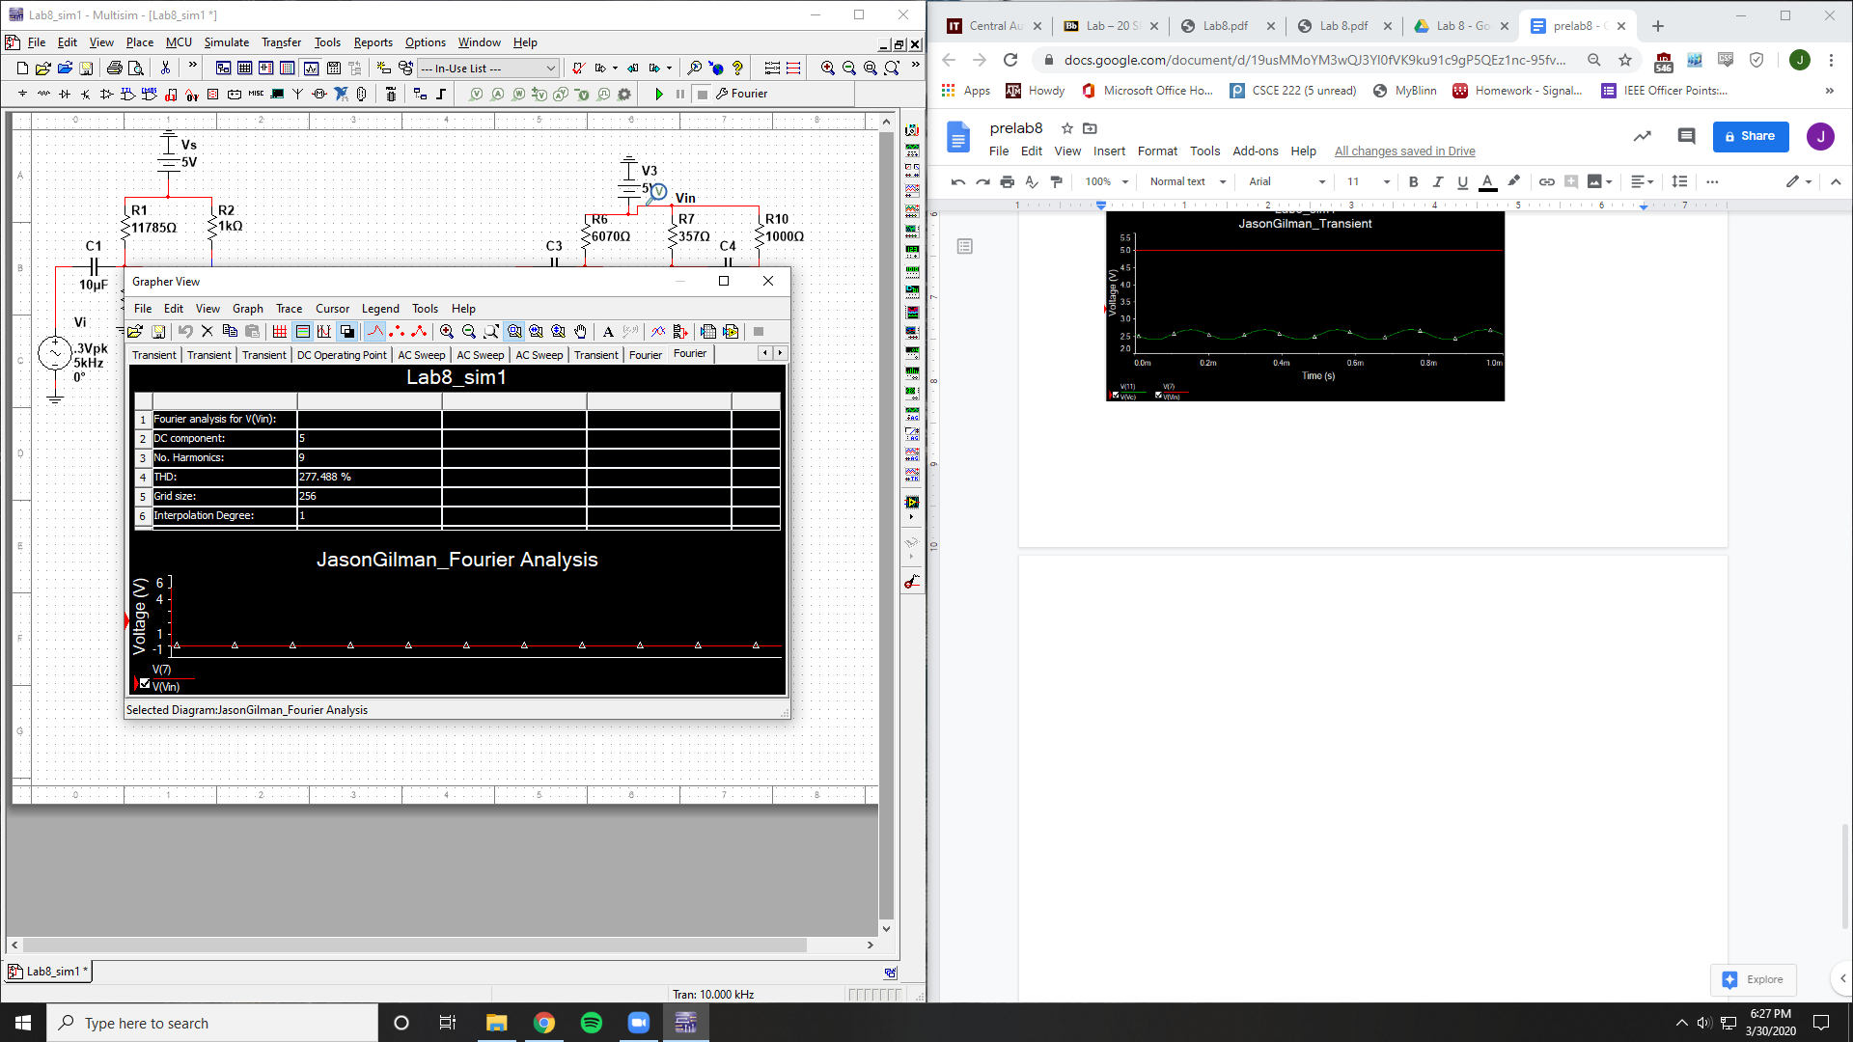

THD = 277.488%

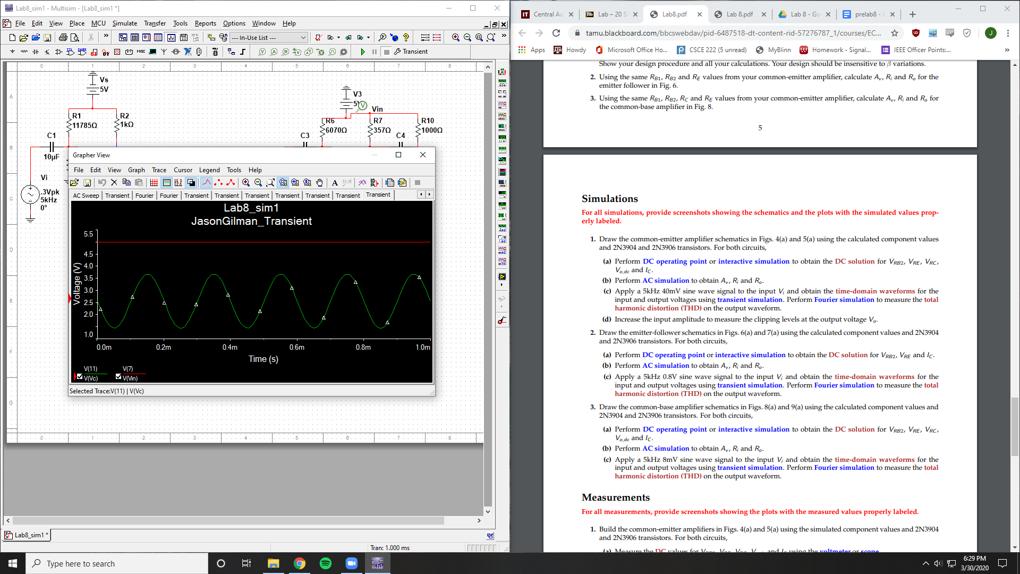

Clipping occuring at .3 V

NPN Common-Collector

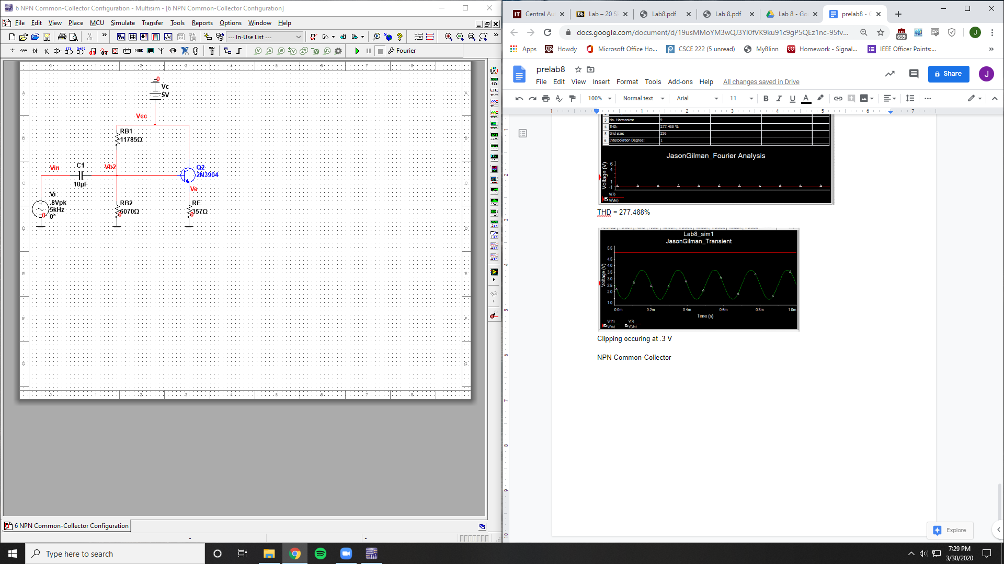

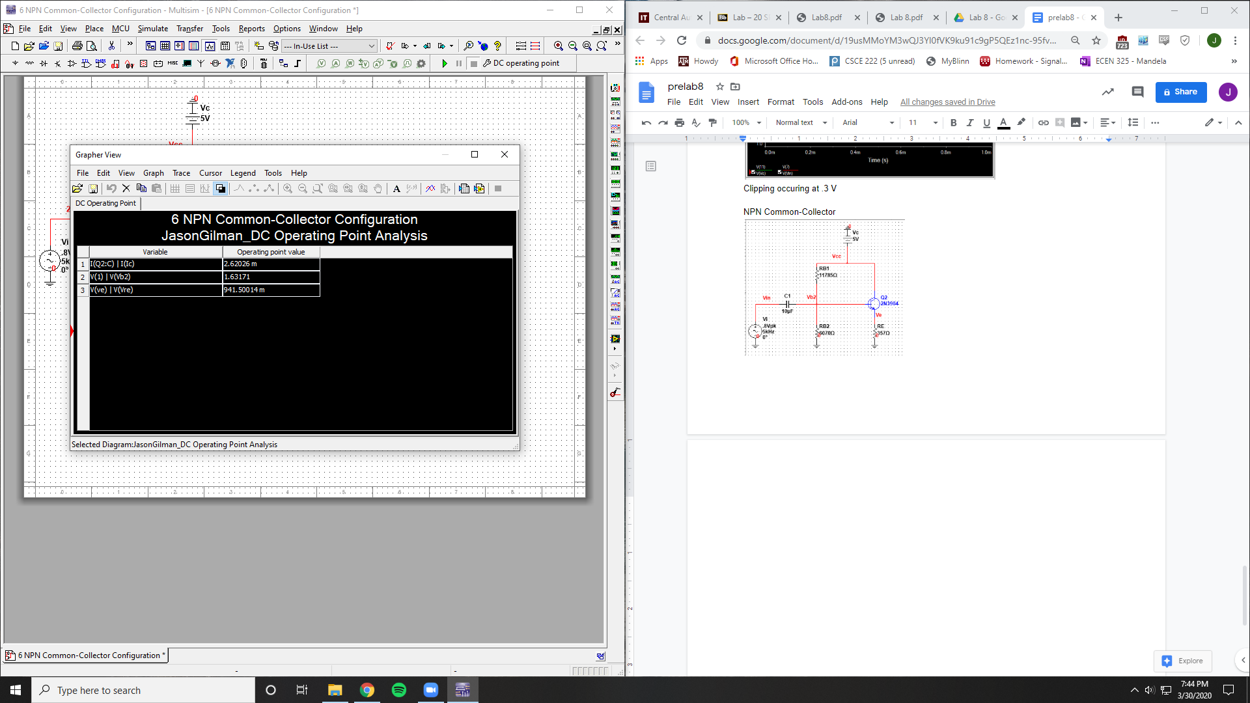

Ic = 2.62026 mA

Vrb2 = 1.63171 V

Vre = .9415 mV

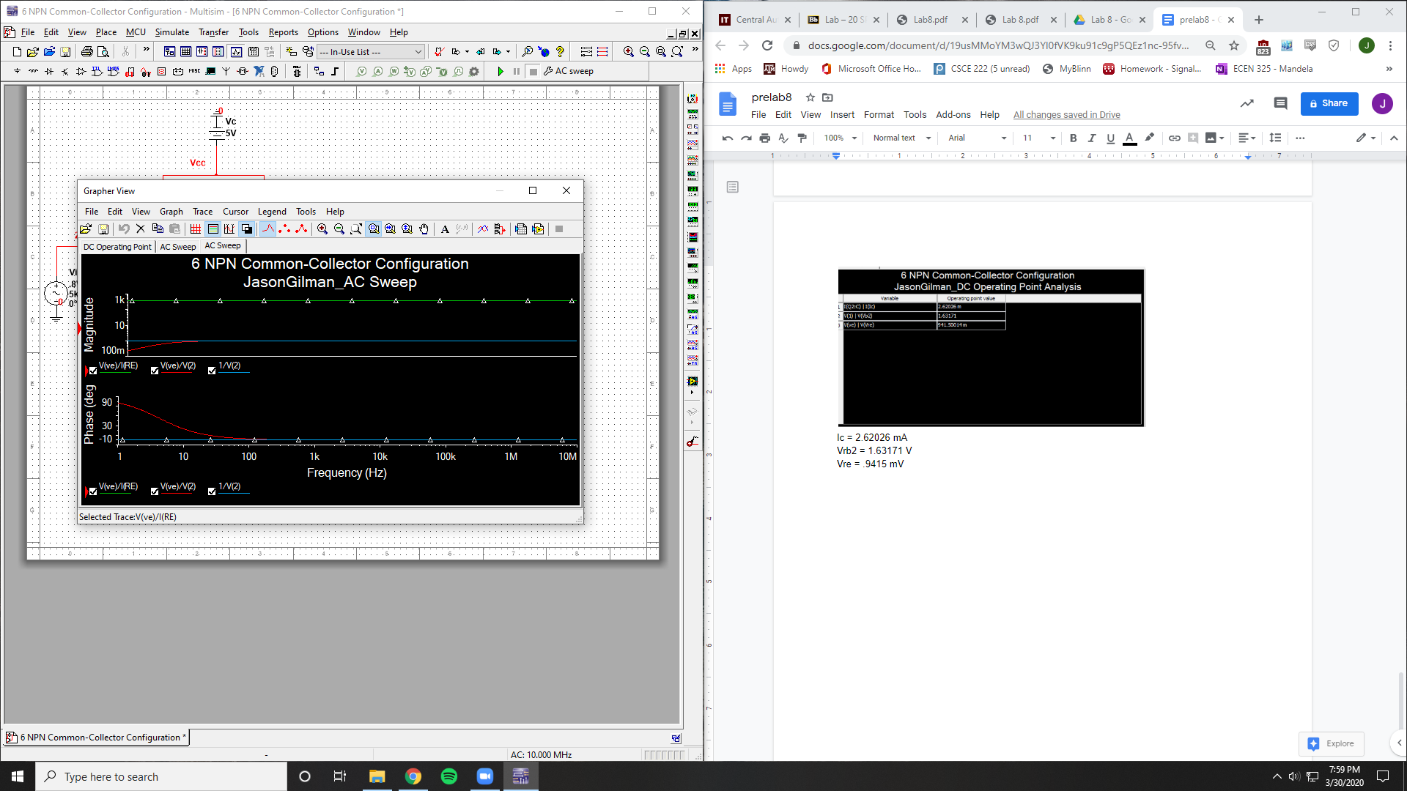

Av =1

Ri = 1

Ro = 357

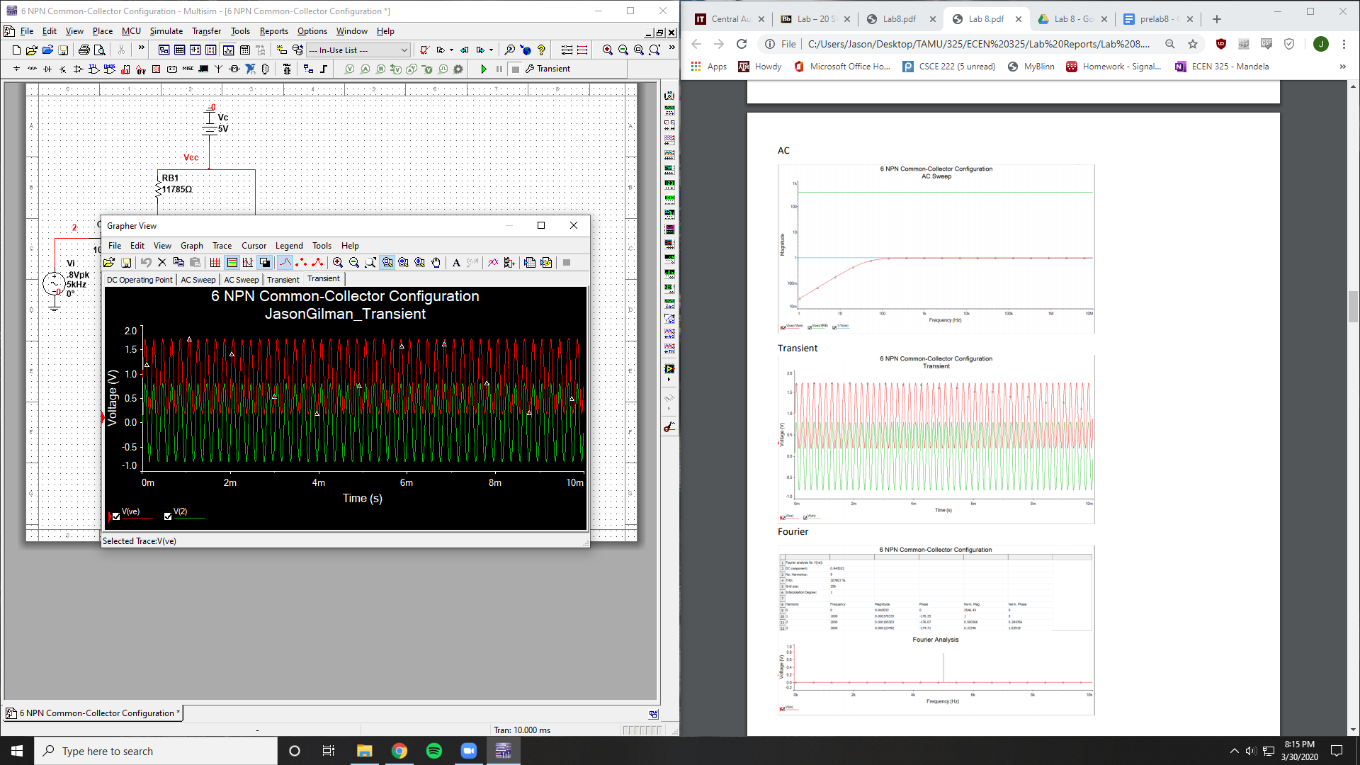

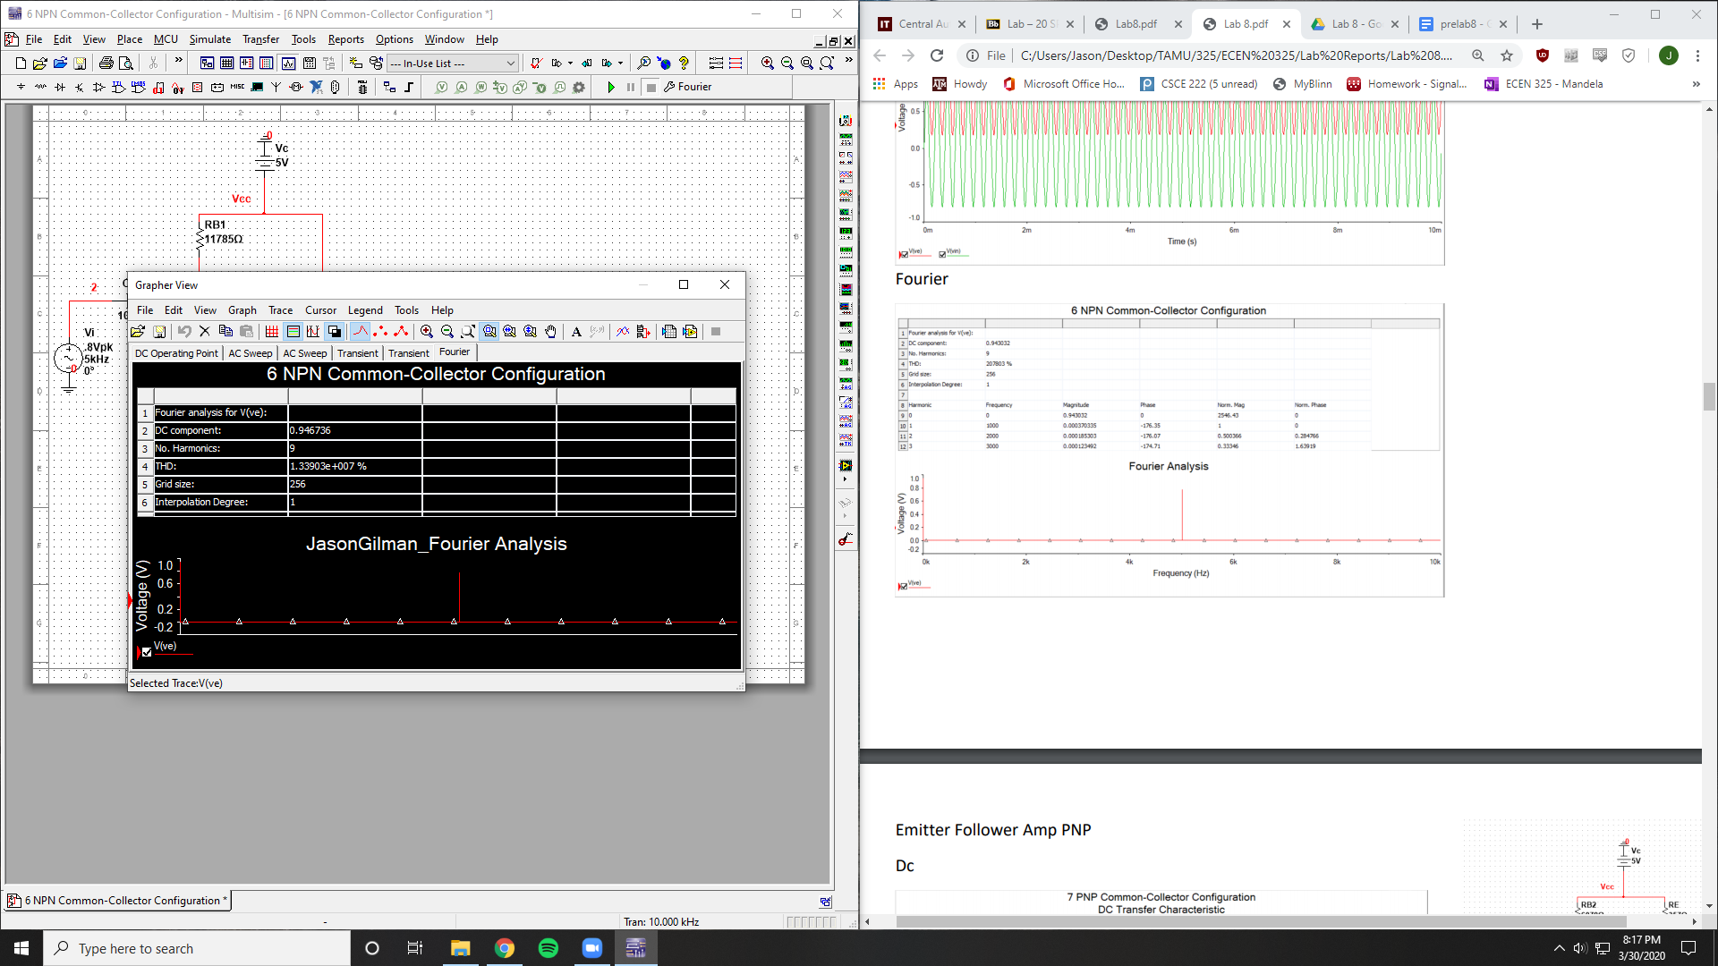

THD = 1.339E7 %

PNP Common-Collector

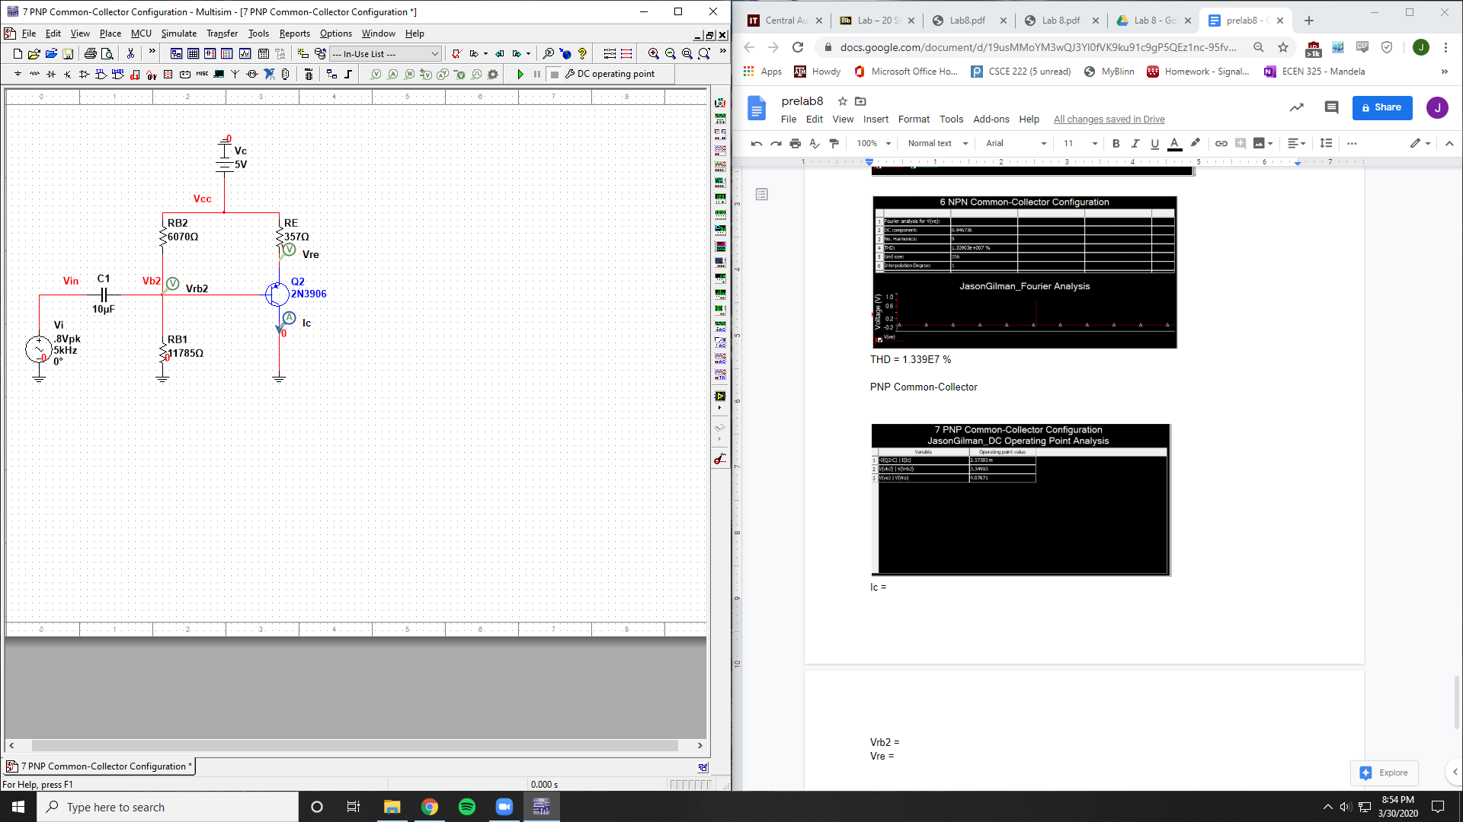

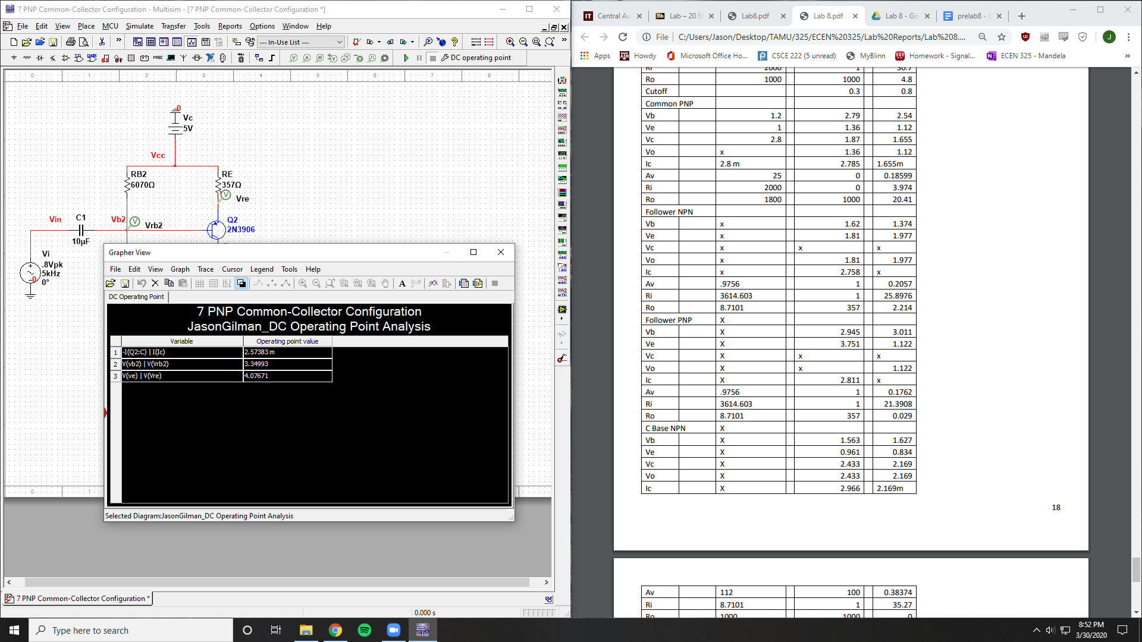

Ic = 2.57383 mA

Vrb2 = 3.34993 V

Vre = 4.076 V

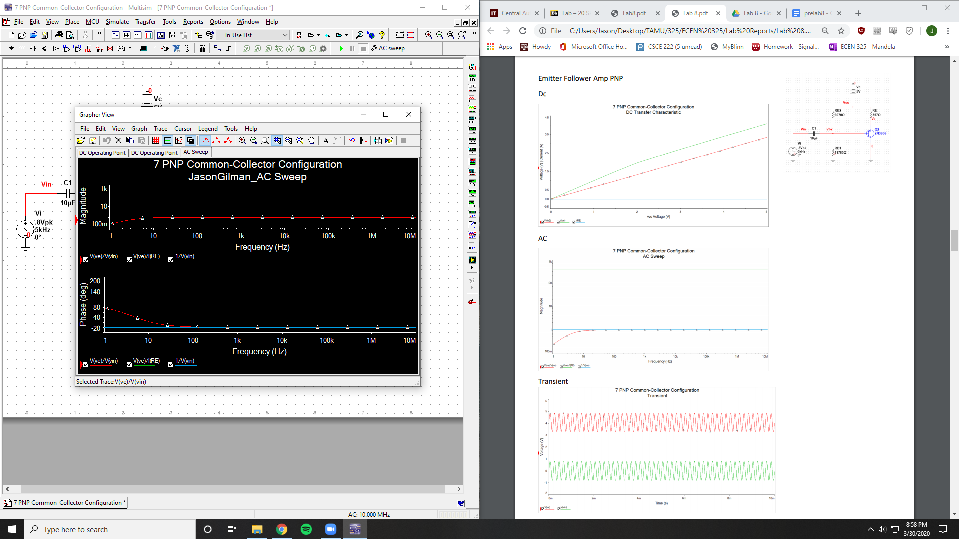

Av = 1

Ri = 1

Ro = 357

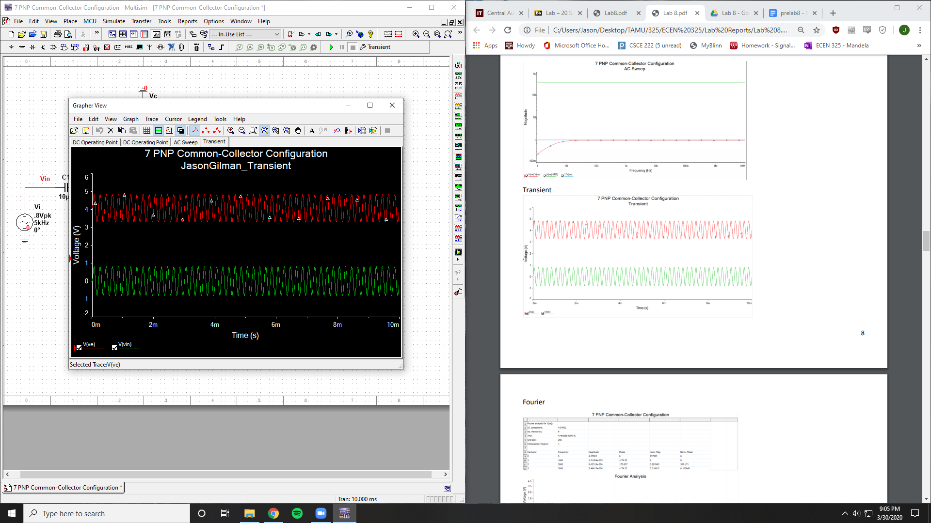

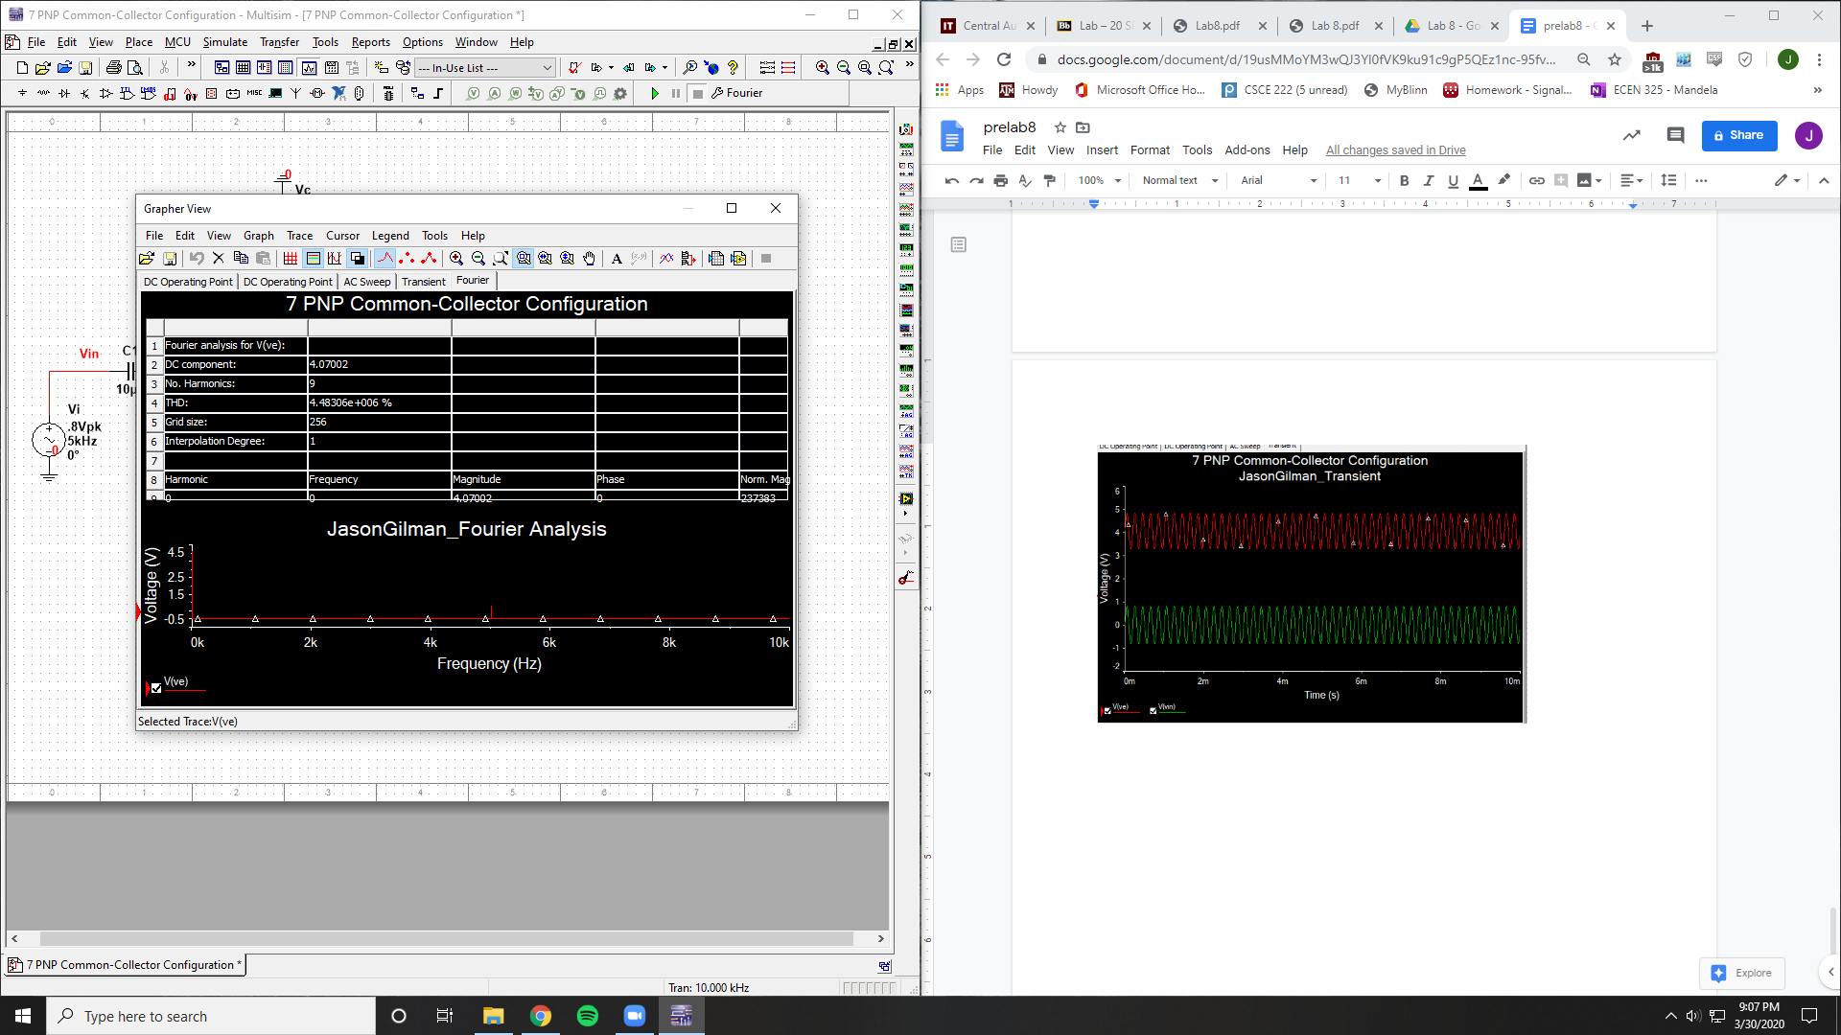

THD = 4.48306E6 %

NPN Common-Base

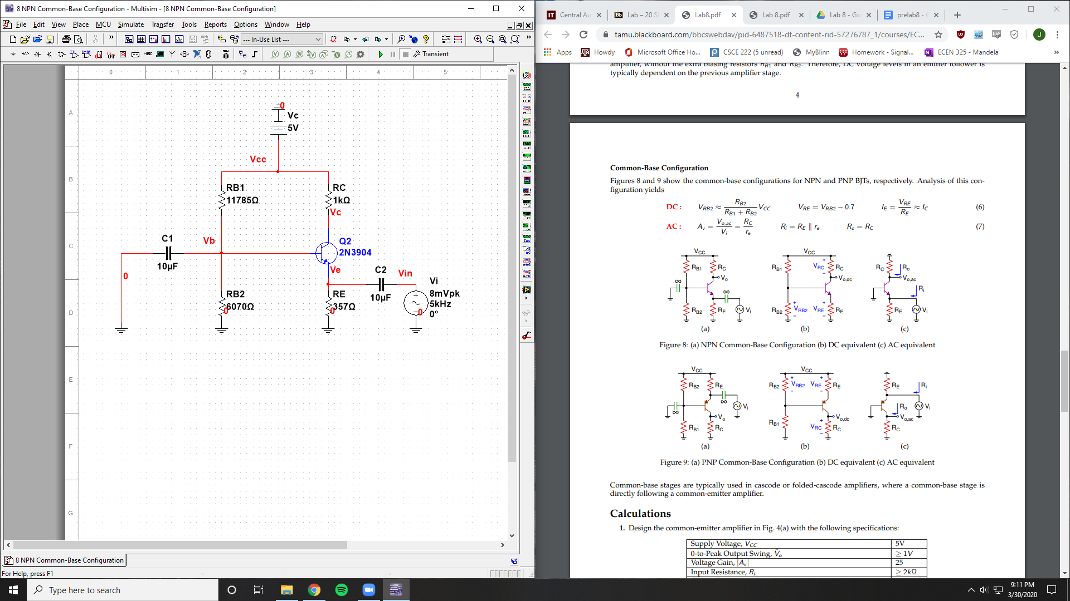

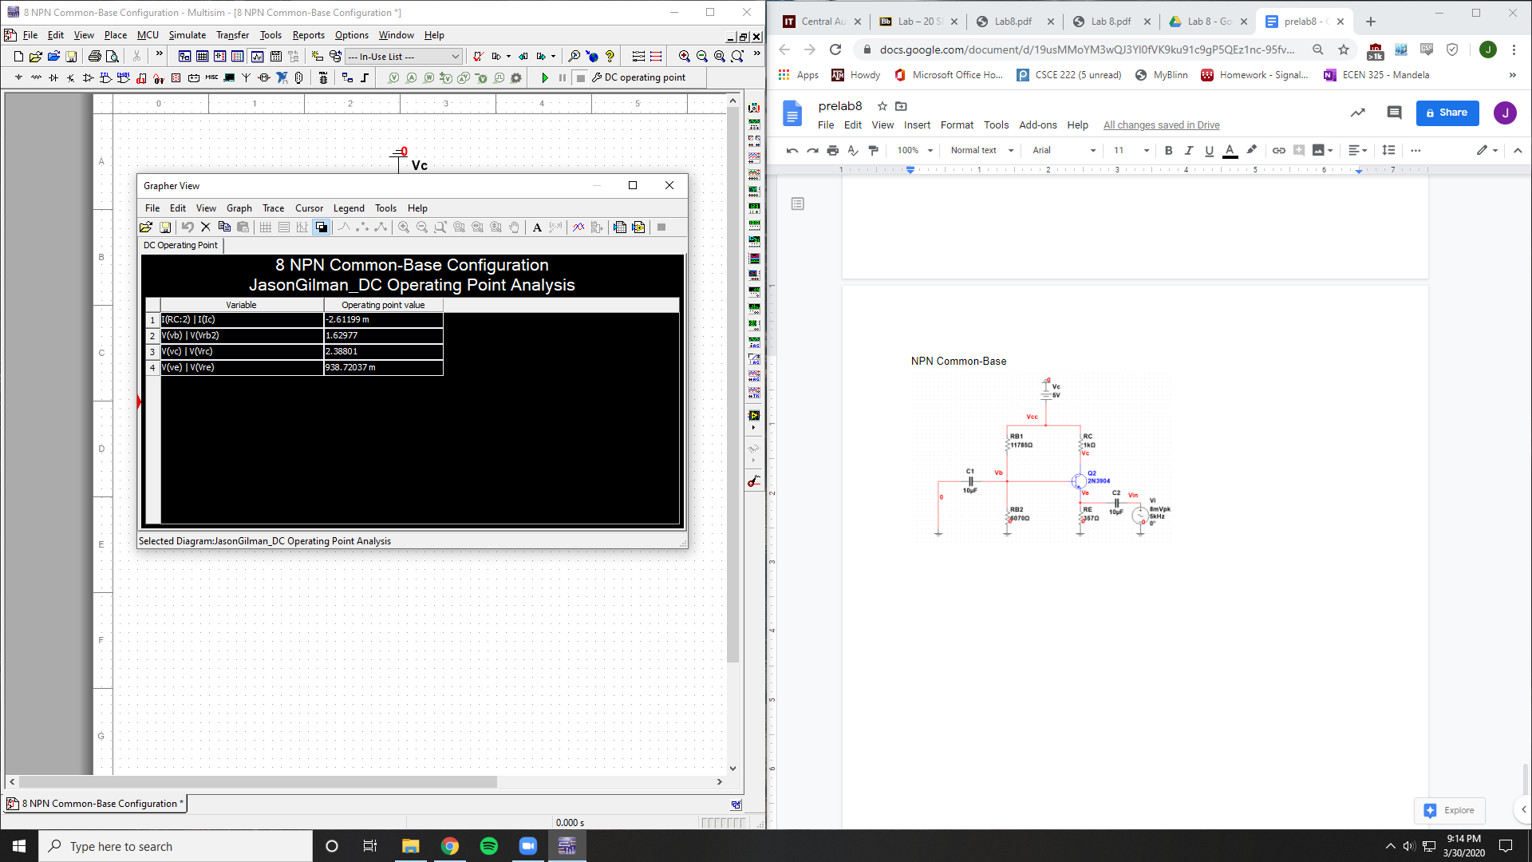

Ic = 2.61199 mA

Vrb2 = 1.62977 V

Vrc = 2.38801 V

Vre = .938 V

Vo = 2.38801 V

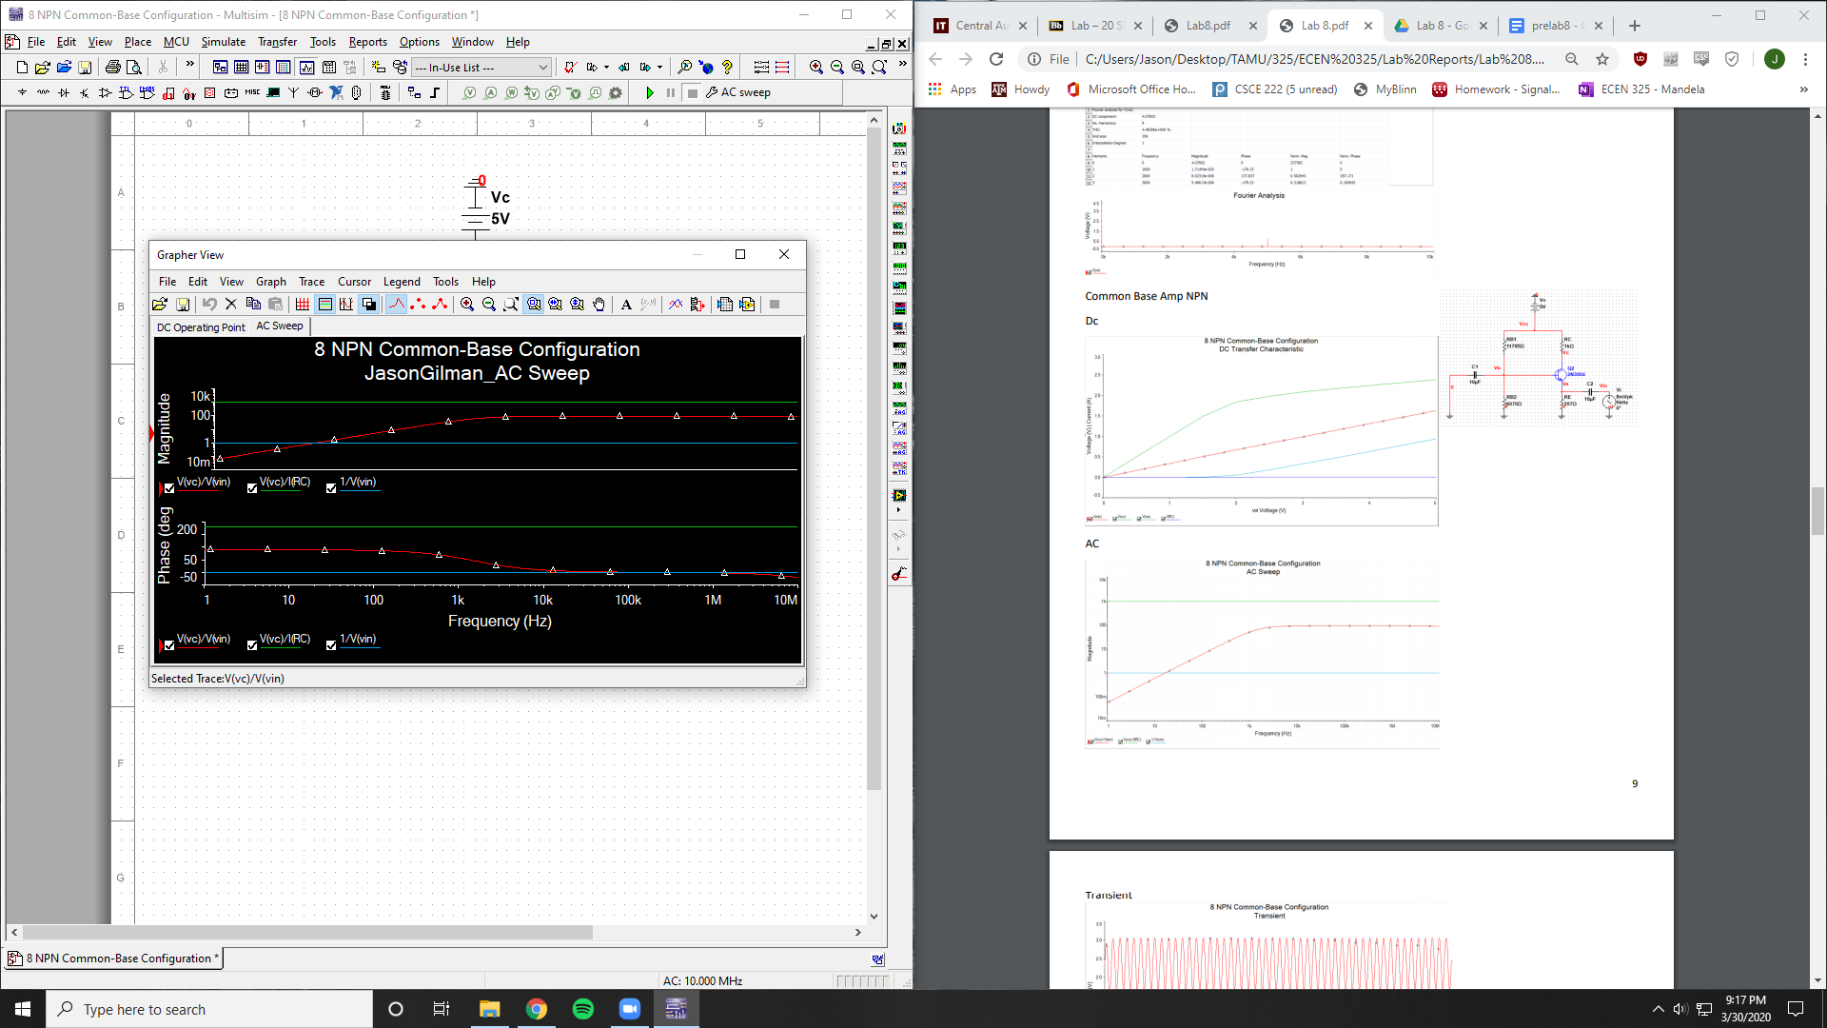

Av = 100

Ri = 1

Ro = 1000

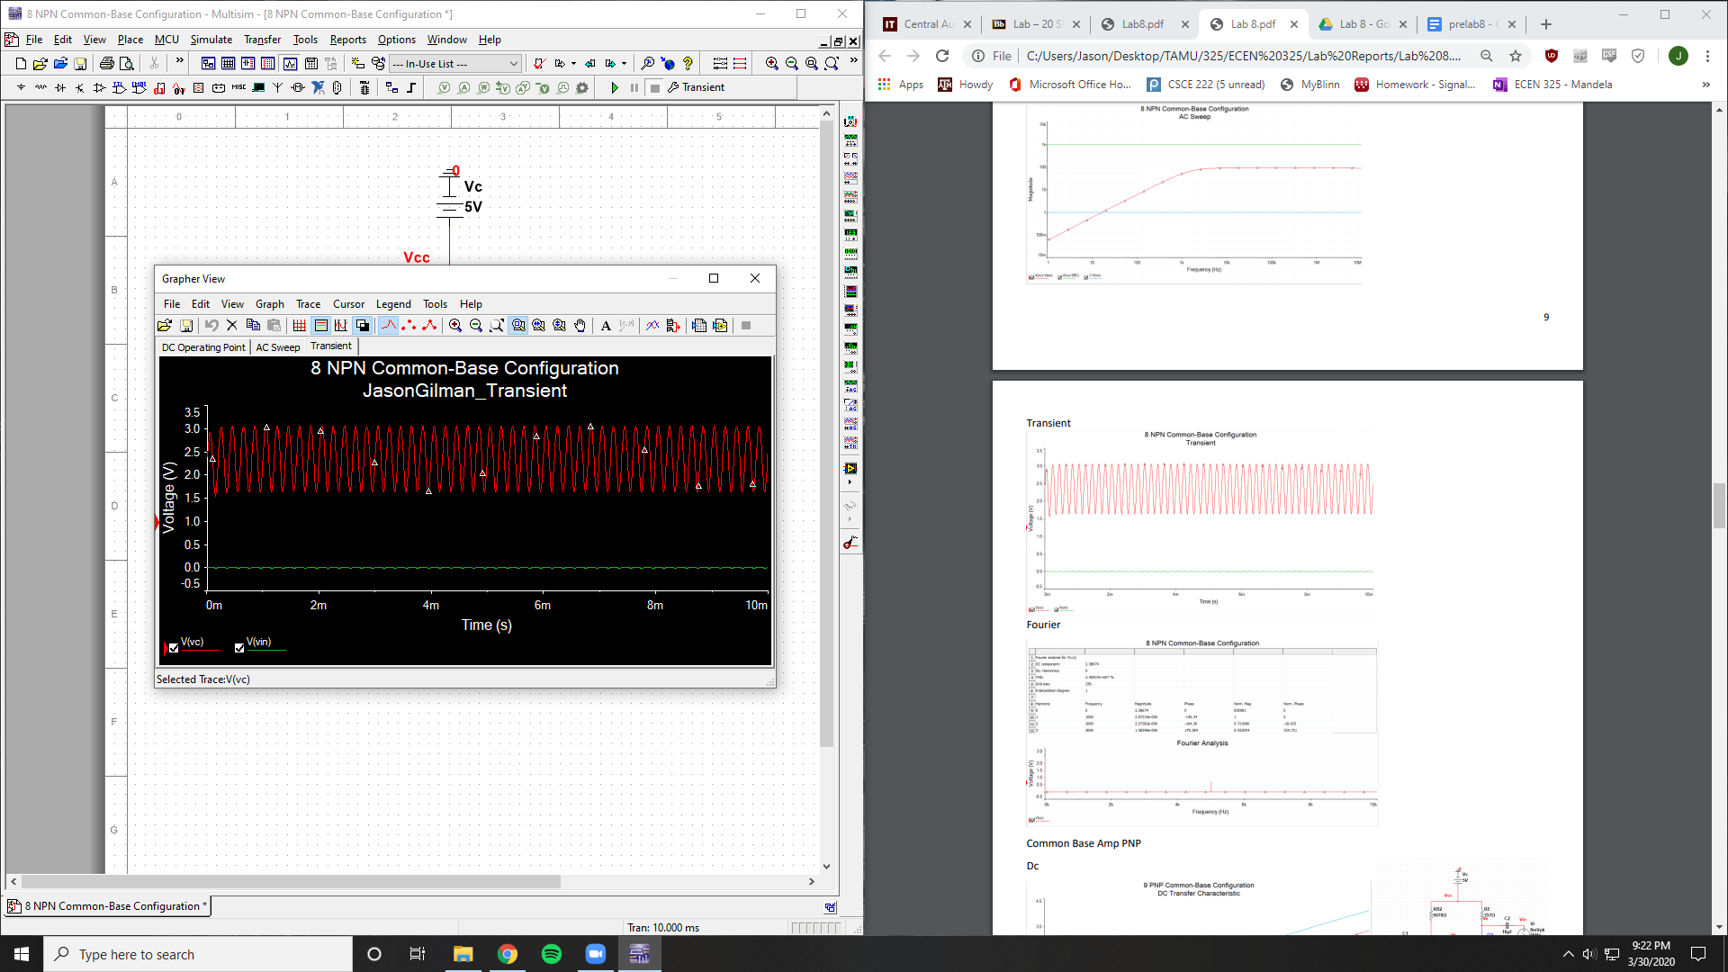

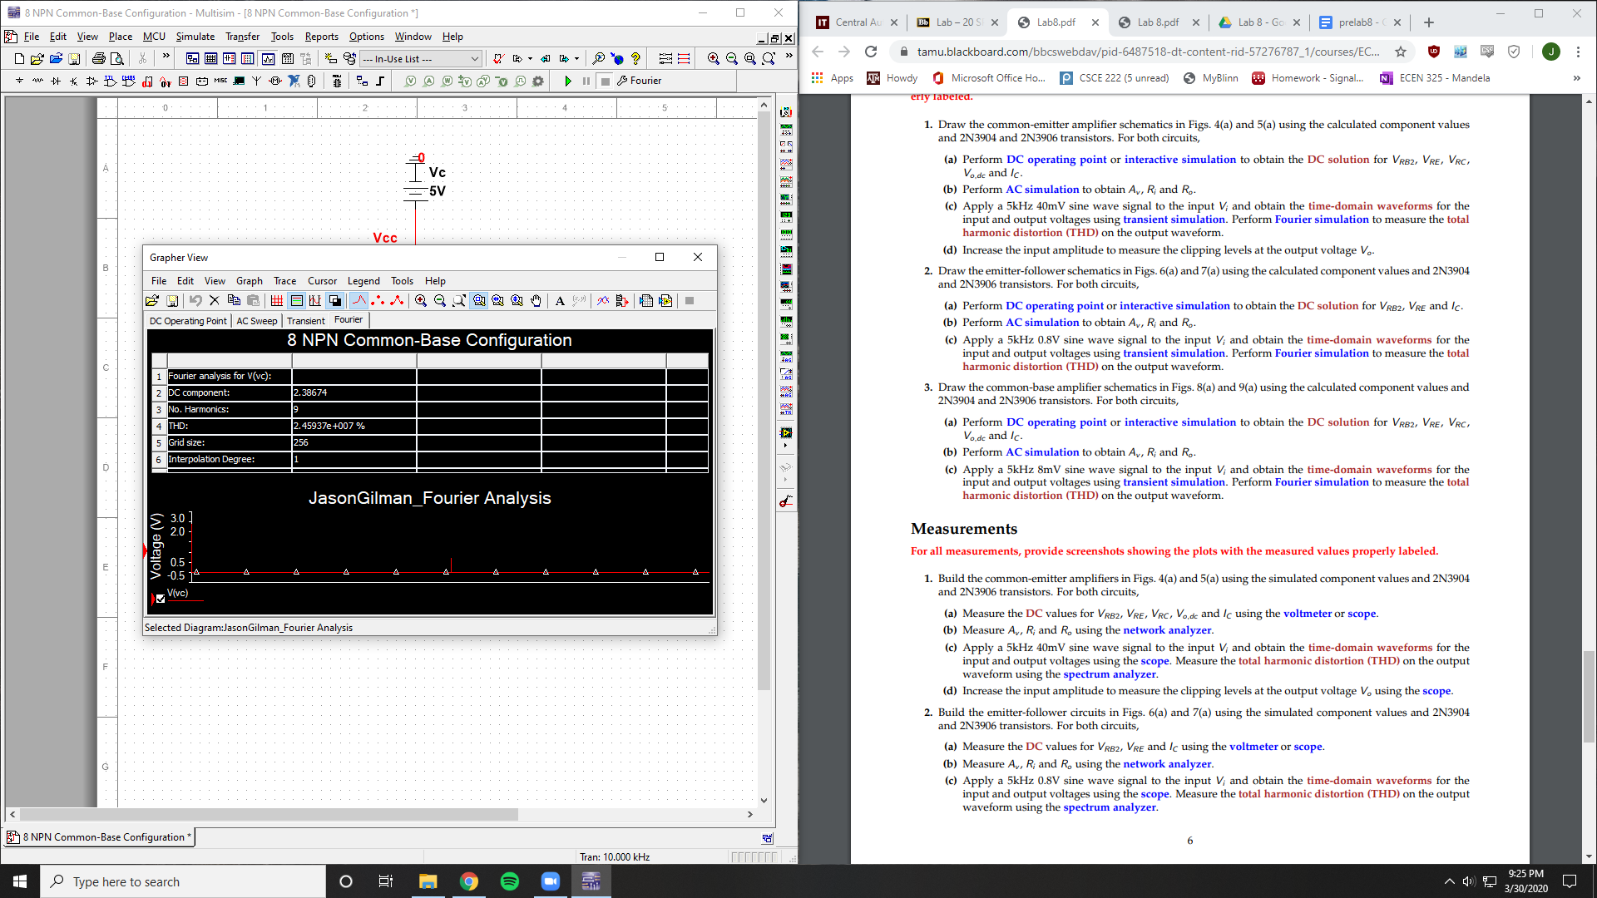

THD = 2.45937E7 %

PNP Common-Base

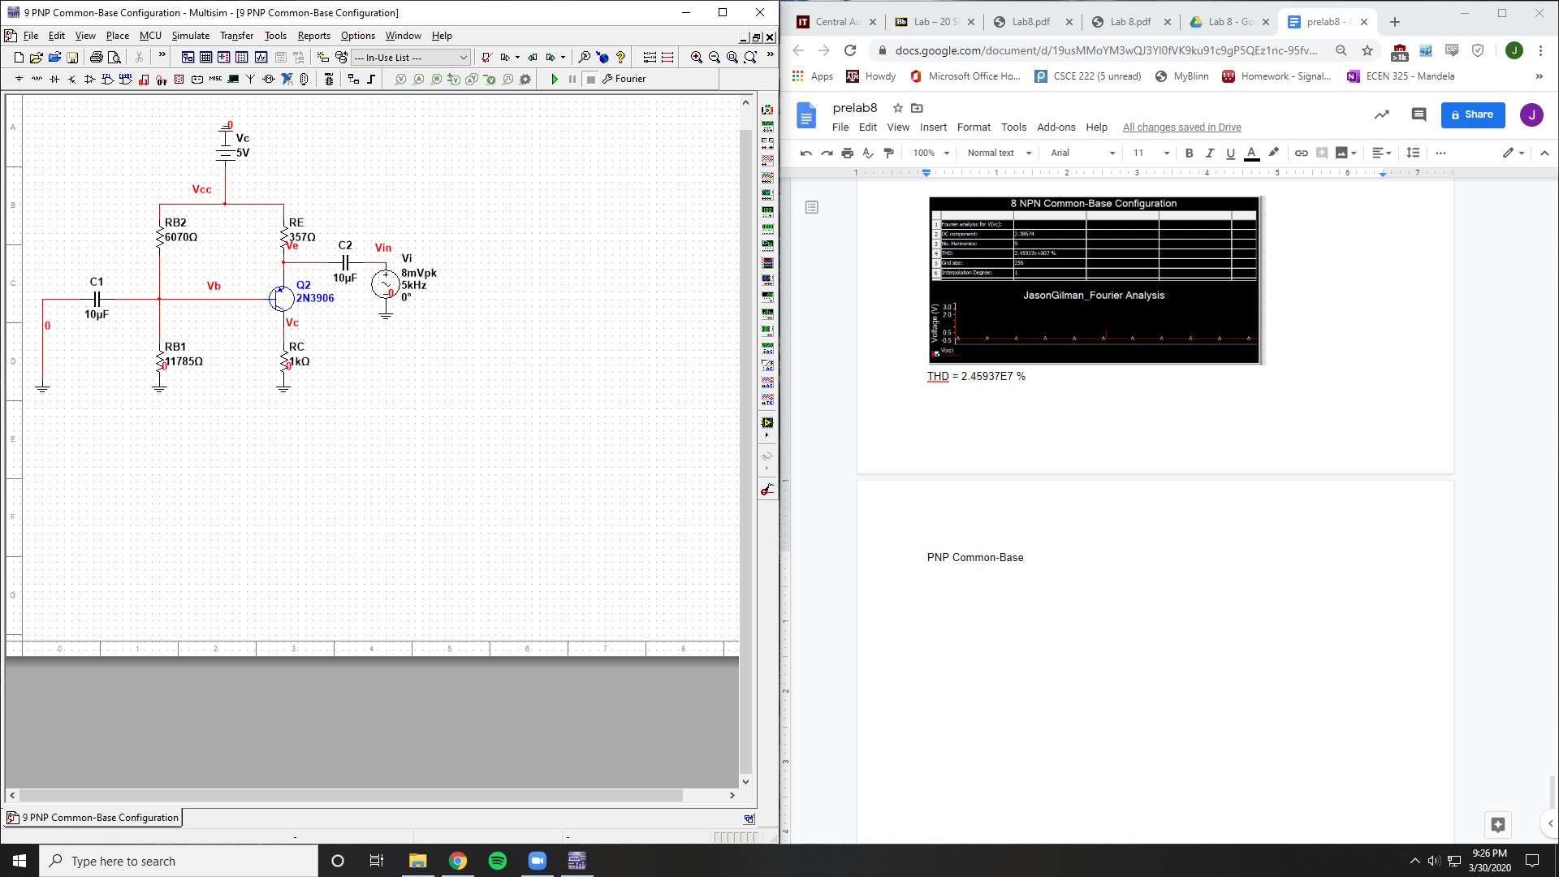

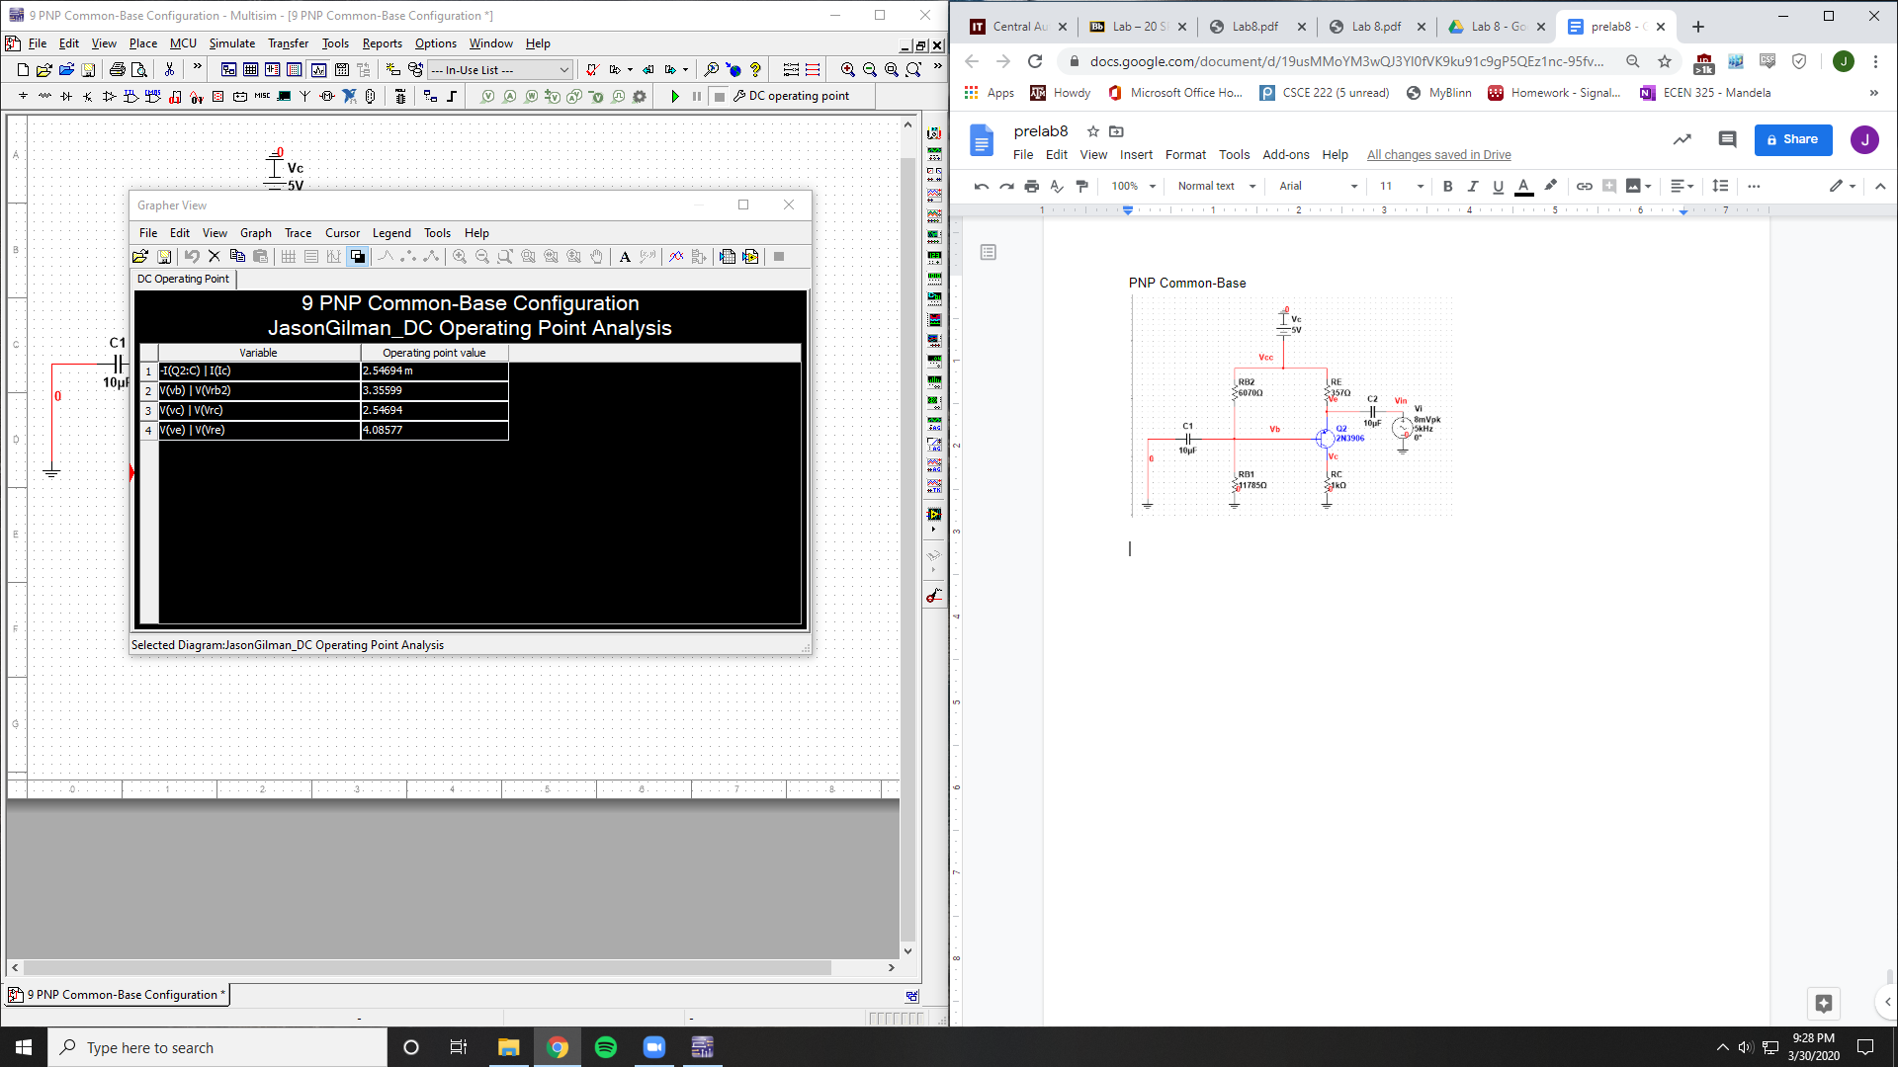

Ic = 2.54694 mA

Vrb2 = 3.35599 V

Vrc = 2.54694 V

Vre = 4.08577 V

Vo = 2.54694 V

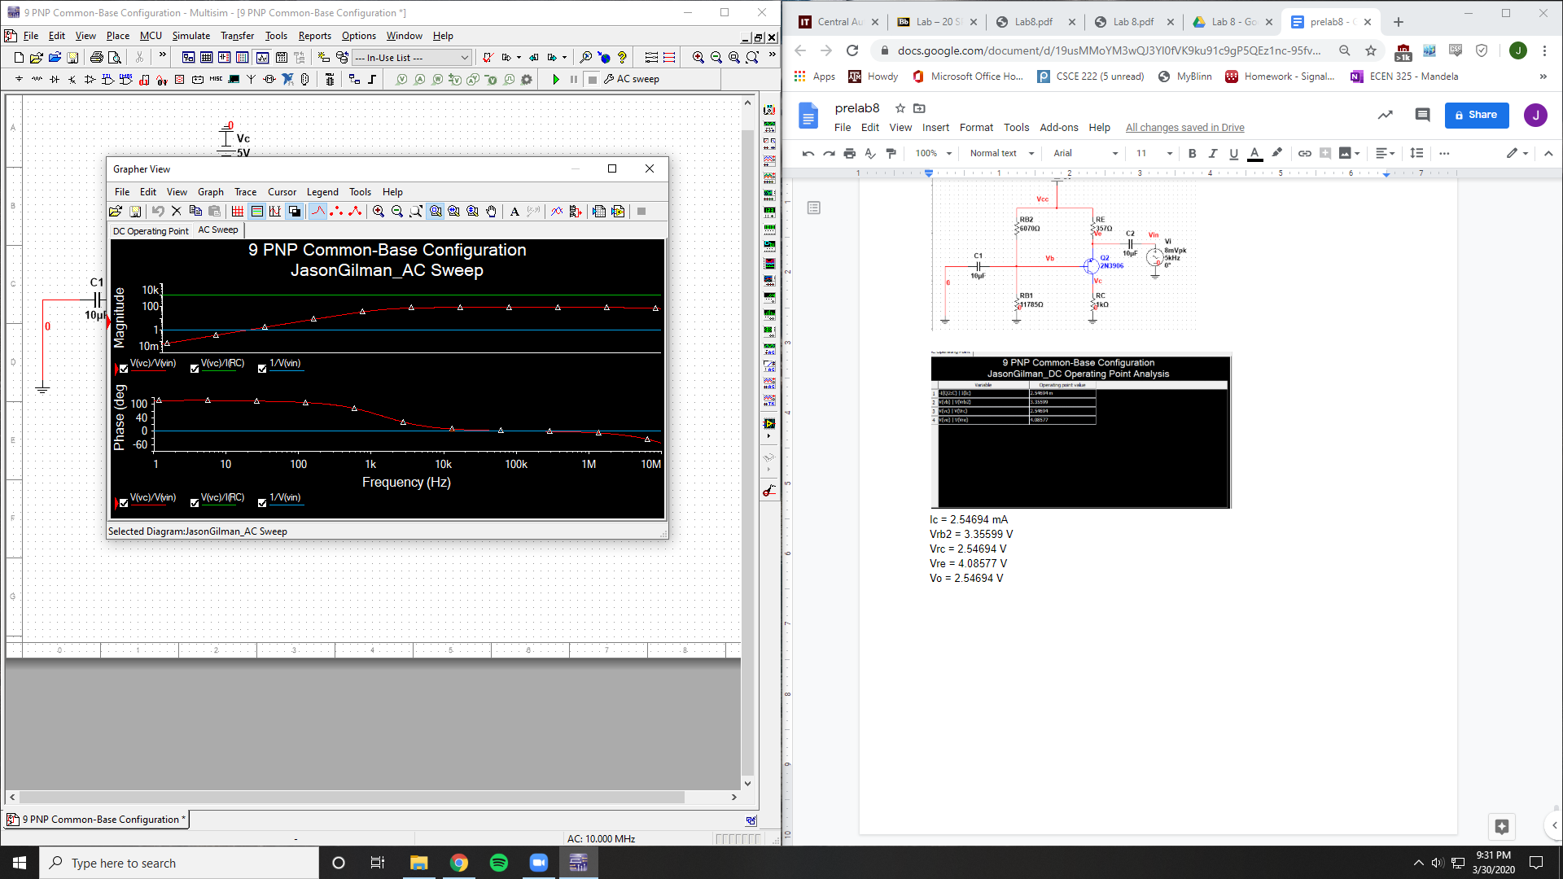

Av = 100

Ri = 1

Ro = 1000

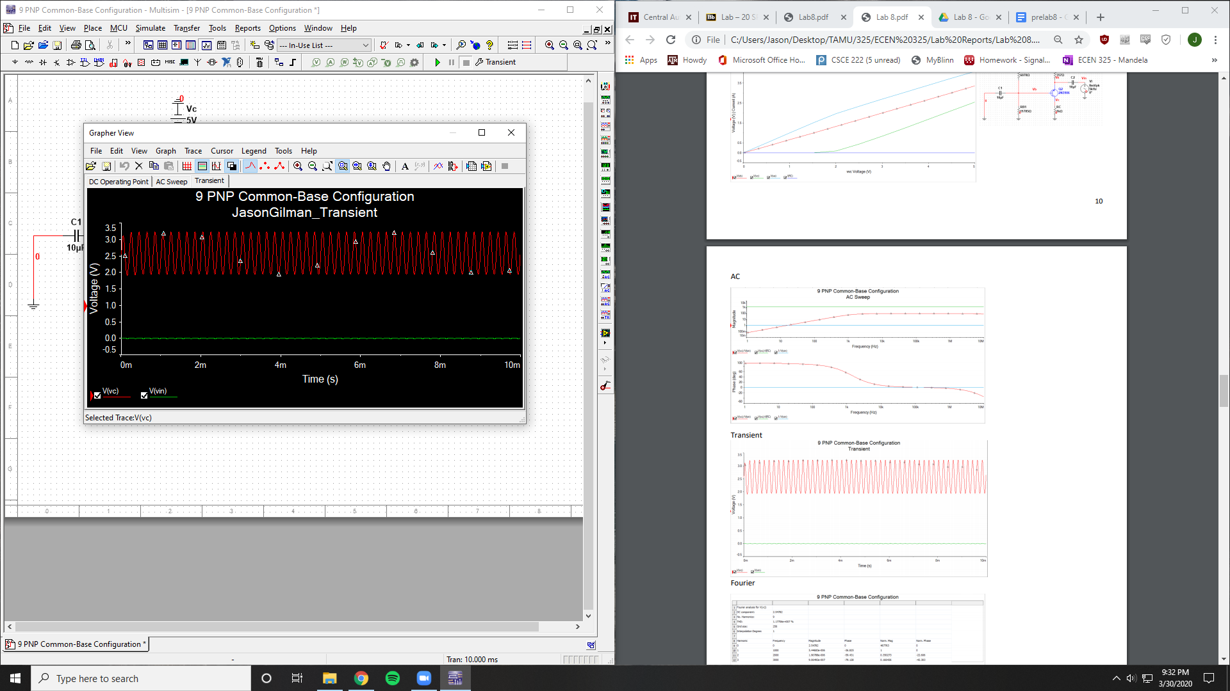

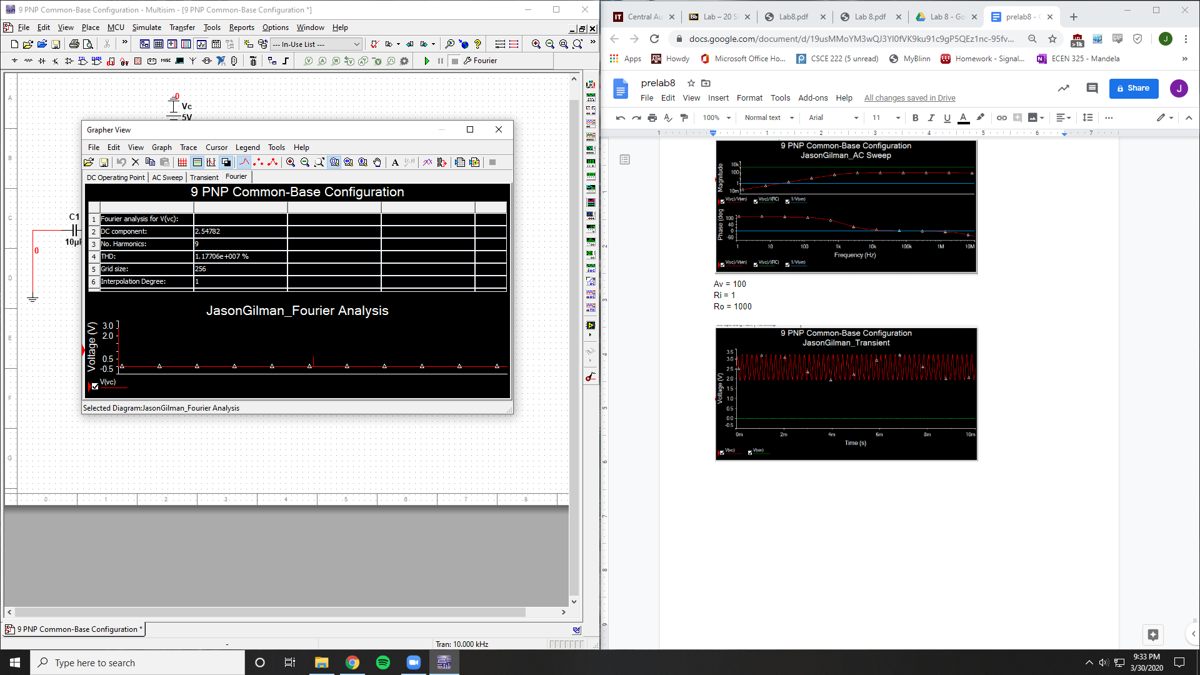

THD = 1.17706E7 %

**Measurements**

NPN Common-Emitter

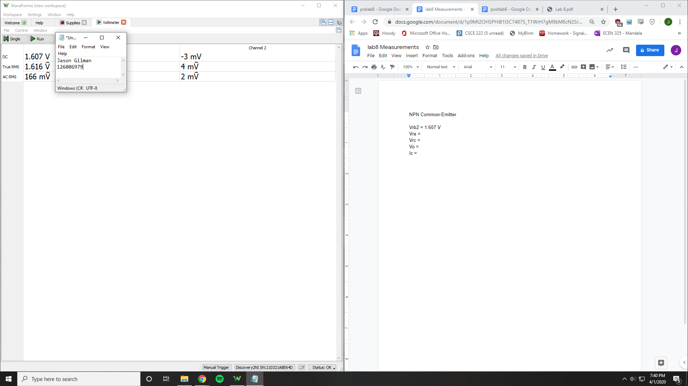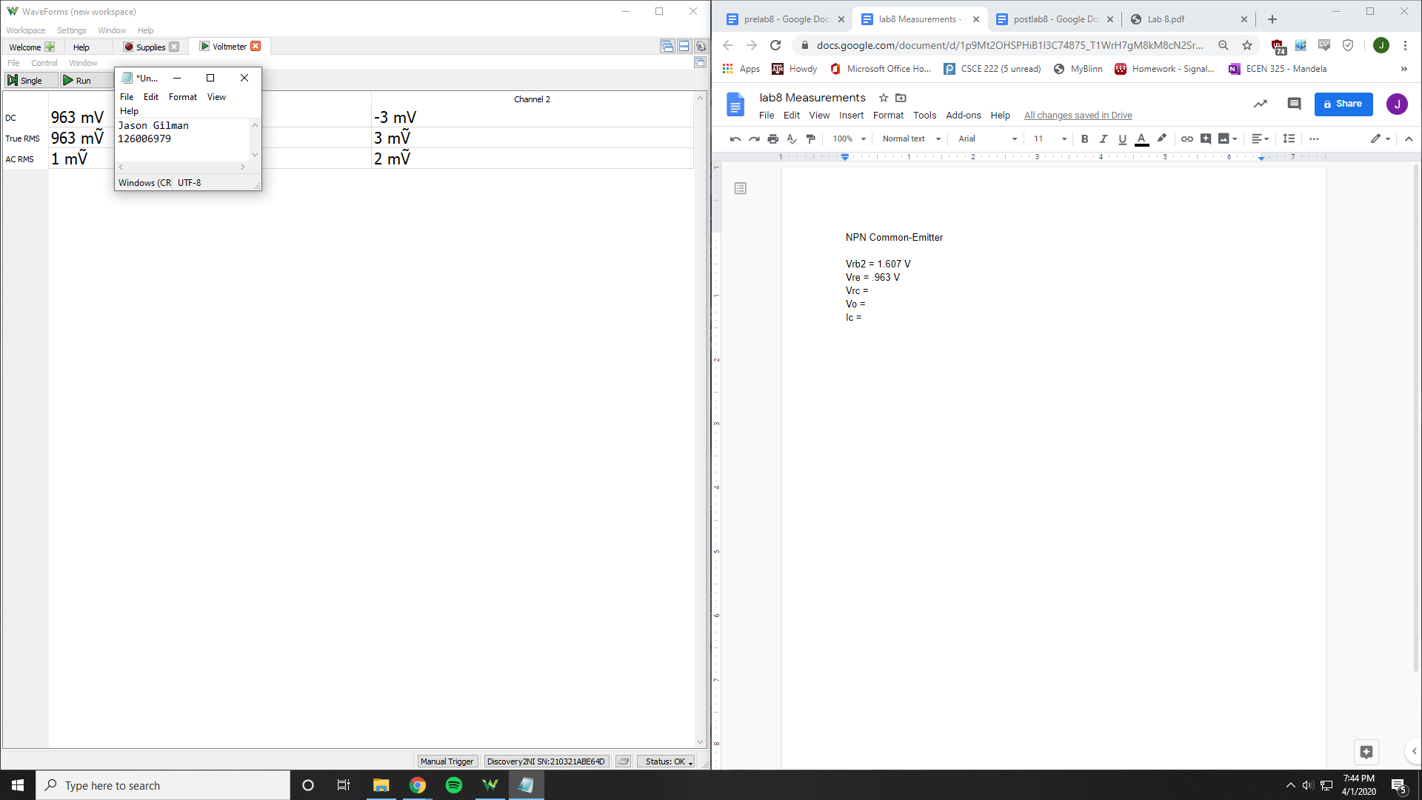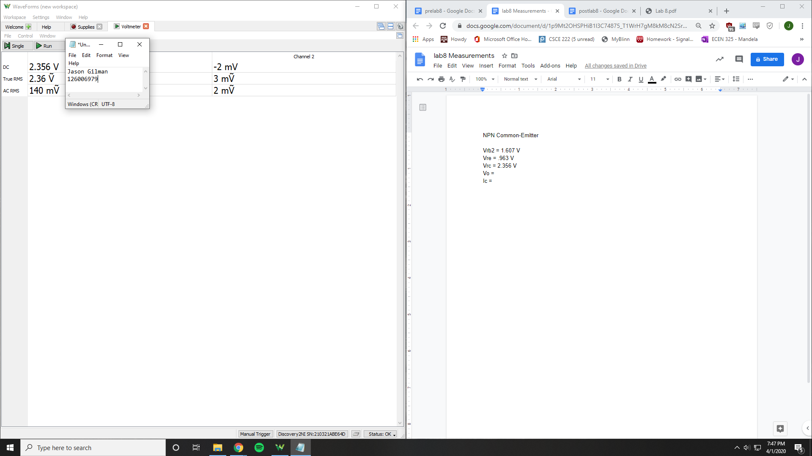

Vrb2 = 1.607 V

Vre = .963 V

Vrc = 2.356 V

Vo = 2.356 V

Ic = 2.356 mA

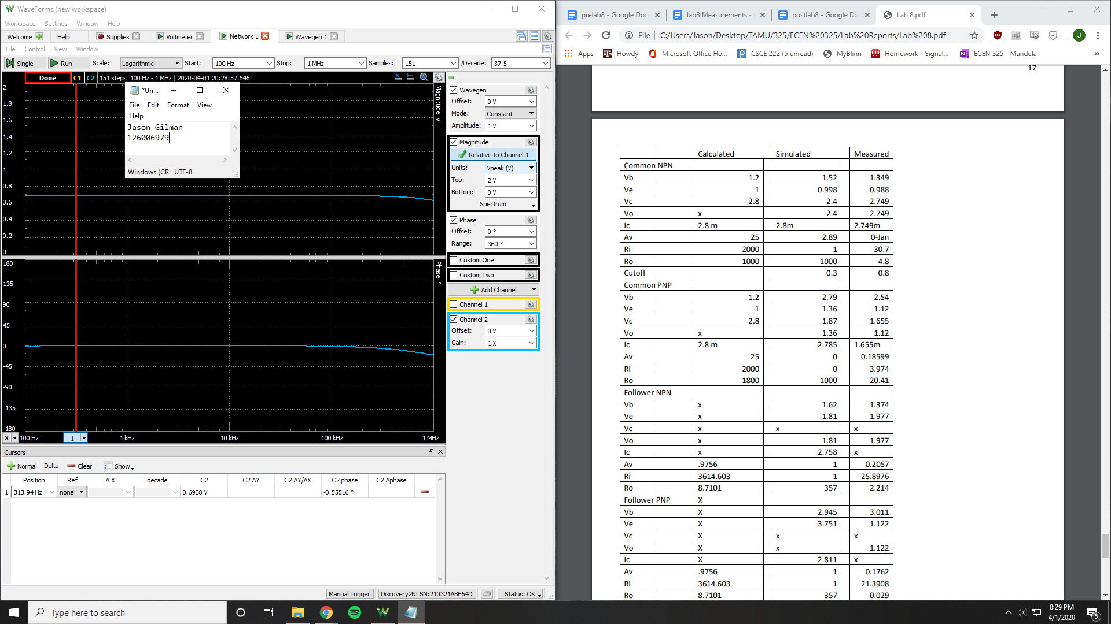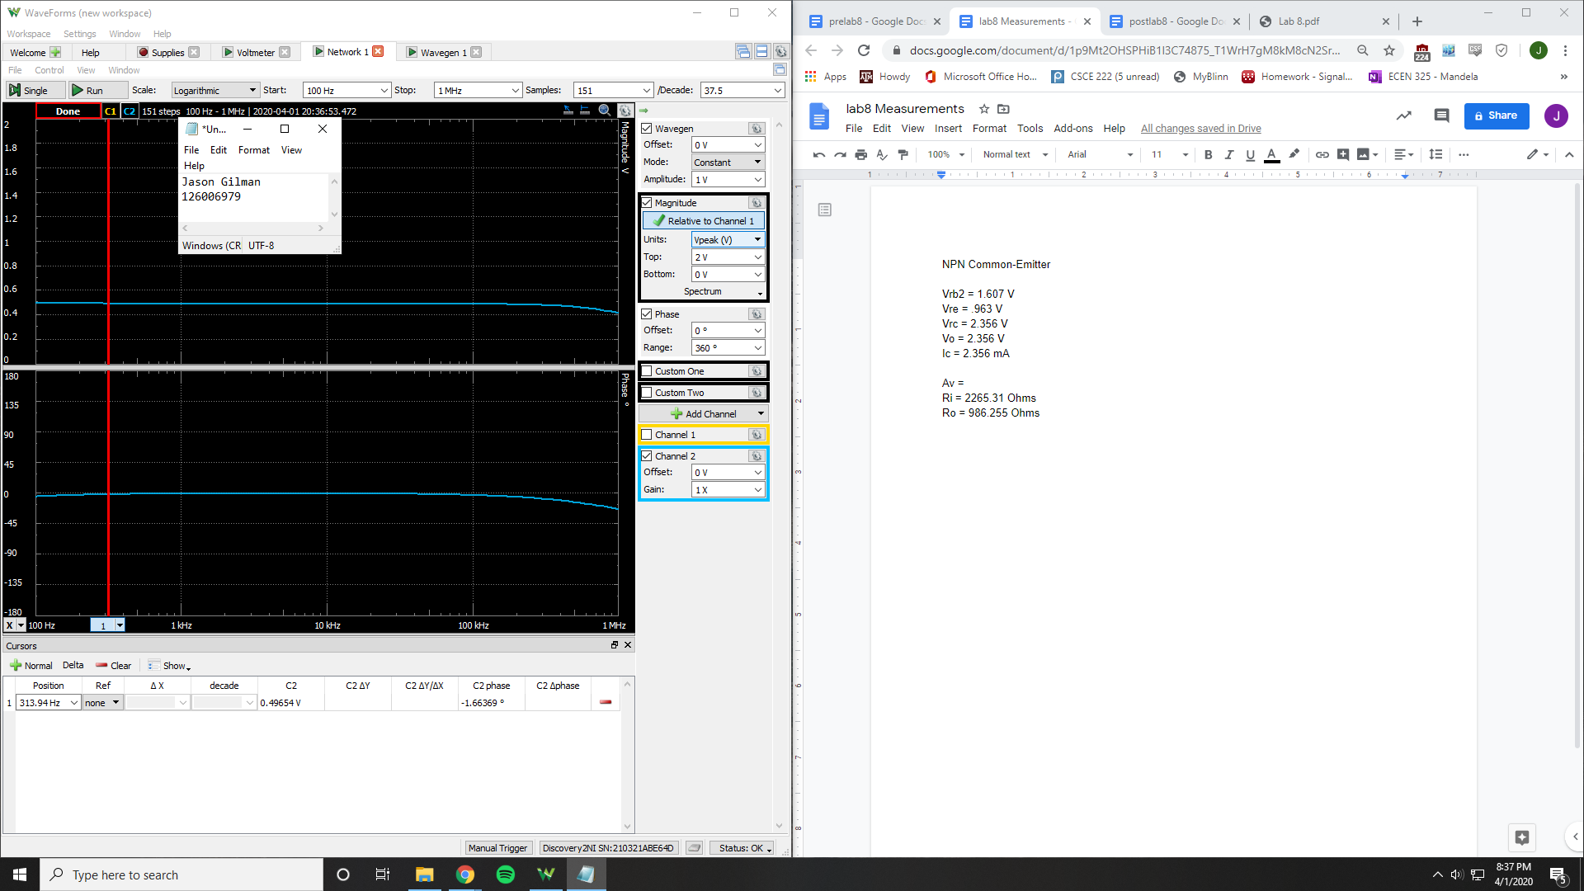

Ri = 2265.31 Ohms

Ro = 986.255 Ohms

Av = .715733 V/V

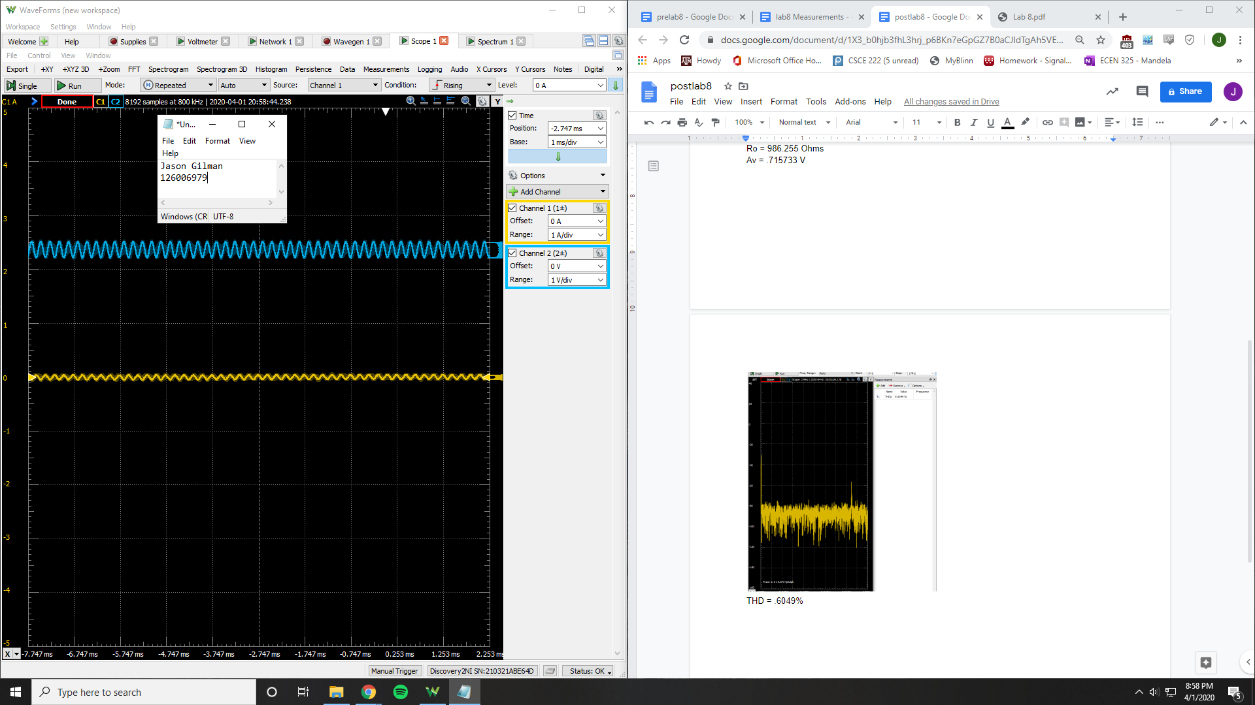

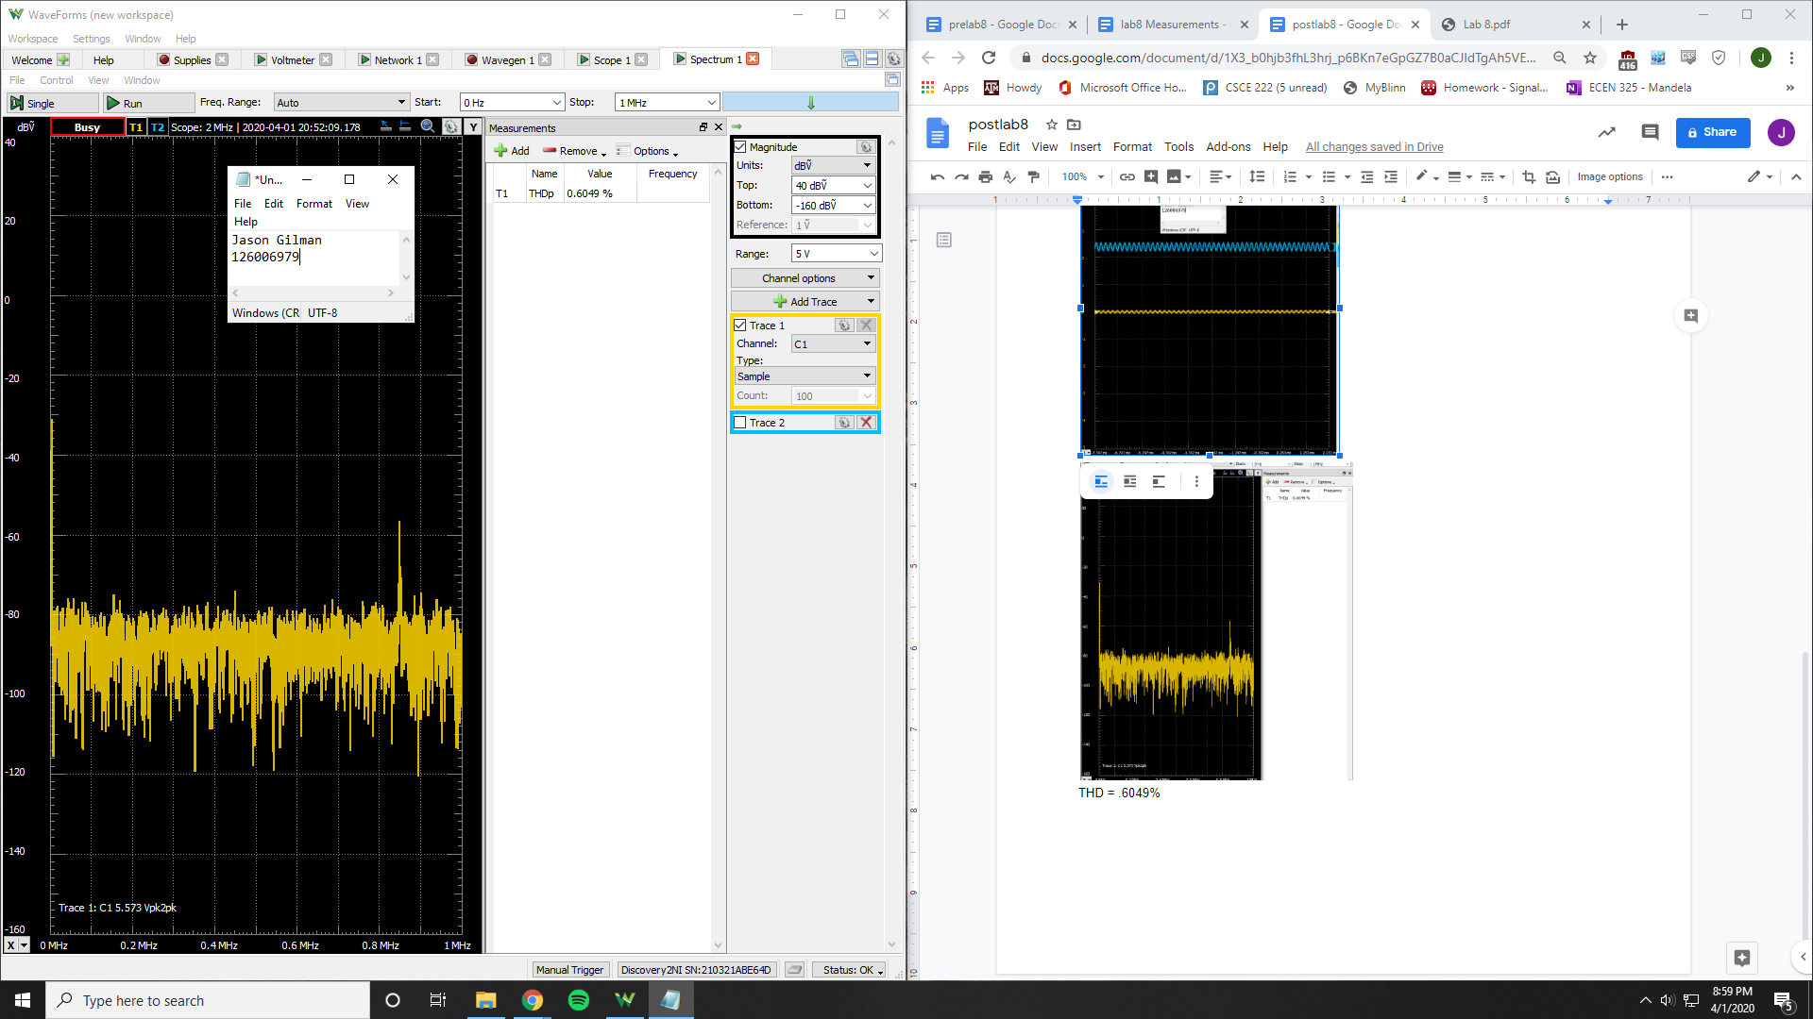

THD = .6049%

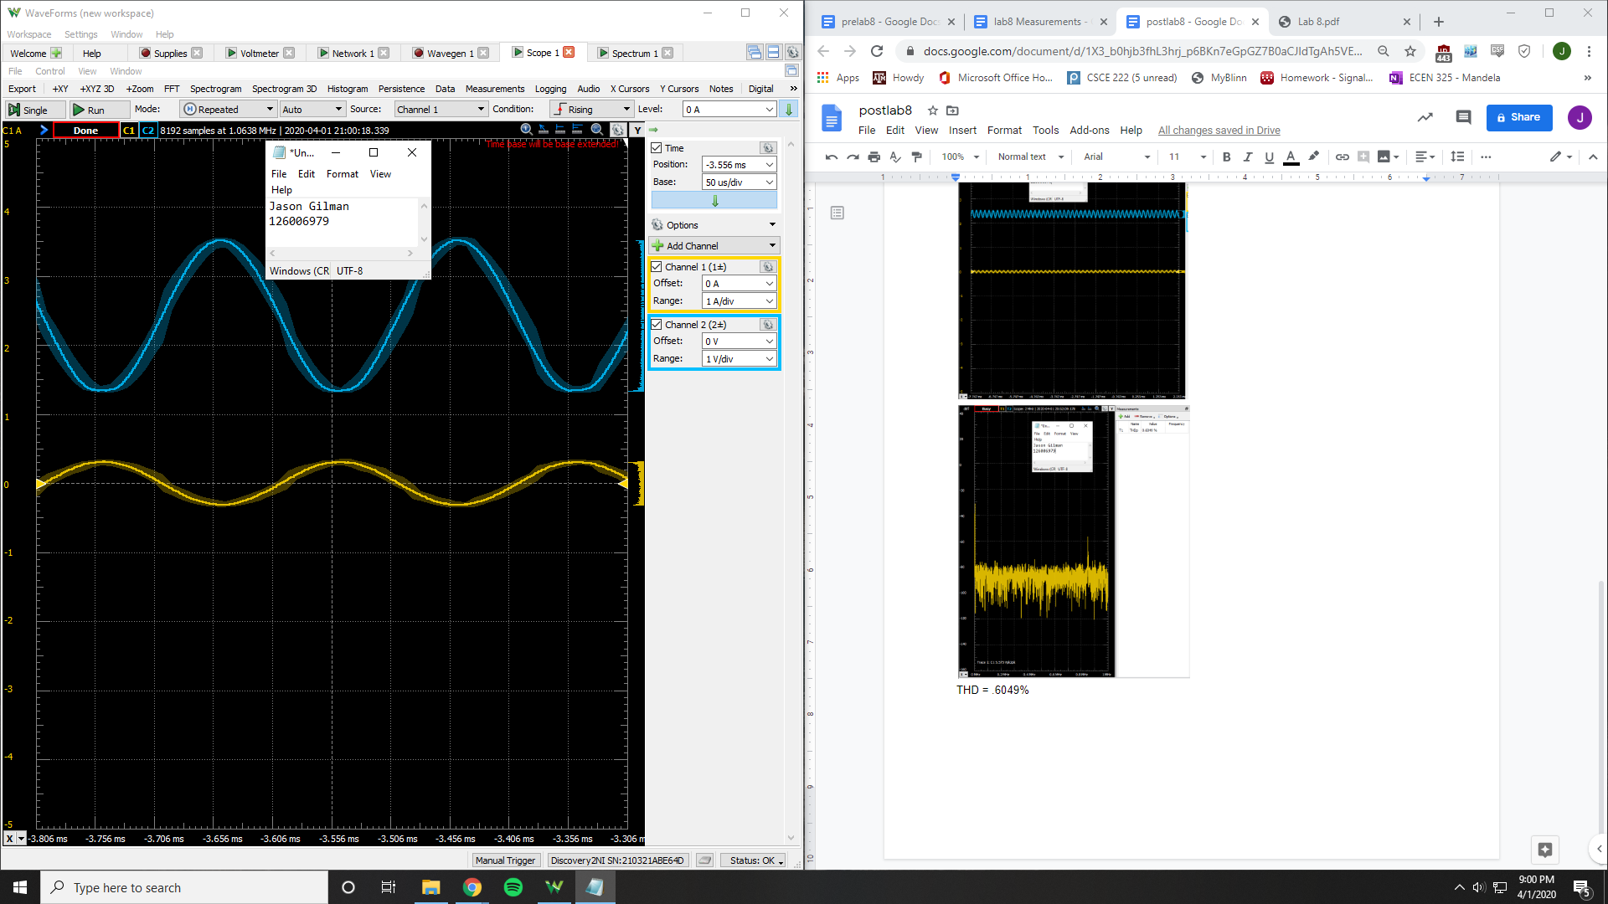

V clipping point = .310 V

PNP Common-Emitter

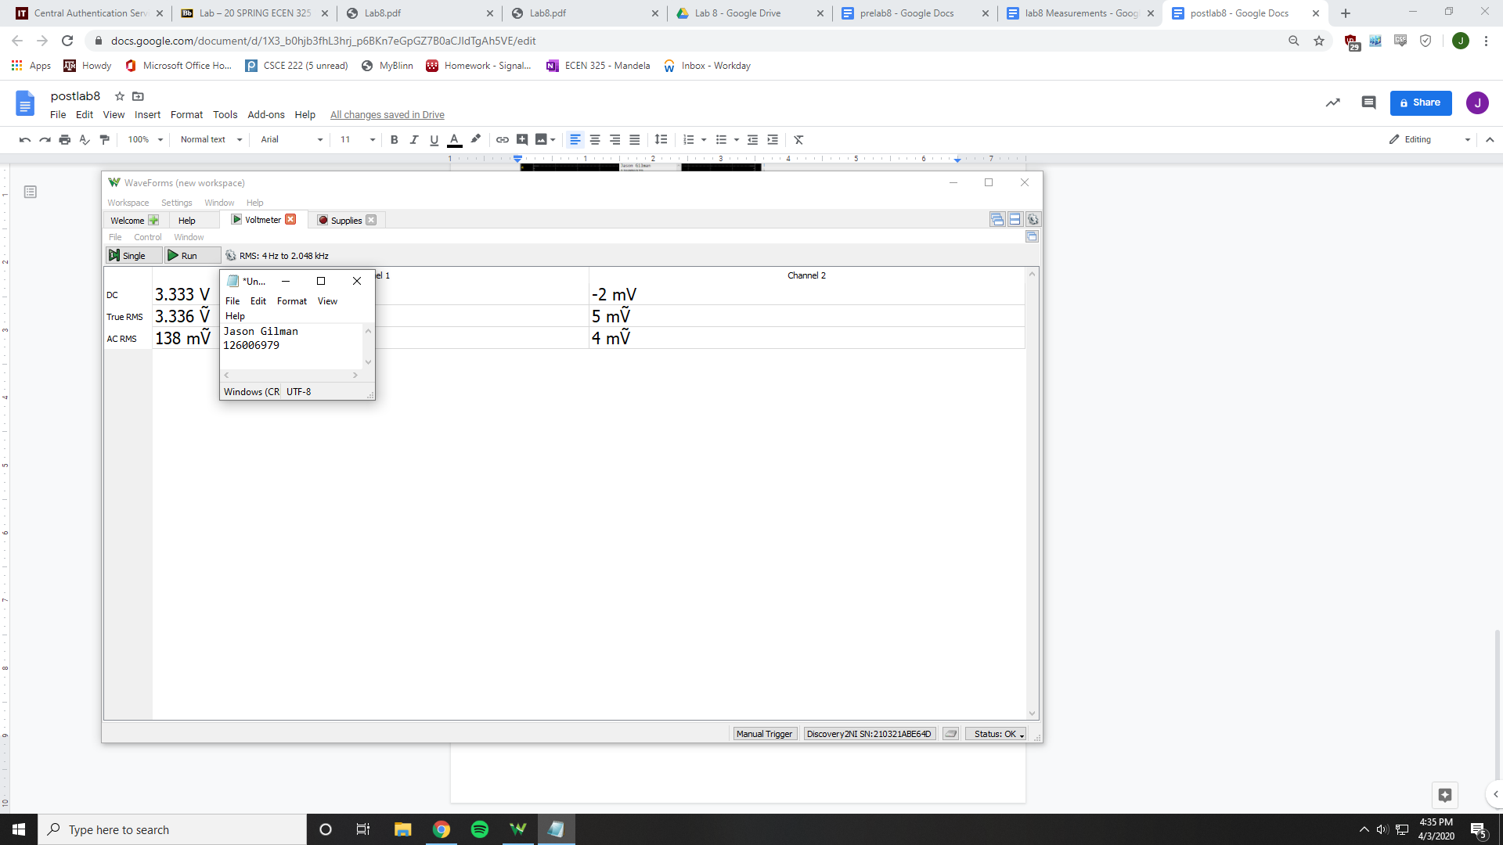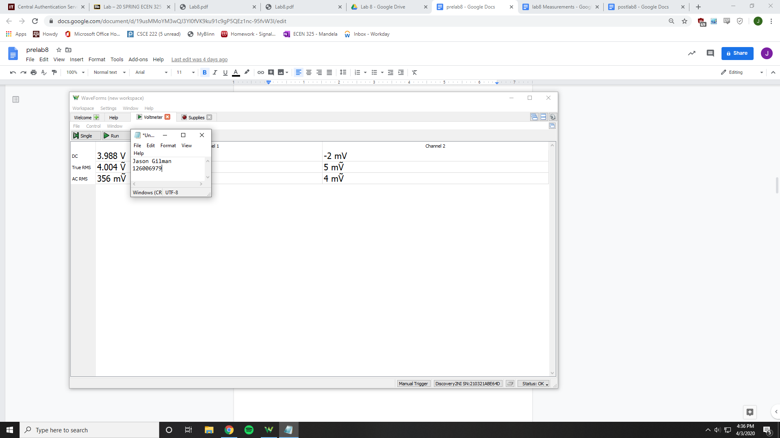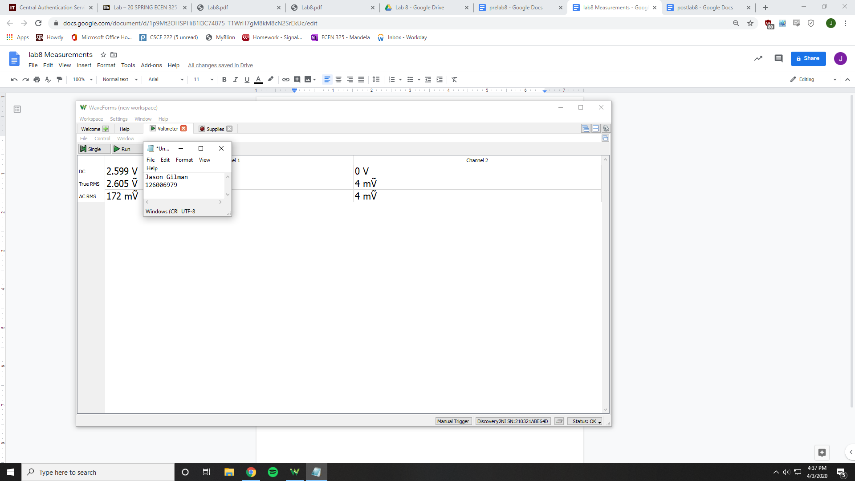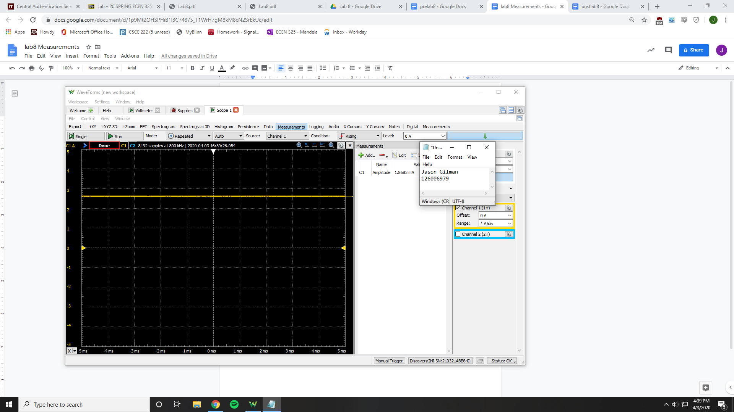

Vrb2 = 3.33 V

Vre = 3.988 V

Vrc = 2.599 V

Vo = 2.599 V

Ic = 1.8683 mA

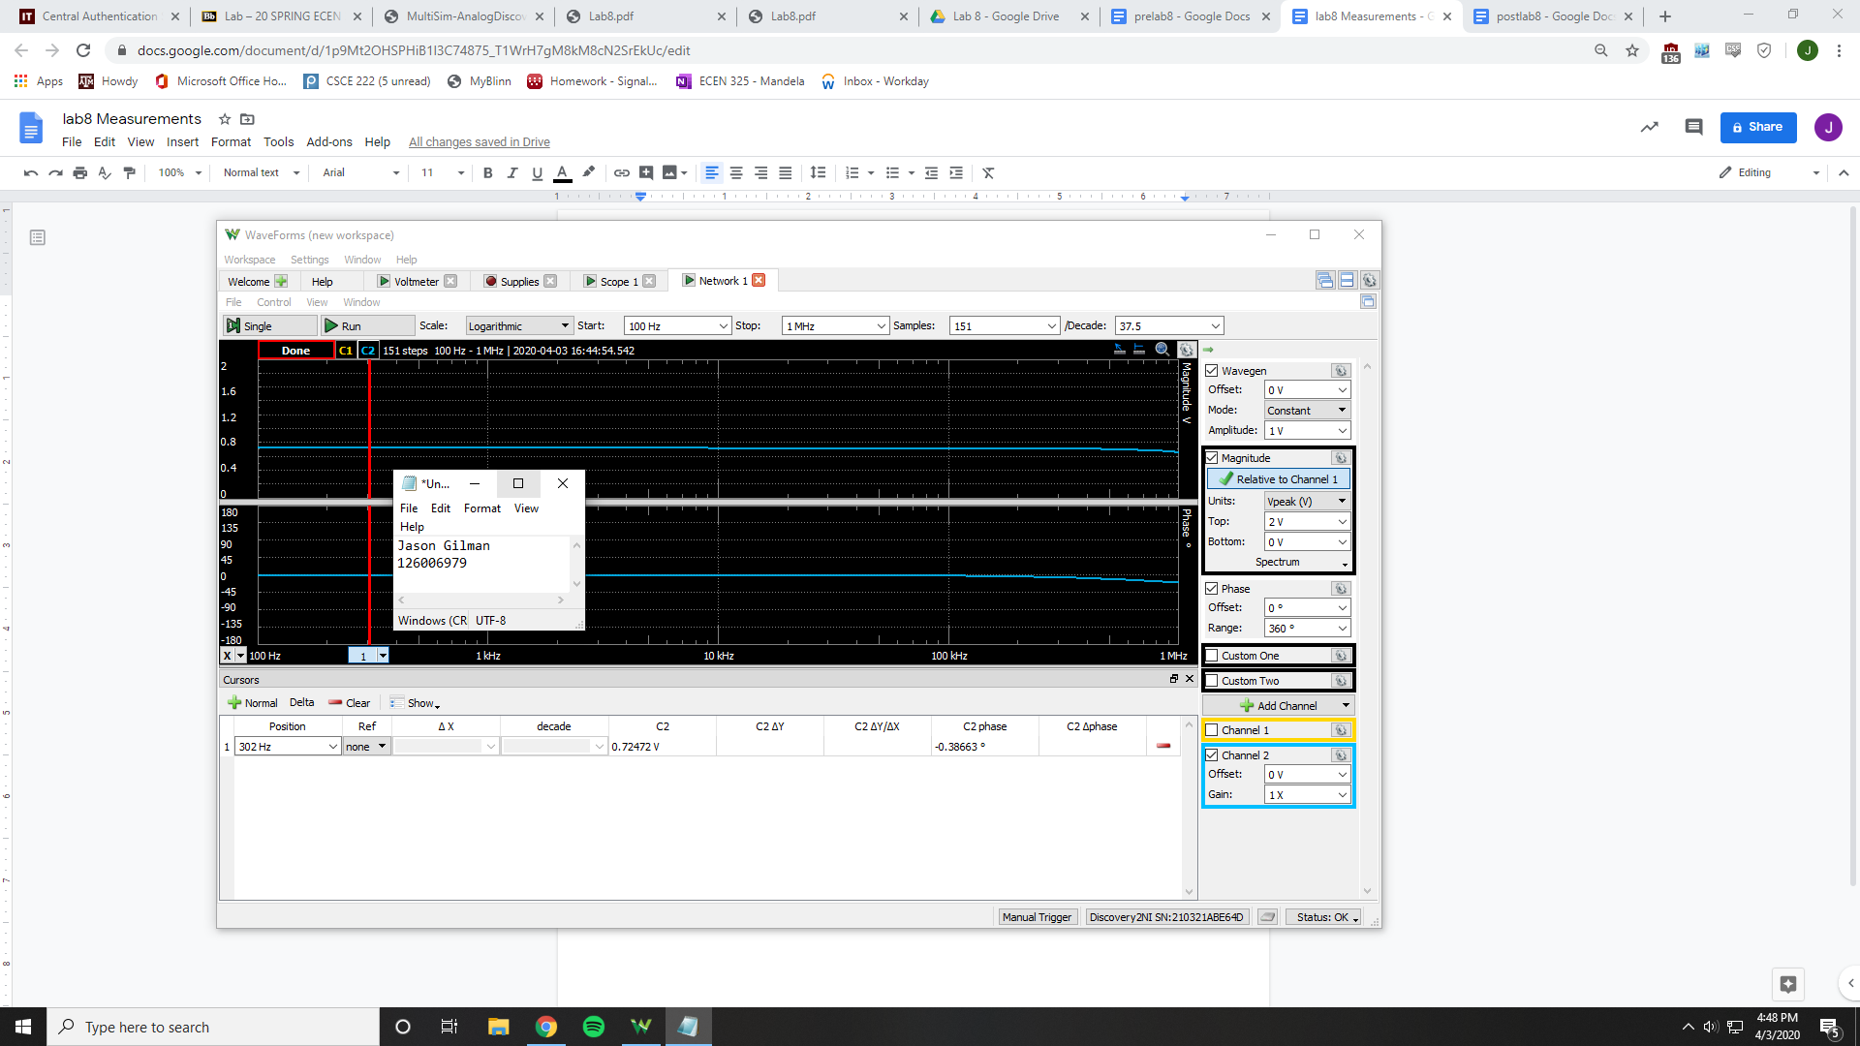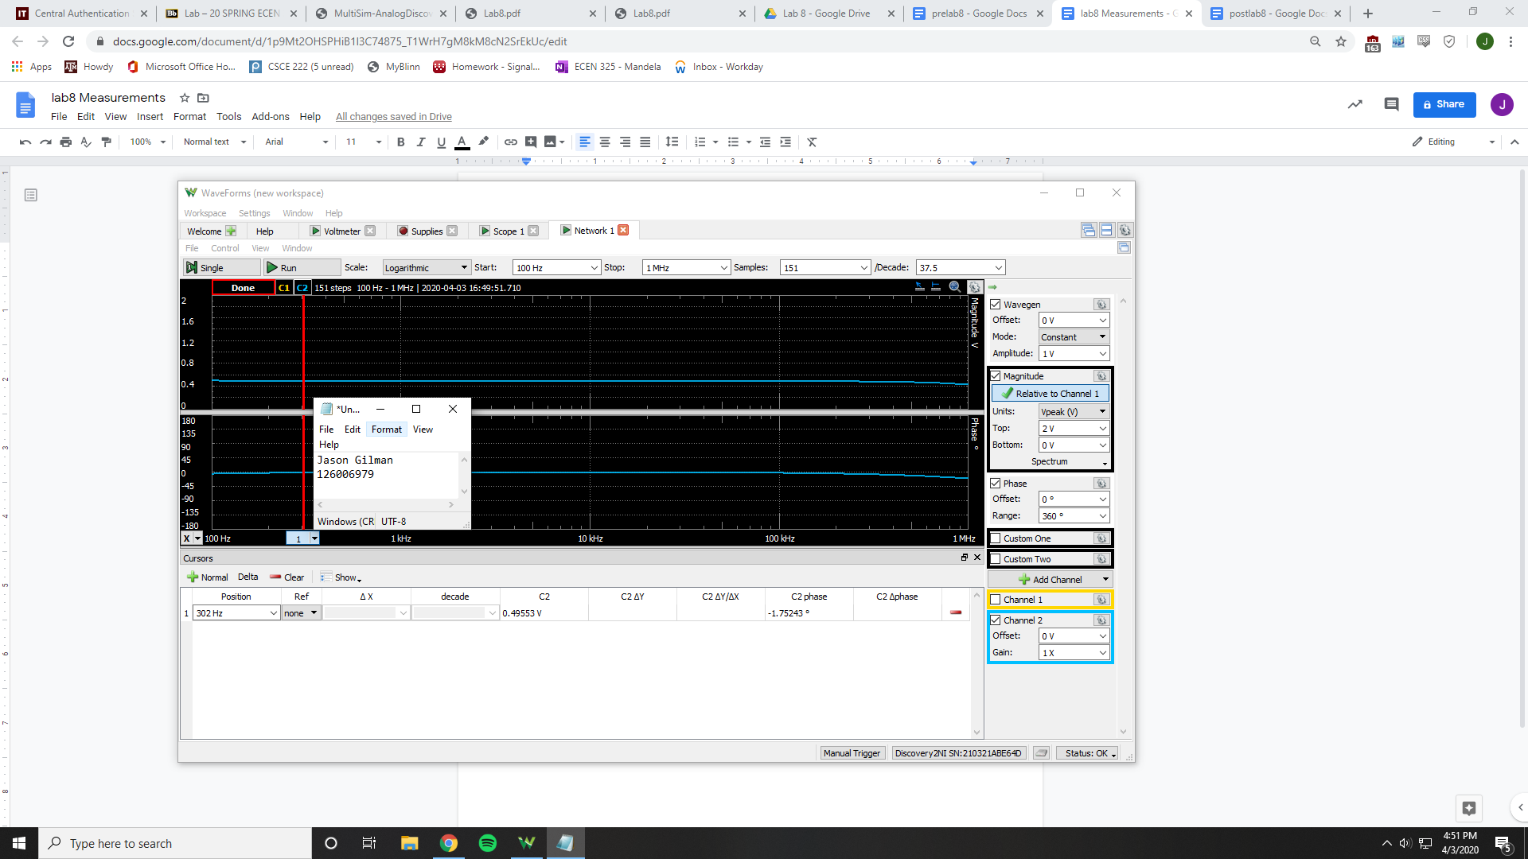

Ri = 2632.66 Ohms

Ro = 982.278 Ohms

Av = .683754 V/V

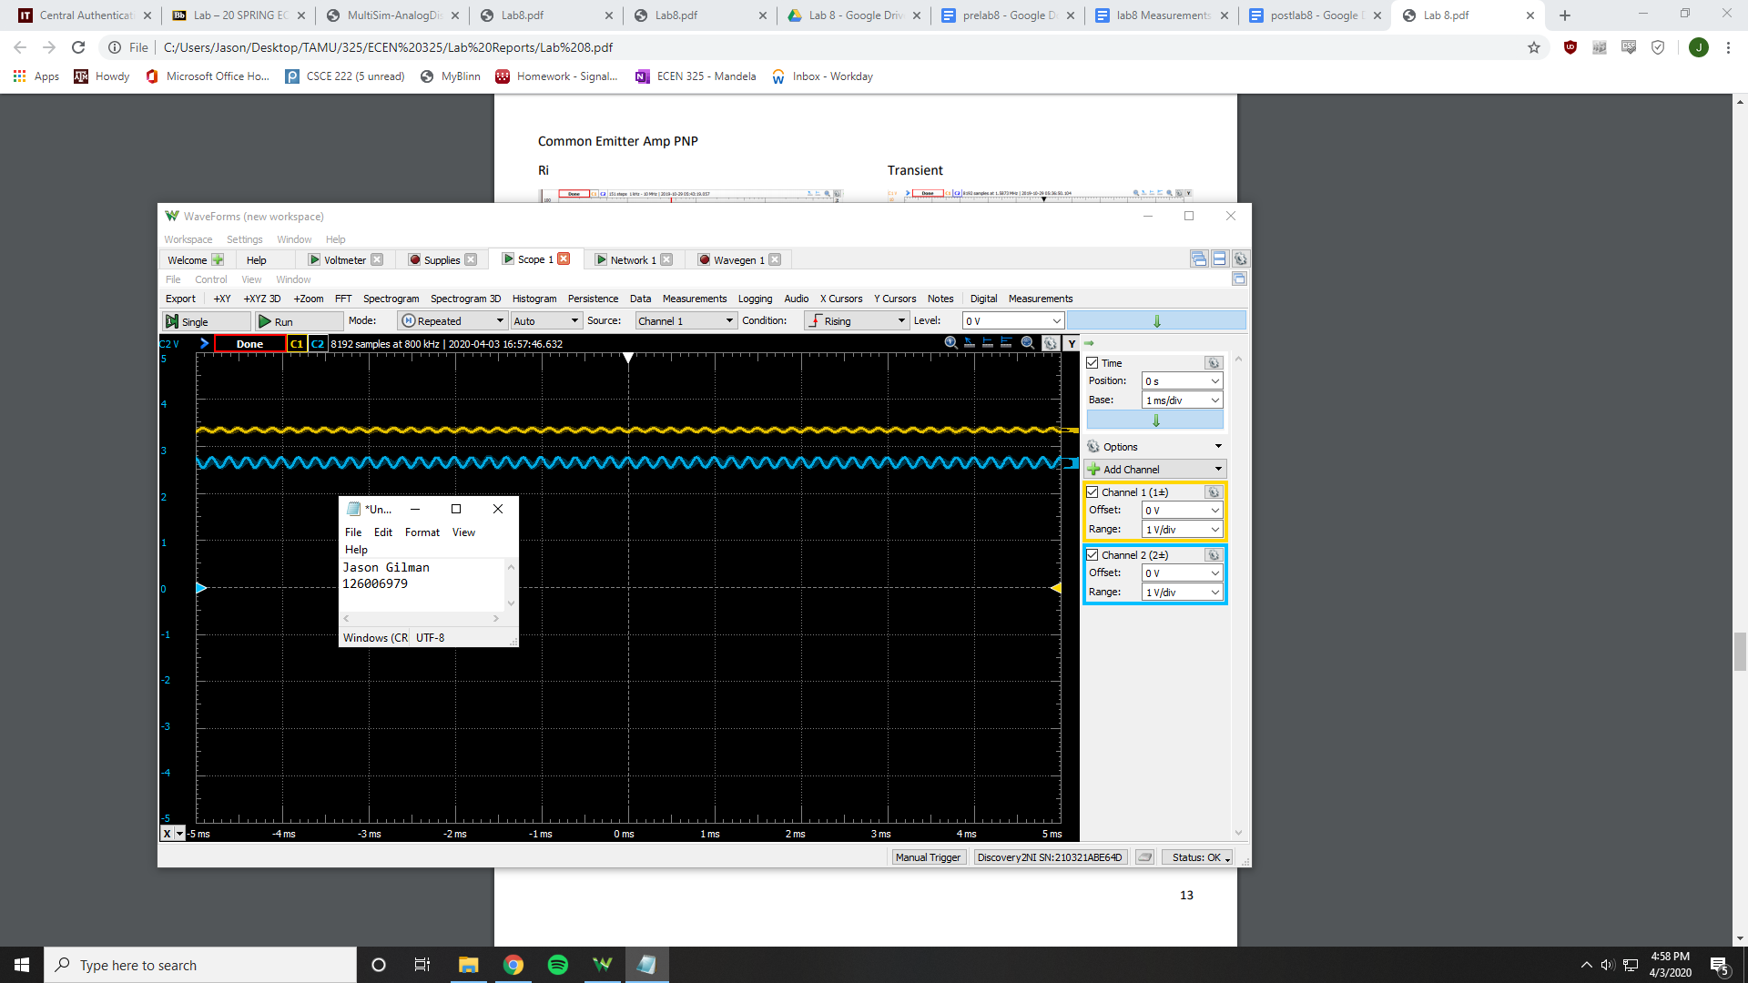

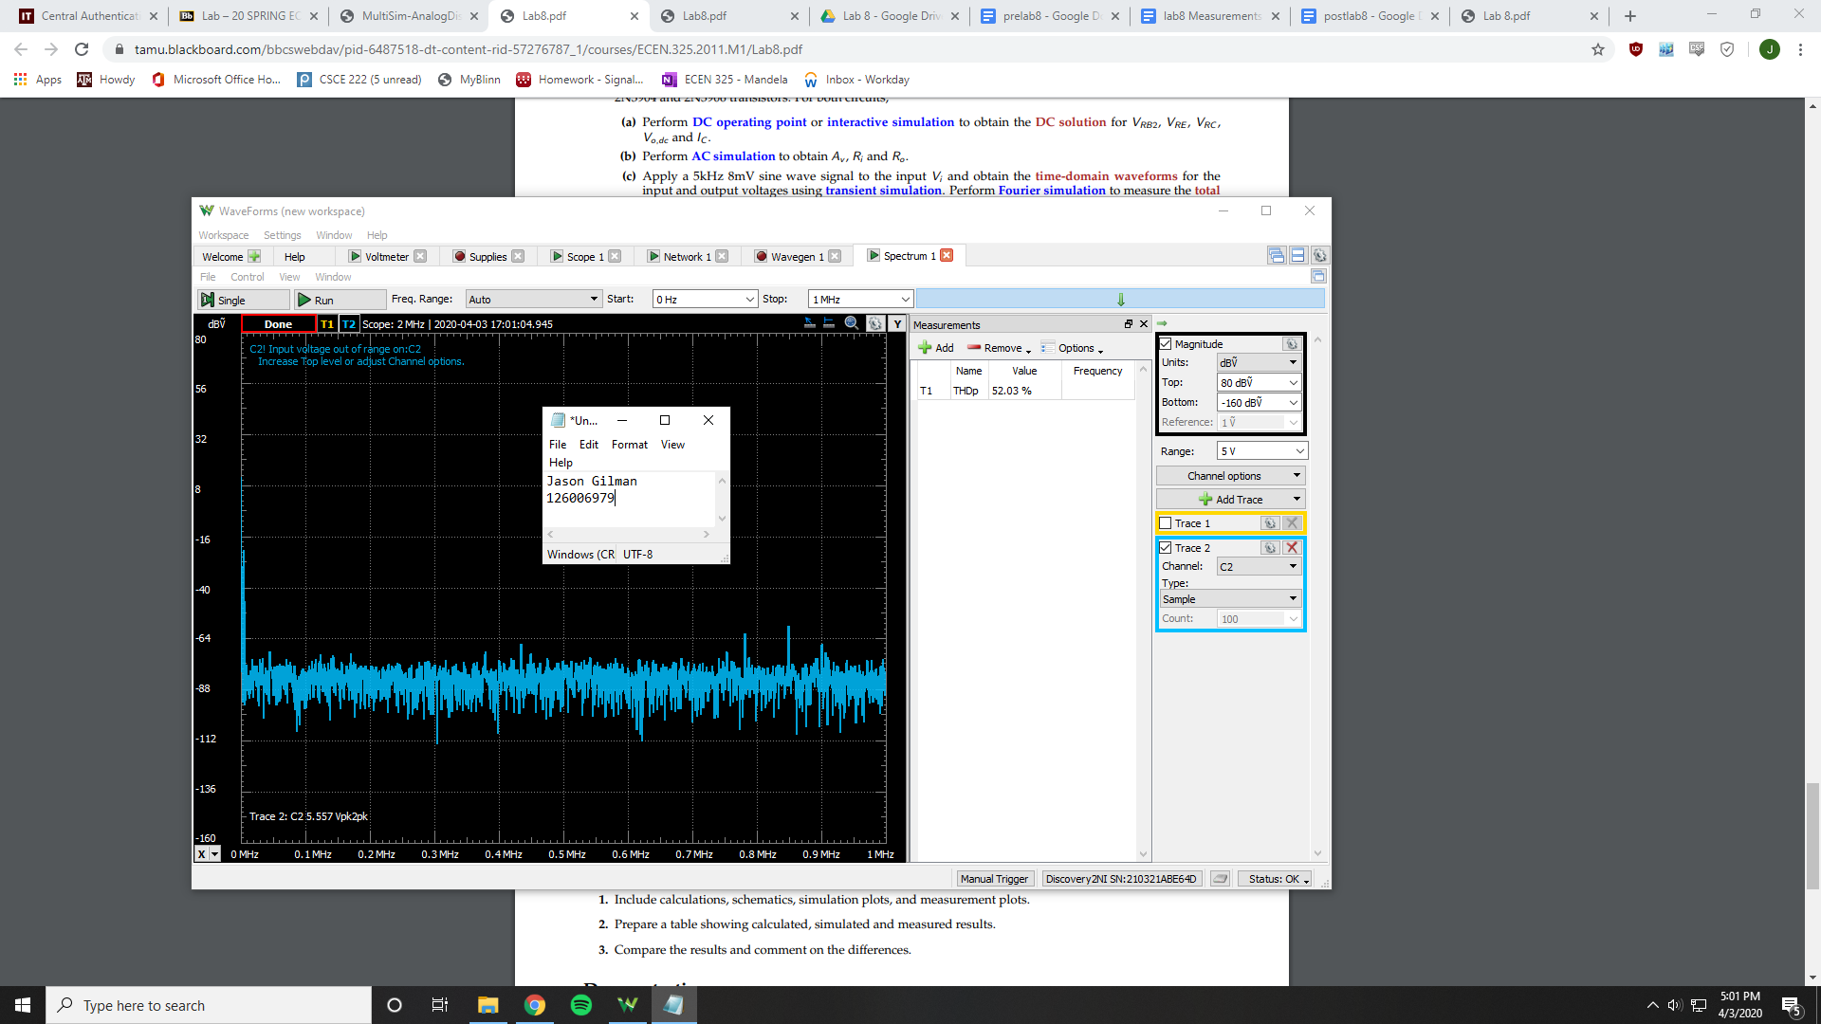

THD = 52.03%

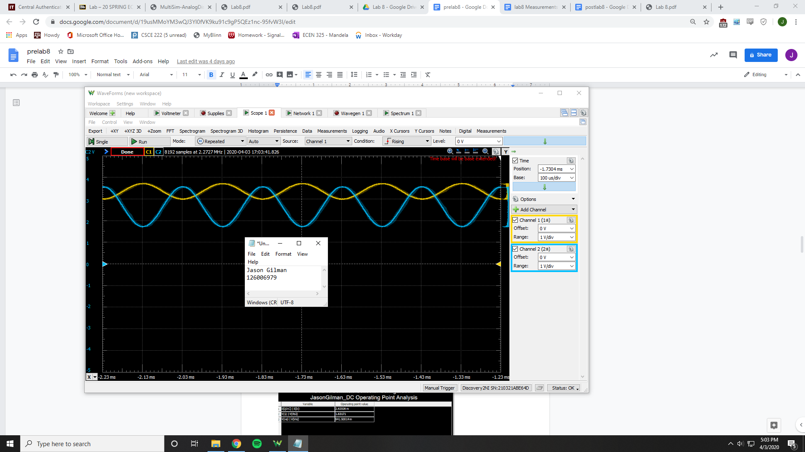

V clipping point = .35 V

NPN Common-Collector

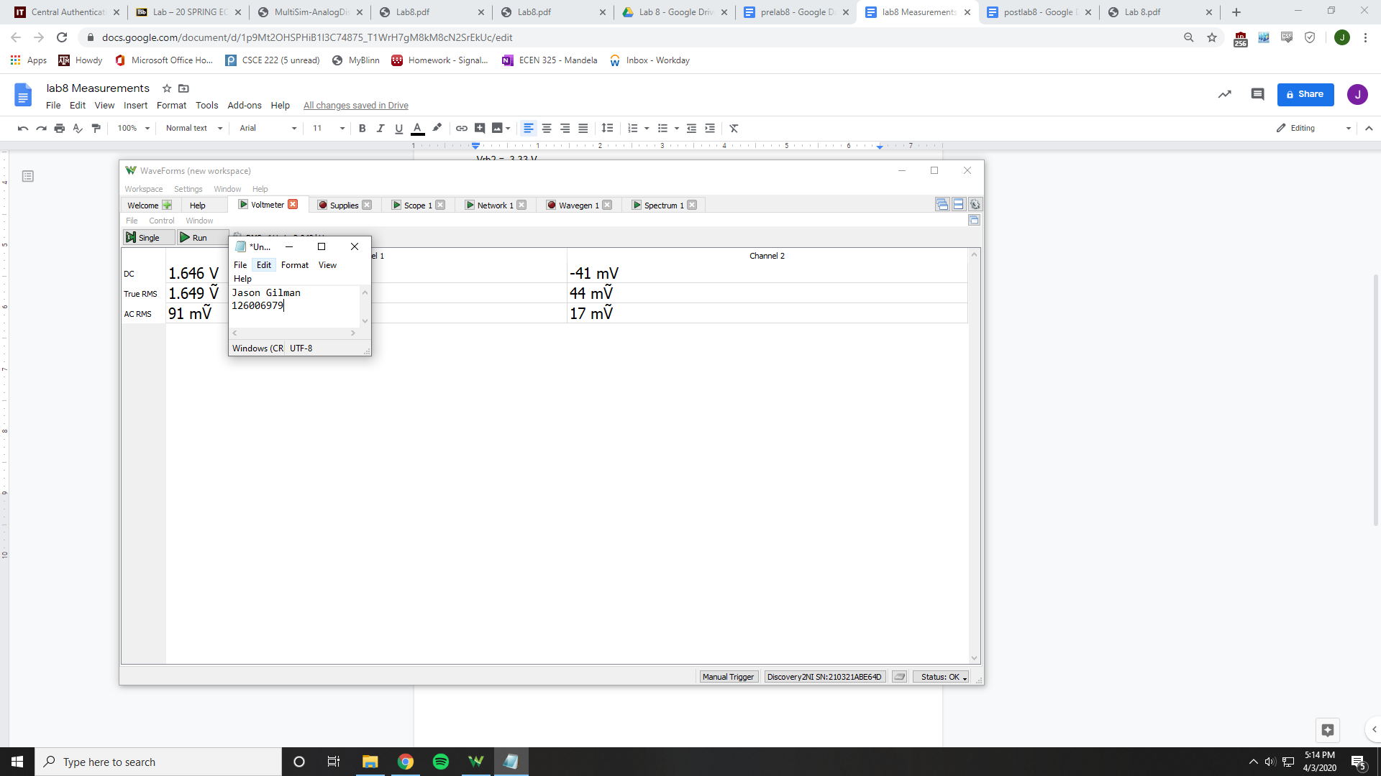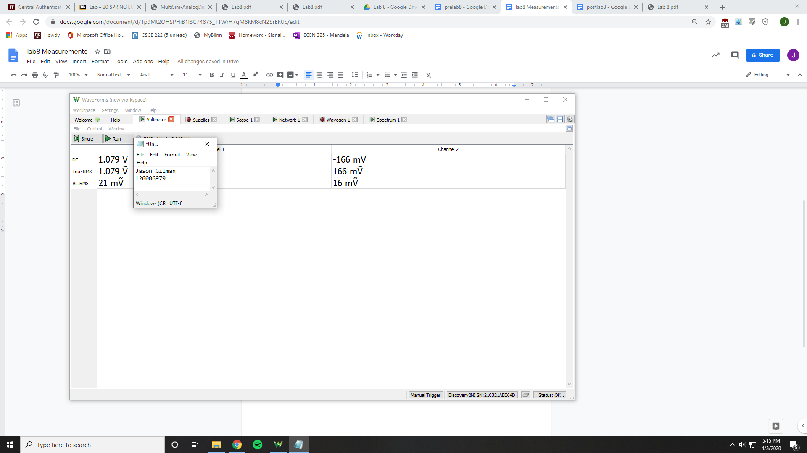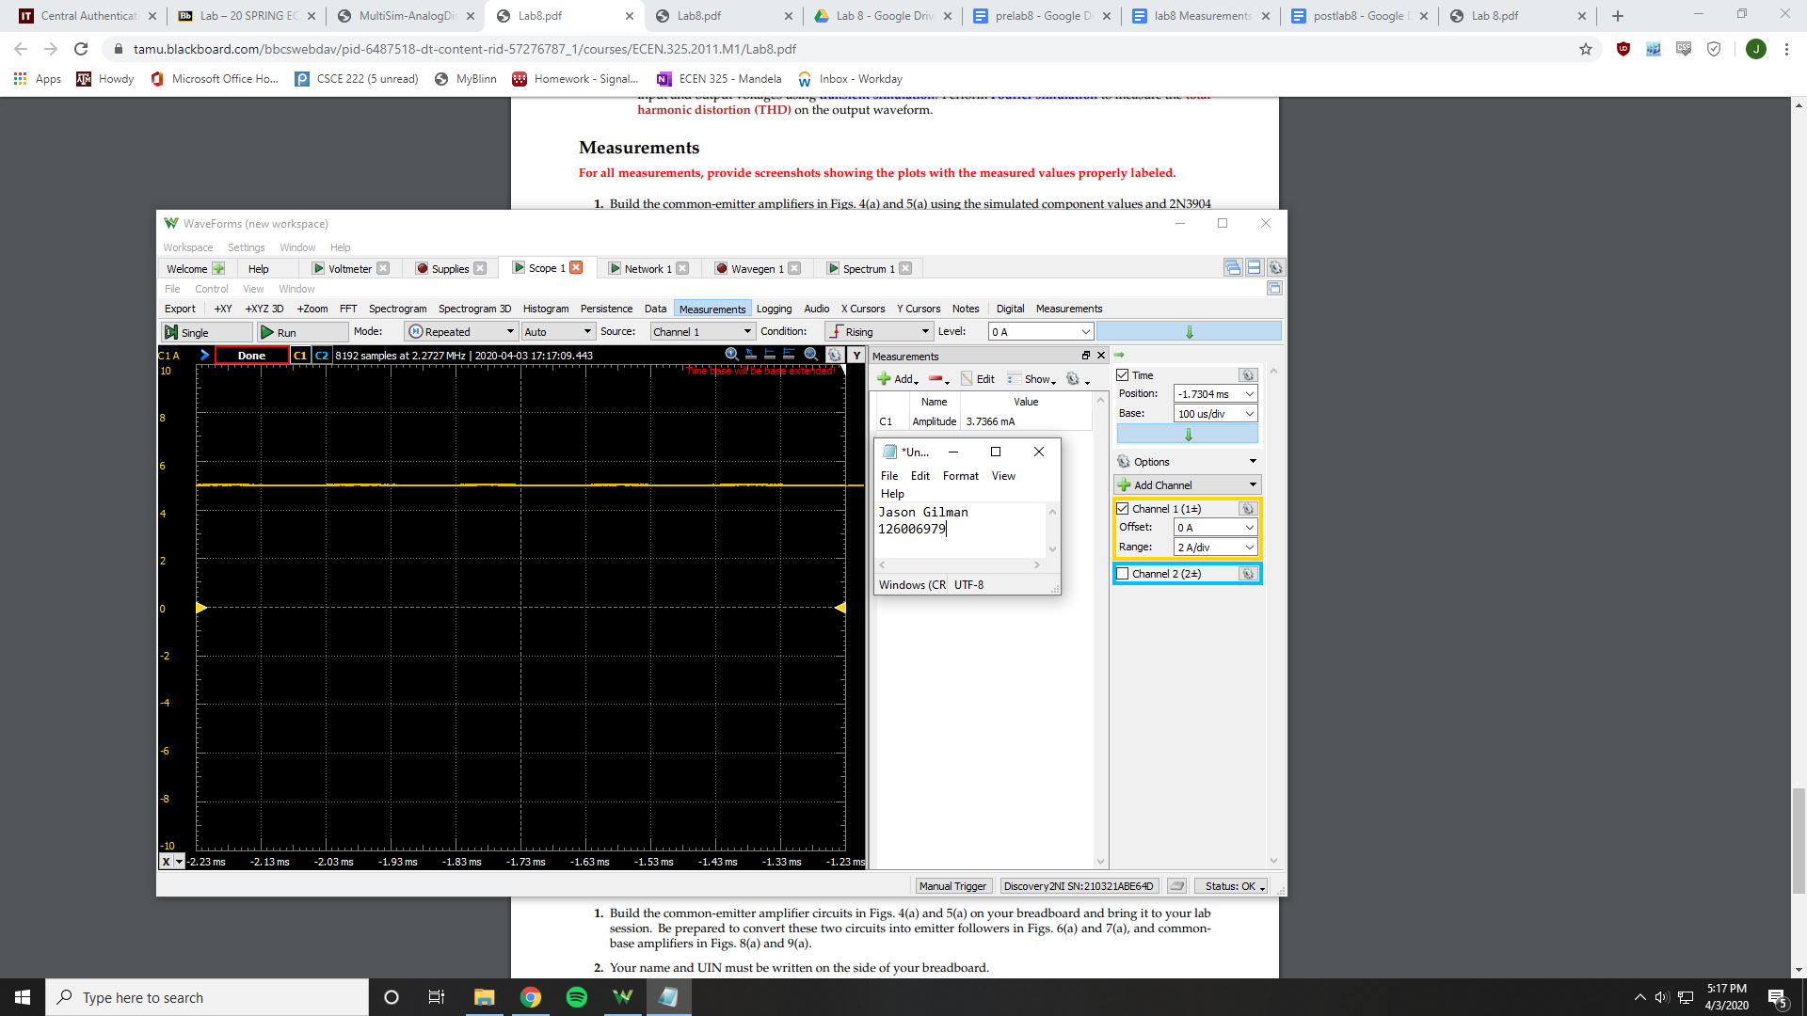

Vrb2 = 1.646 V

Vre = 1.079 V

Ic = 3.7366 mA

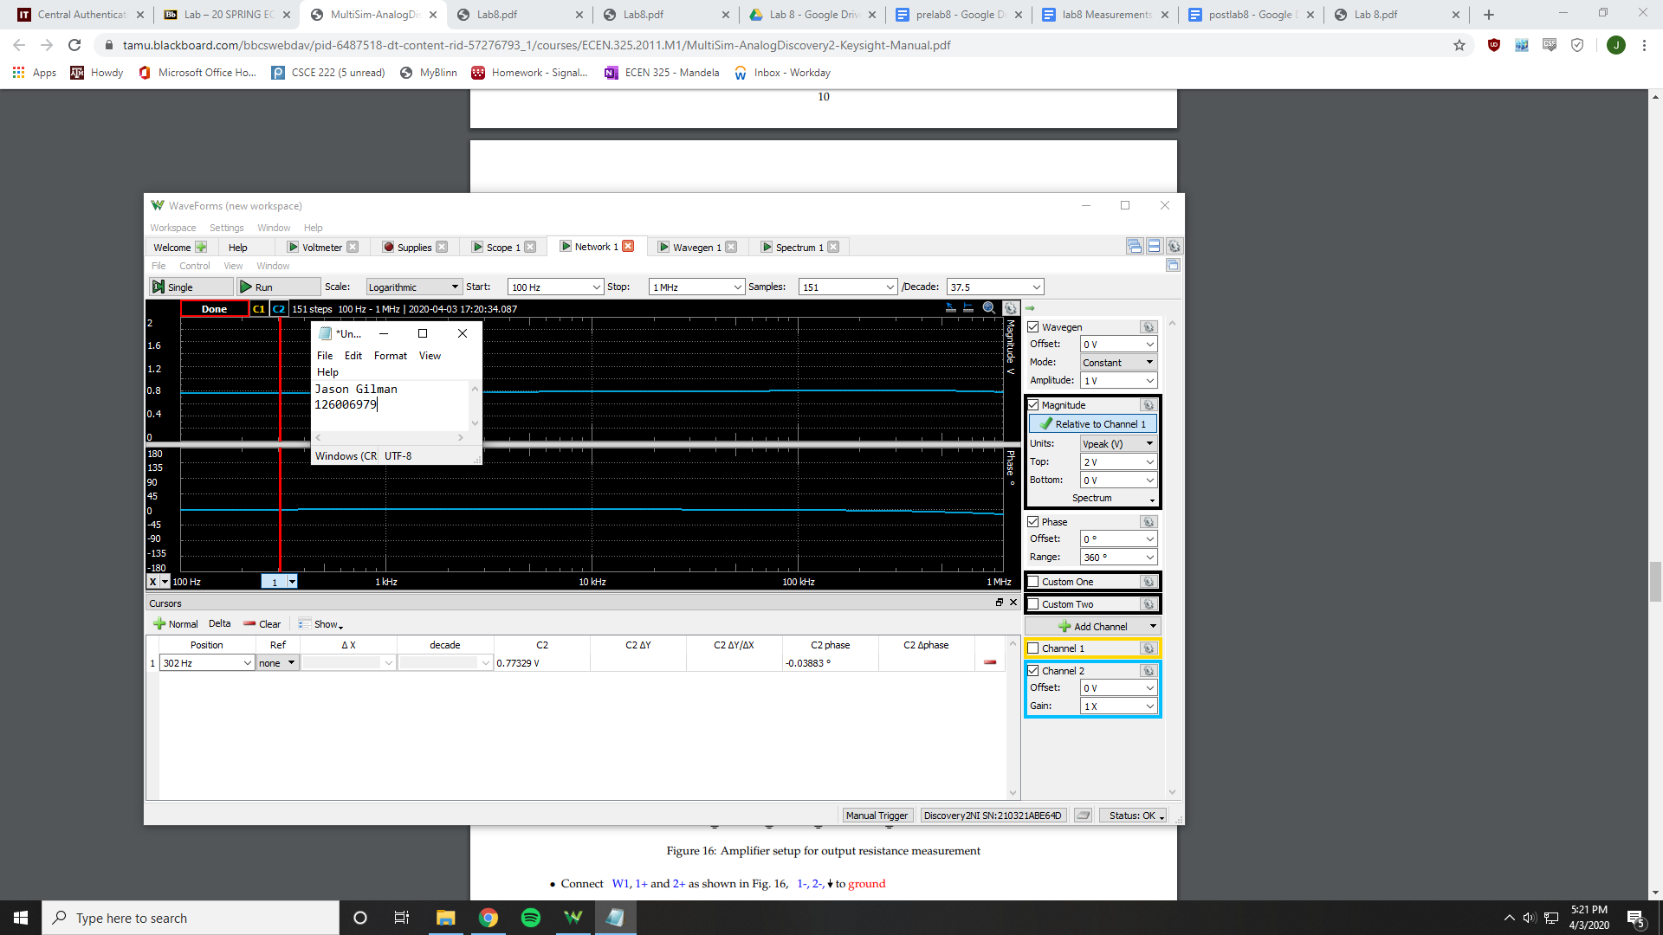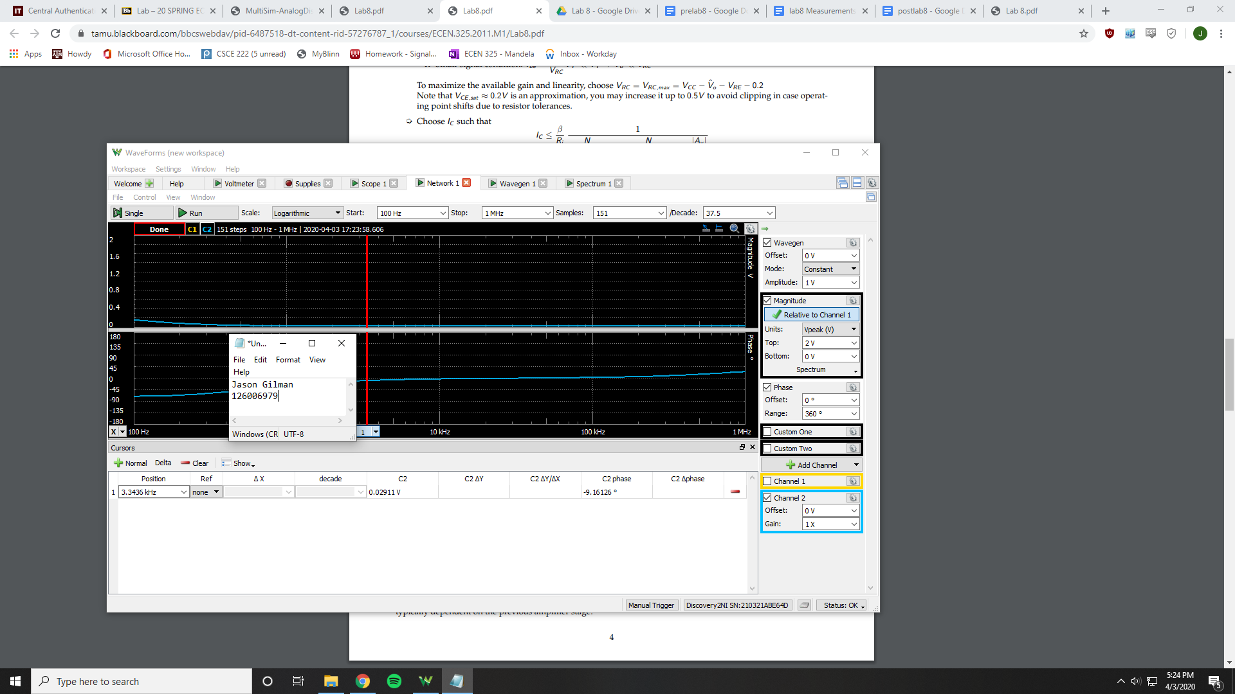

Ri = 3386.35 Ohms

Ro = 29.98 Ohms

Av = .037706 V/V

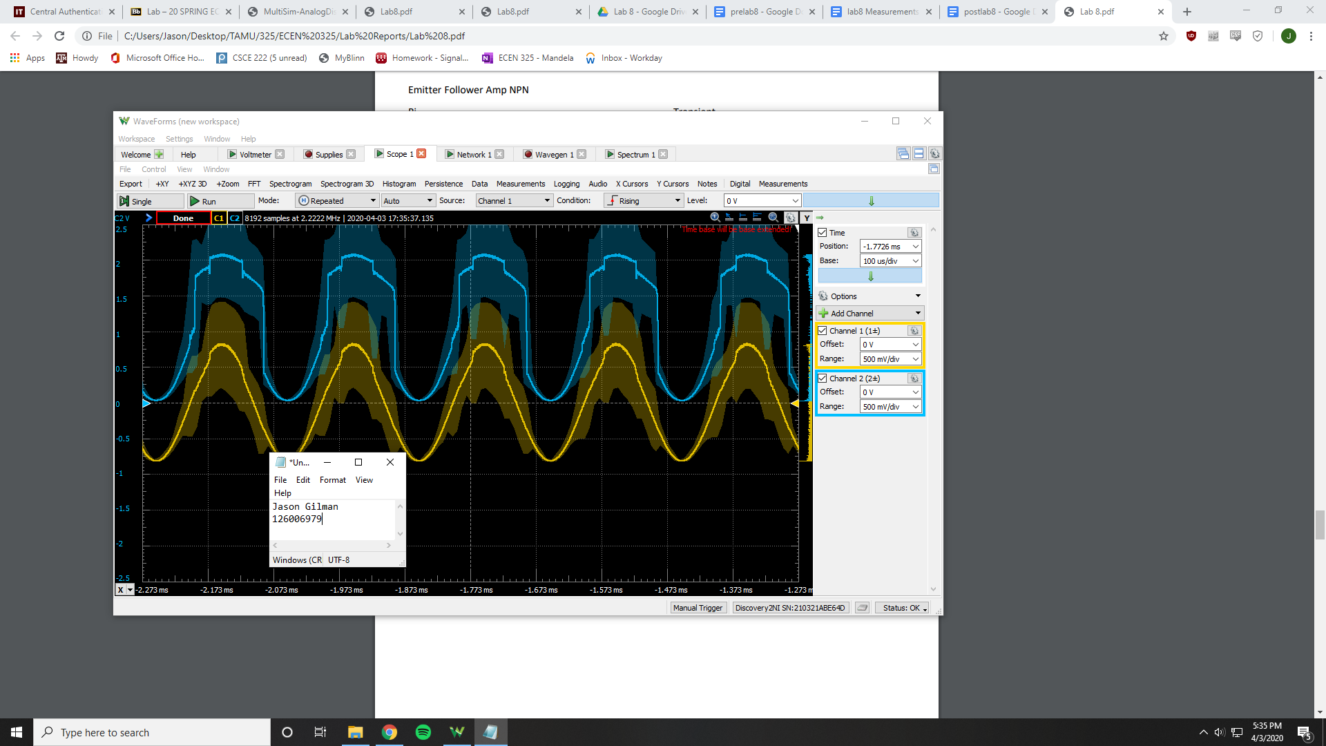

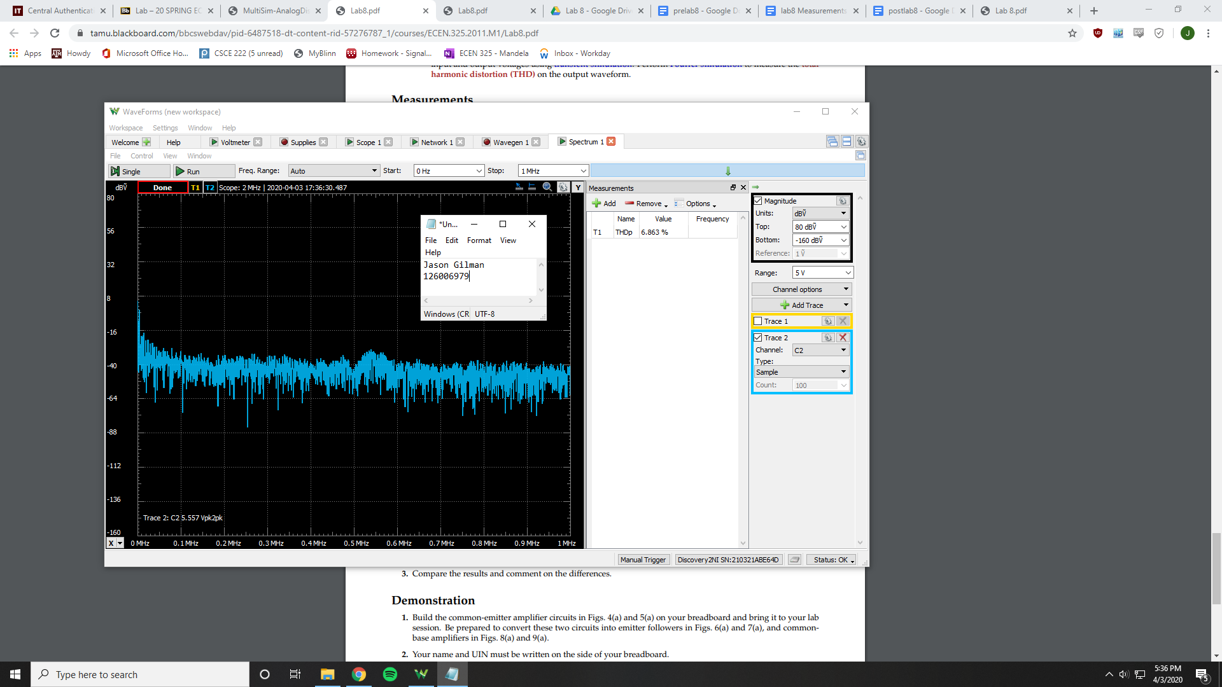

THD = 6.863%

PNP Common-Collector

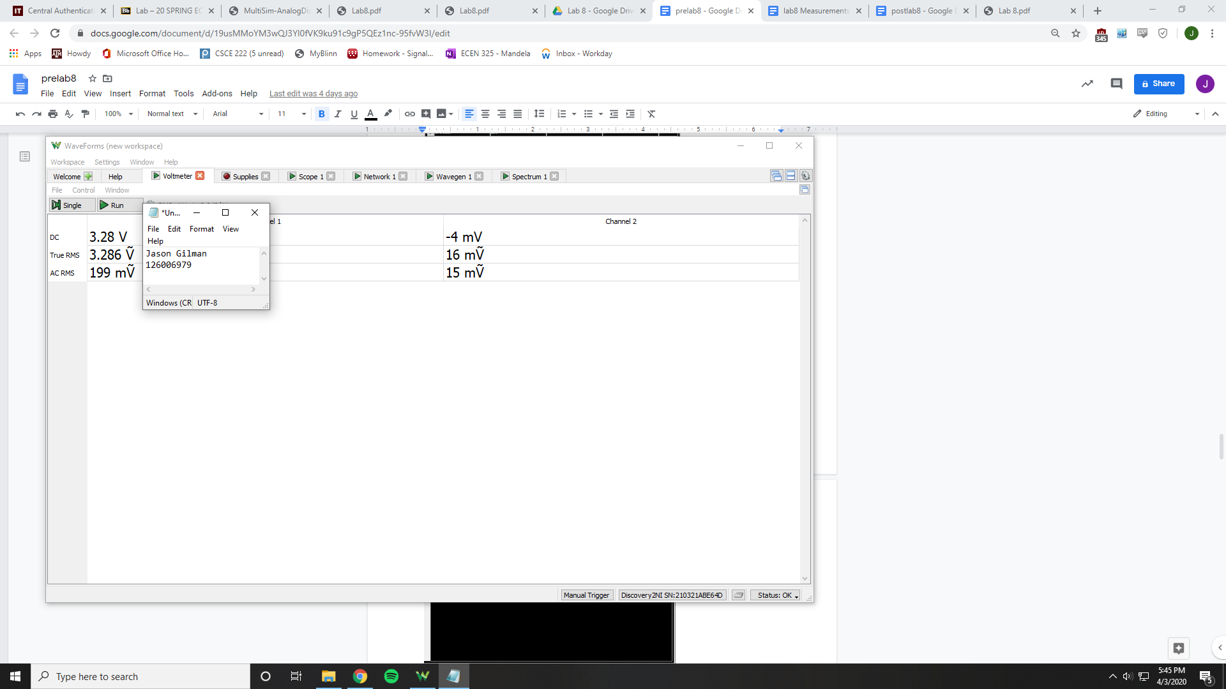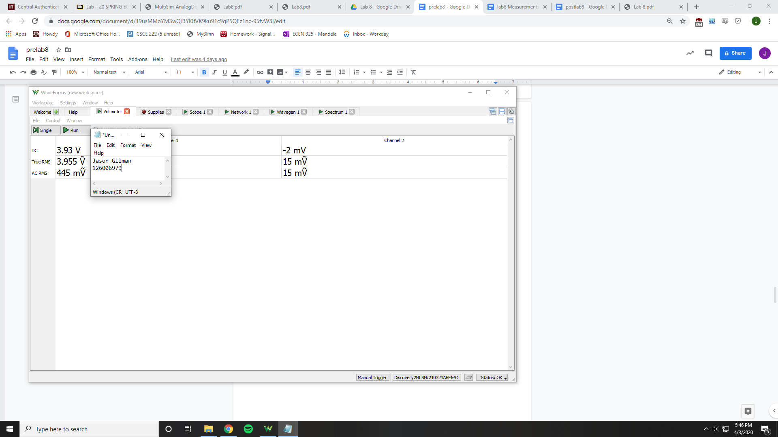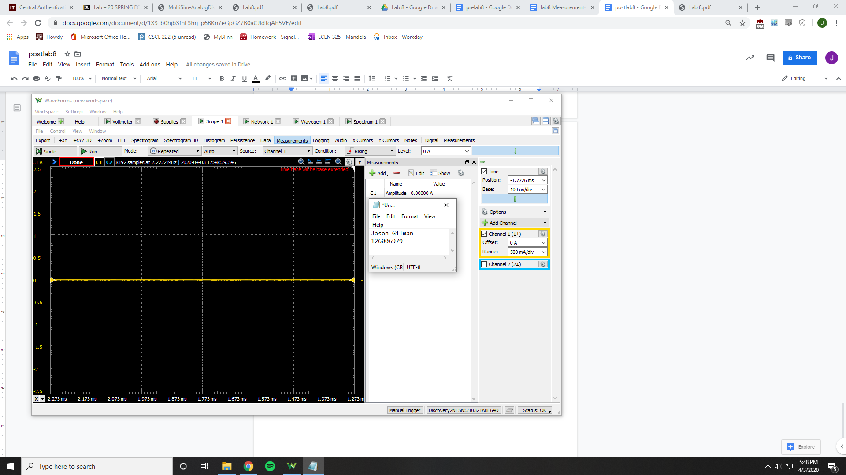

Vrb2 = 3.28 V

Vre = 3.93 V

Ic = 0 A

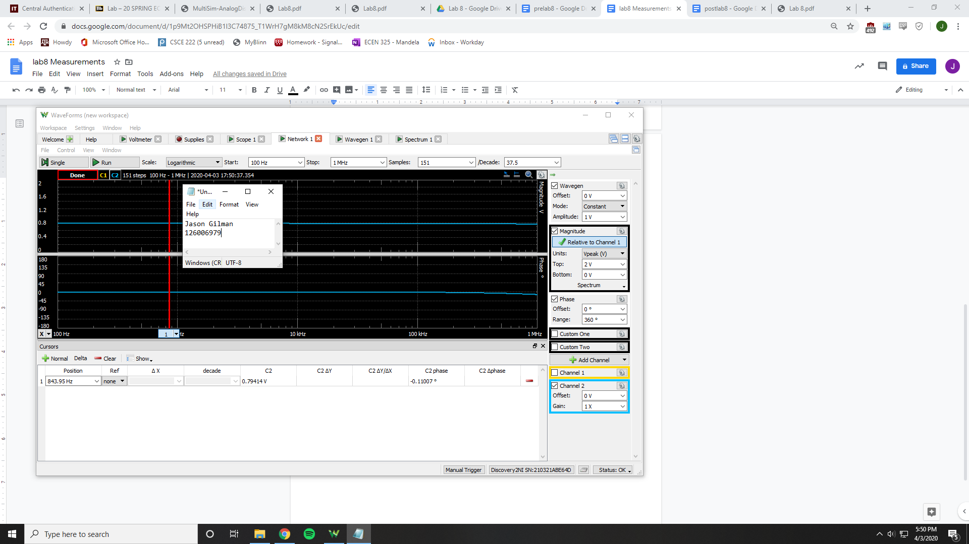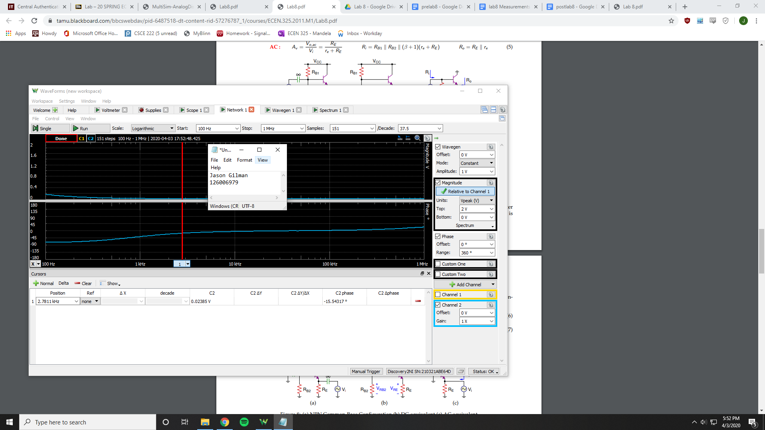

Ri = 3857.67 Ohms

Ro = 24.4327 Ohms

Av = .030032 V/V

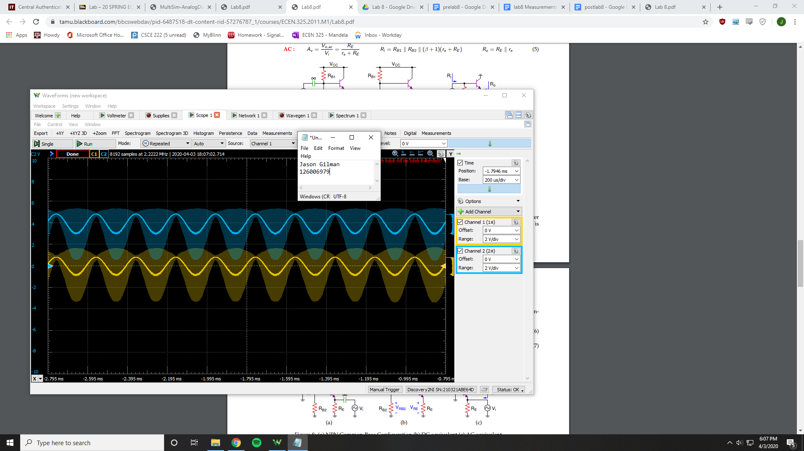

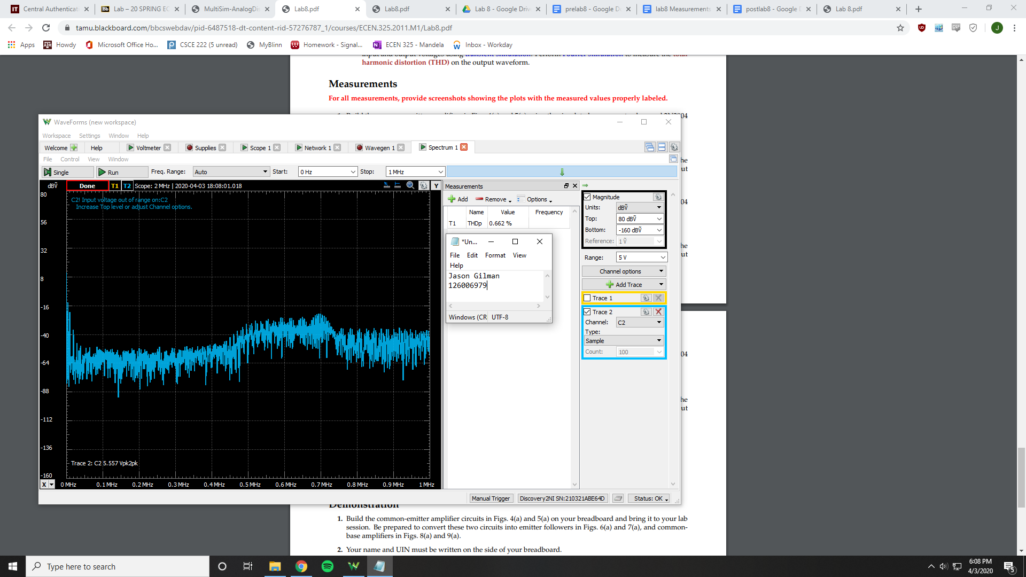

THD = .662%

NPN Common-Base

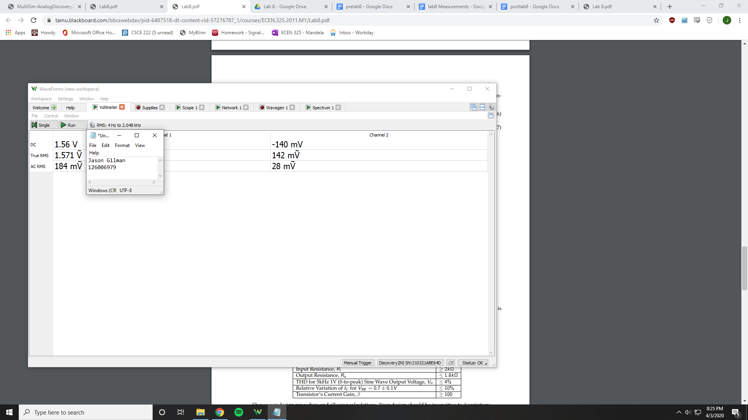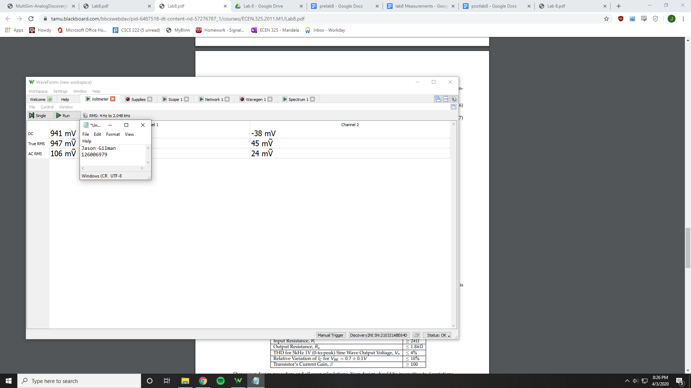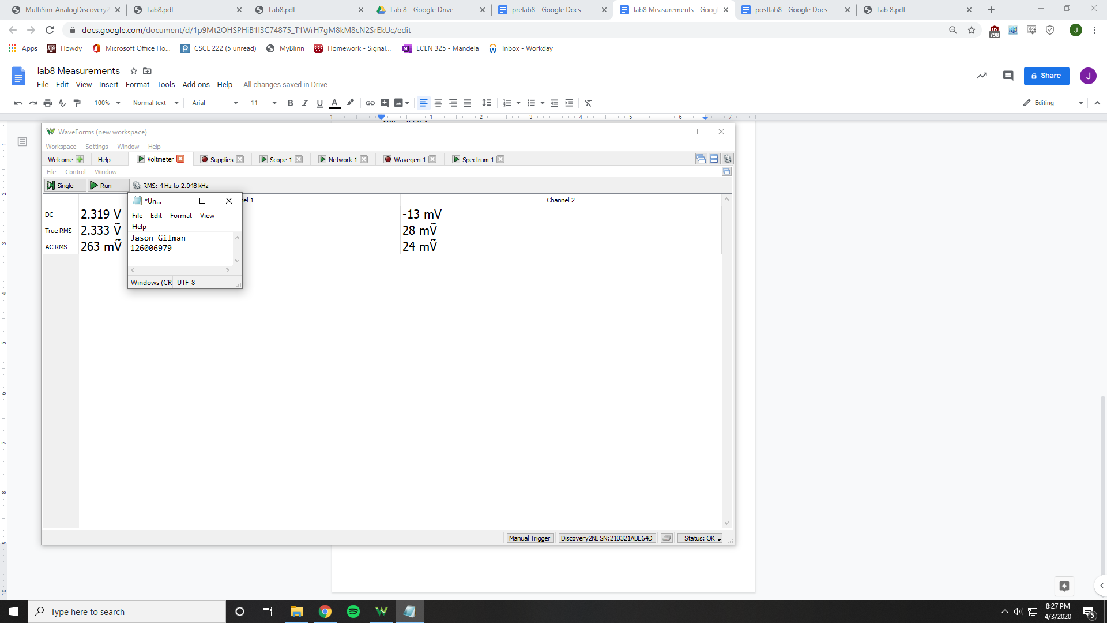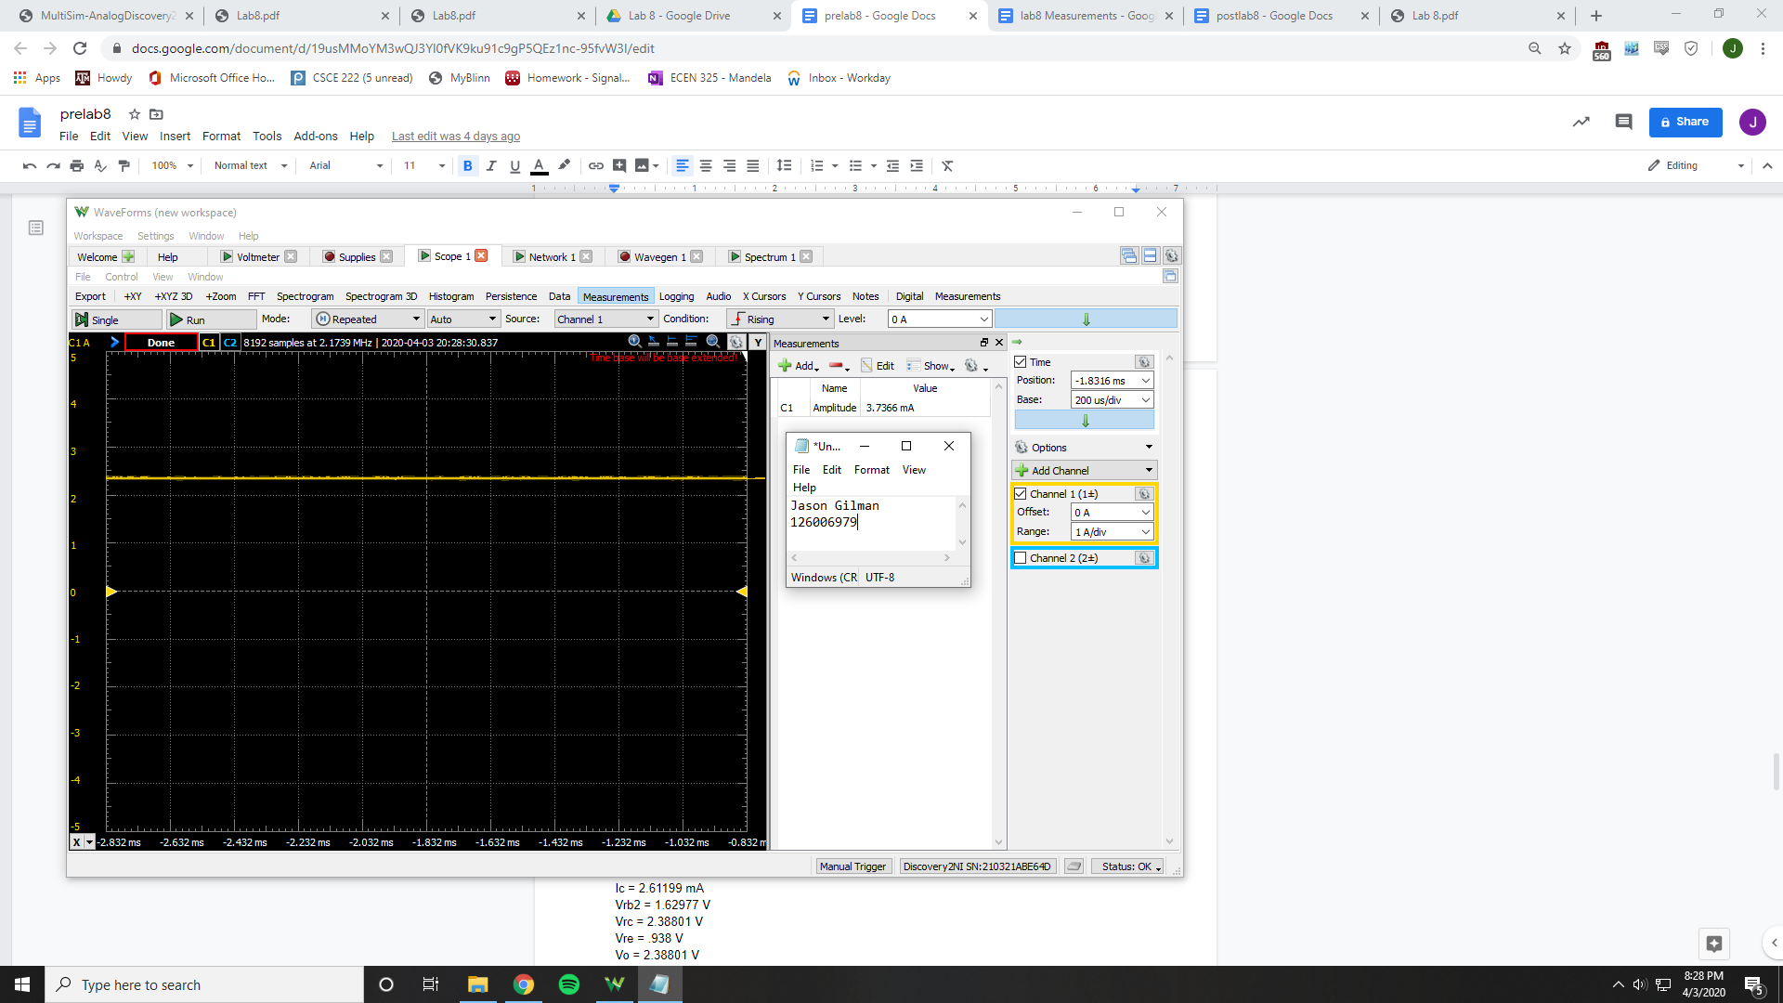

Vrb2 = 1.56 V

Vre = 941 mV

Ic = 3.7366 mA

Vrc = 2.585 V

Vo = 2.585 V

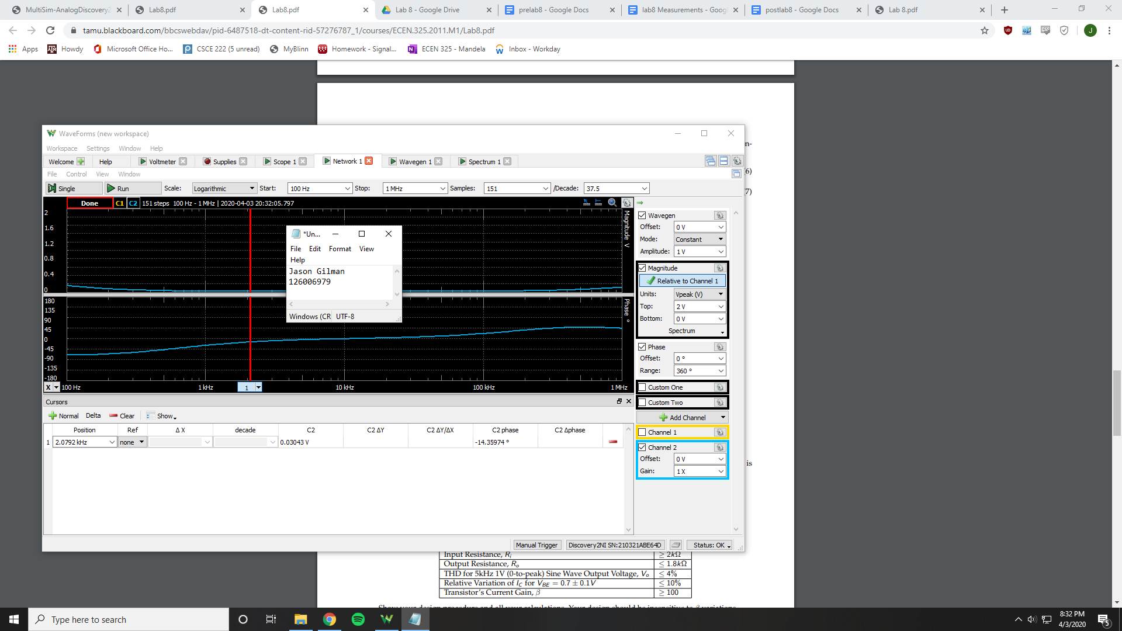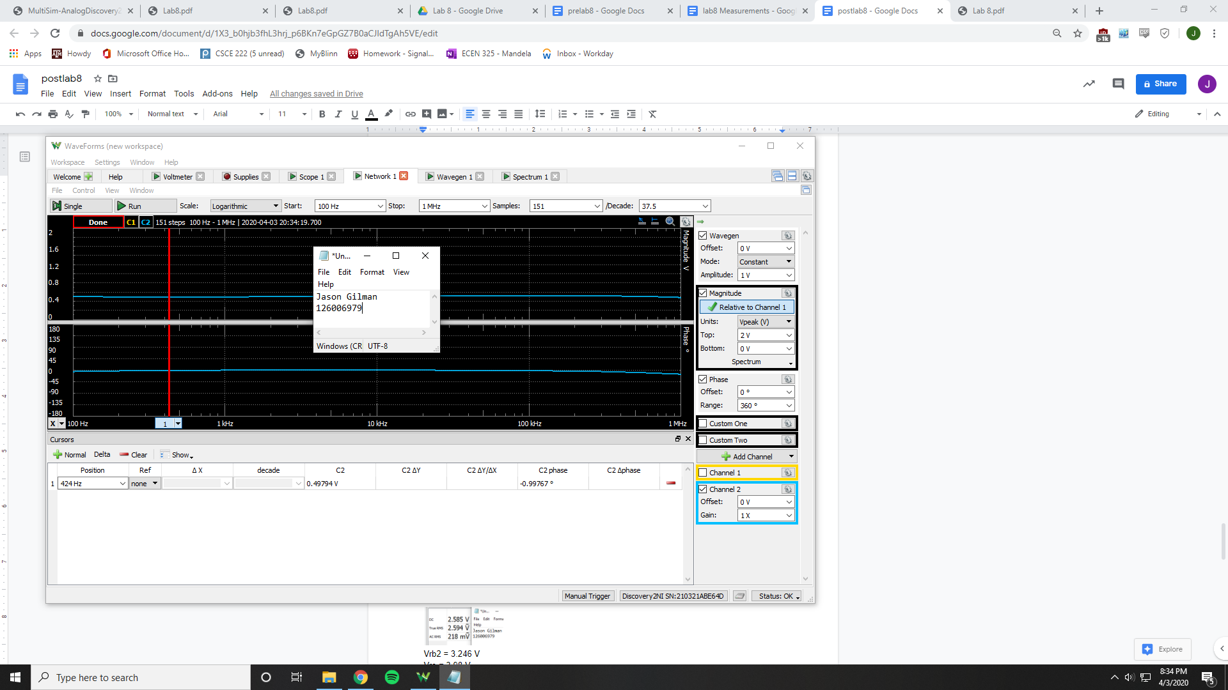

Ri = 31.385 Ohms

Ro = 991.794 Ohms

Av = 16.3635 V/V

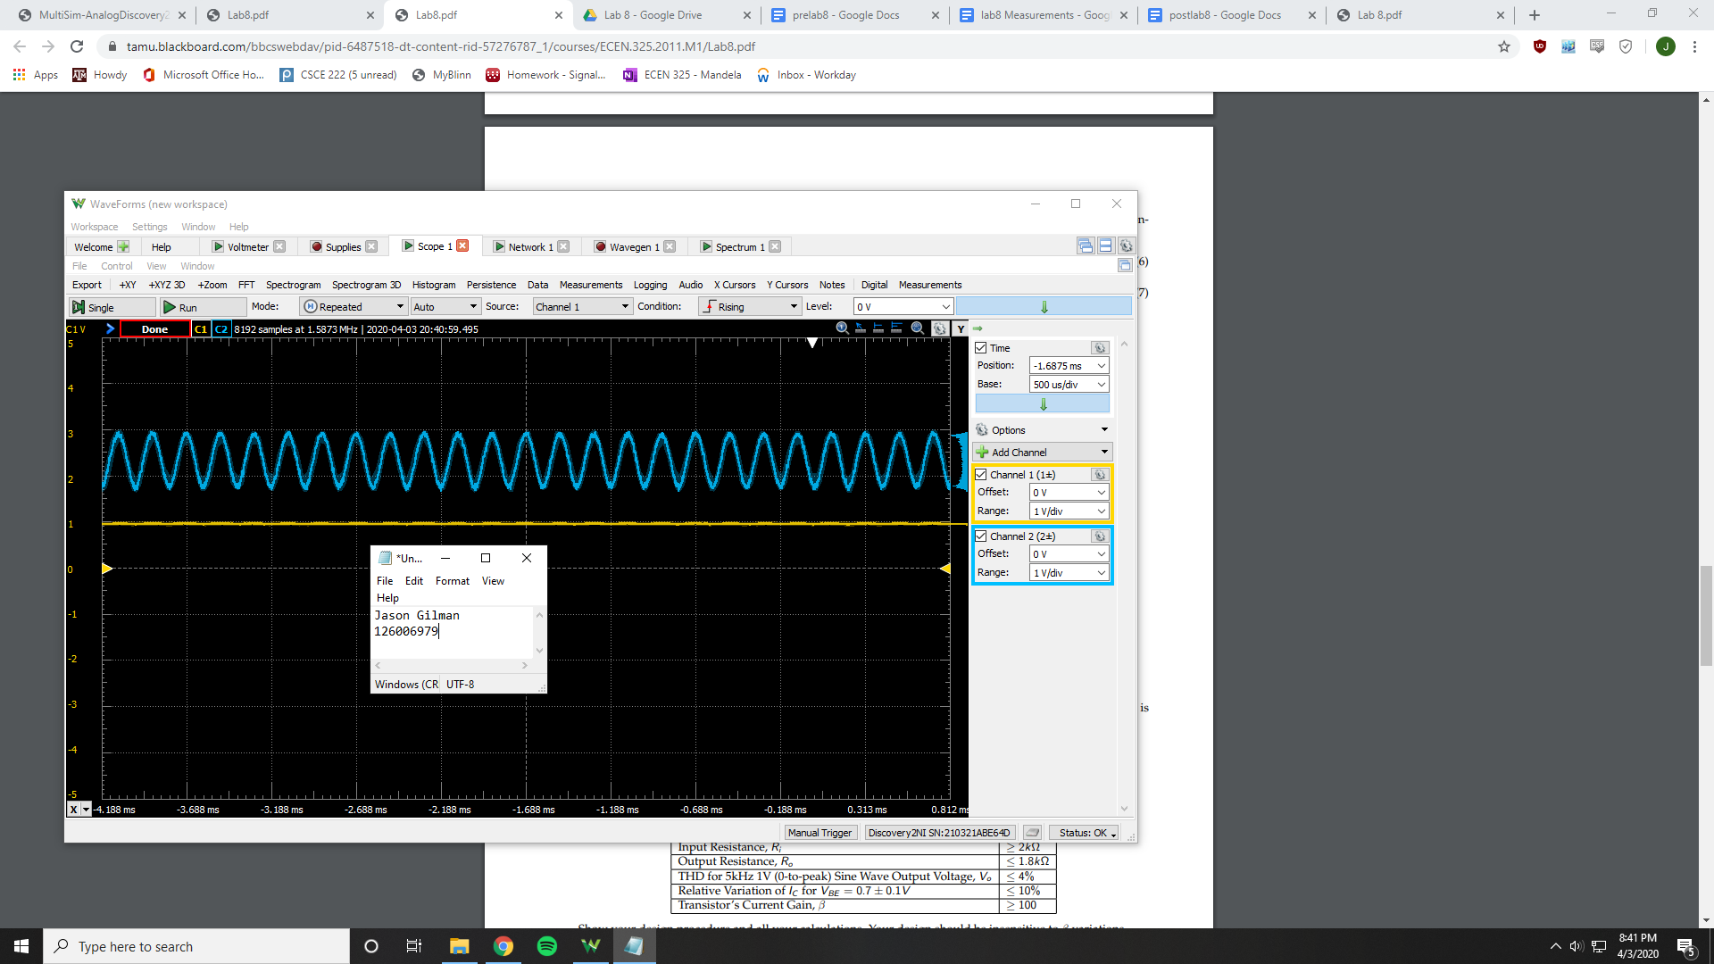

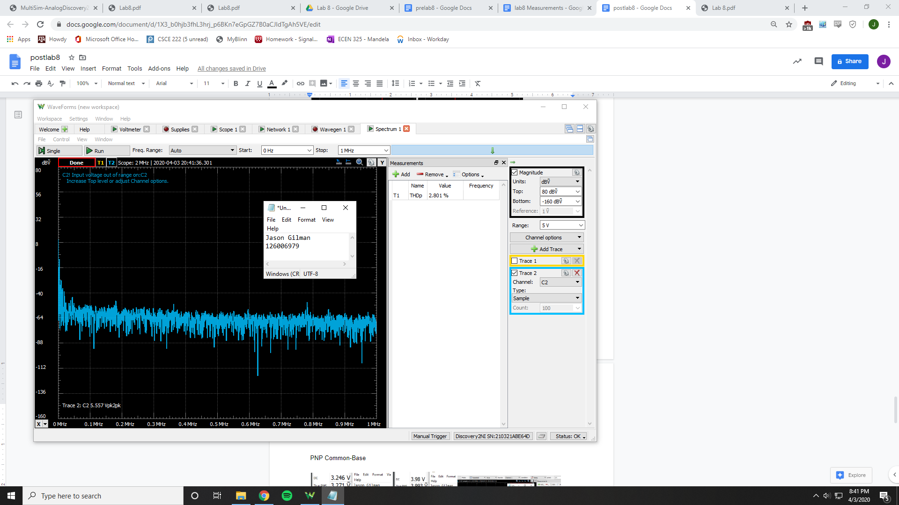

THD = 2.801%

PNP Common-Base

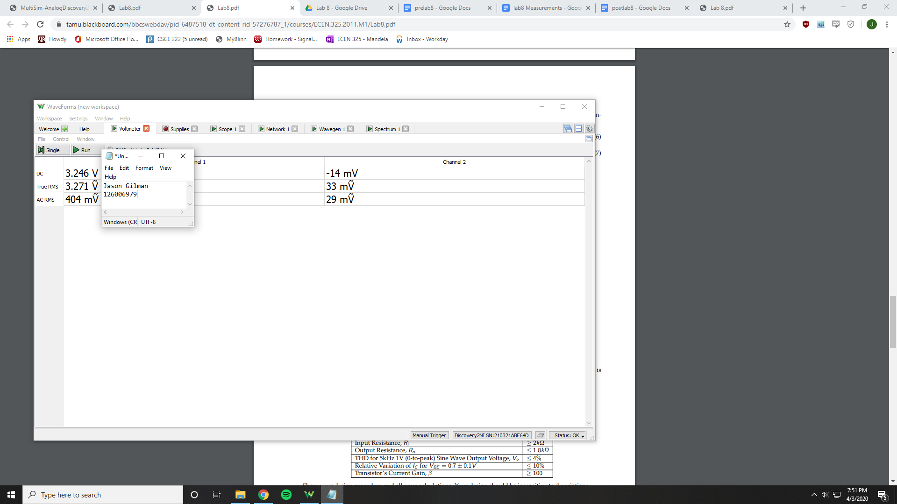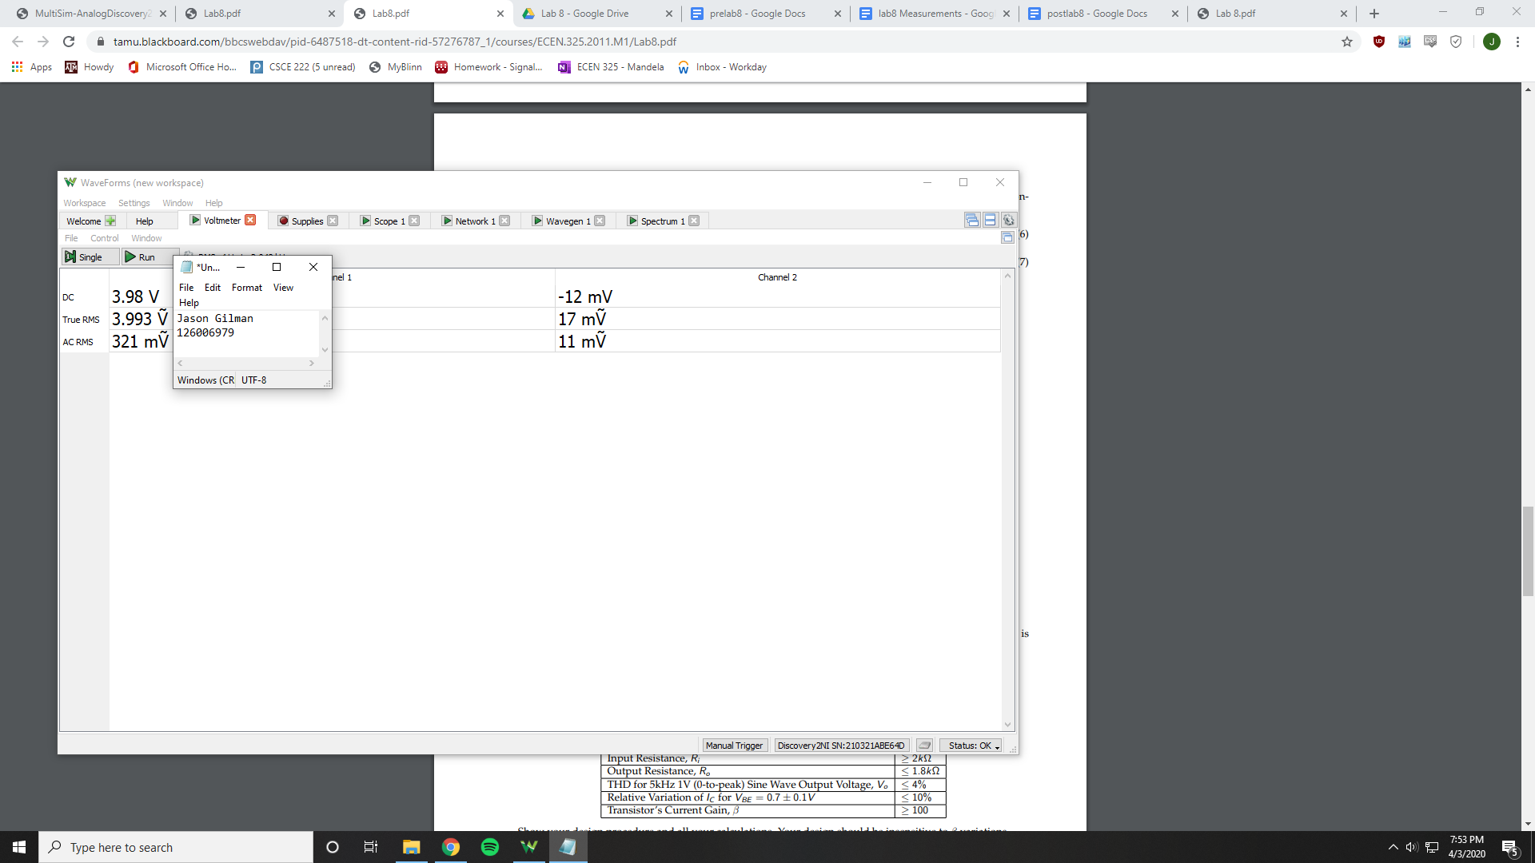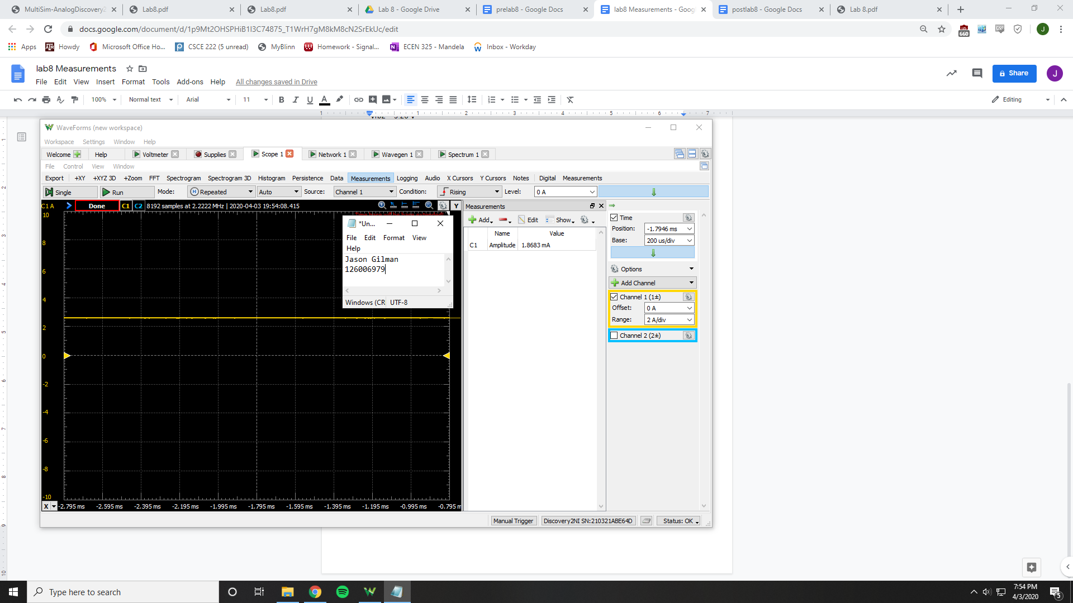

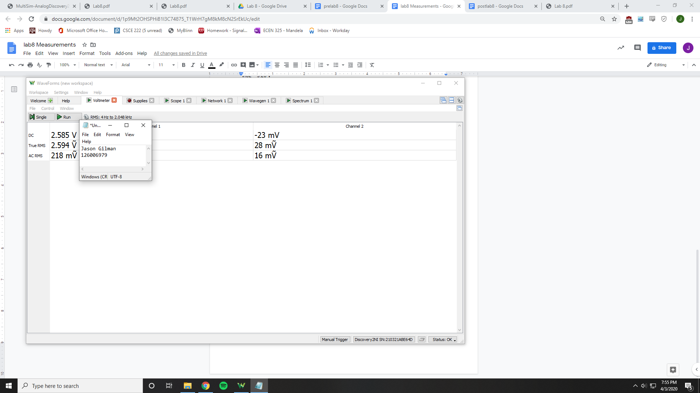

Vrb2 = 3.246 V

Vre = 3.98 V

Ic = 1.8683 mA

Vrc = 2.585 V

Vo = 2.585 V

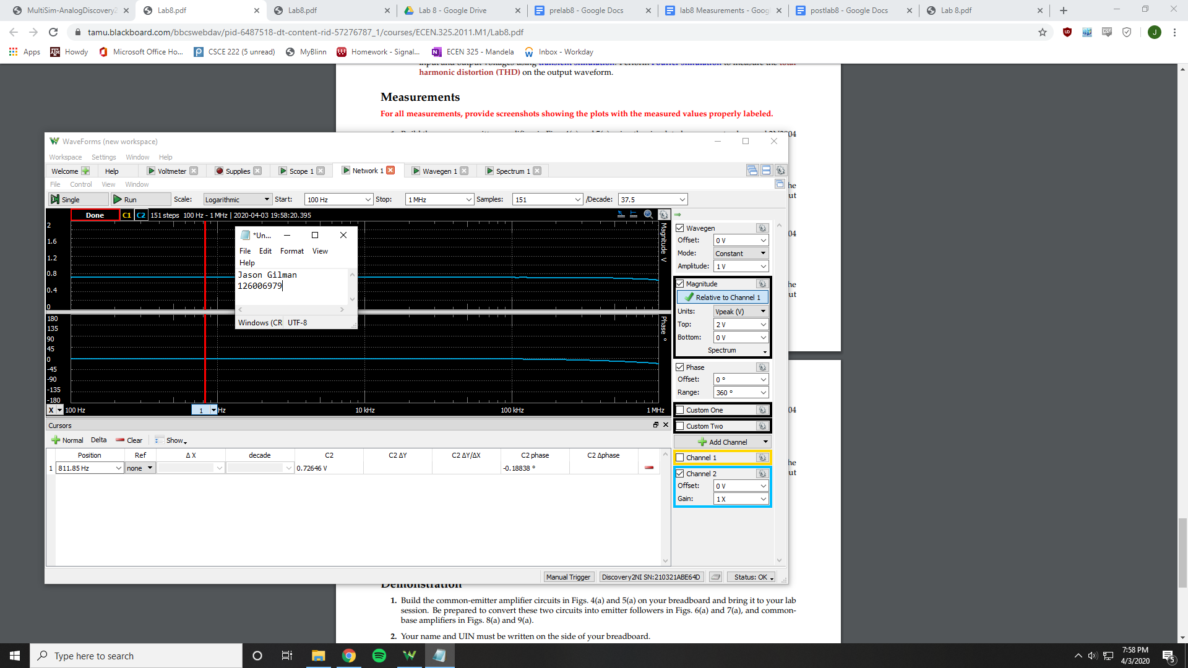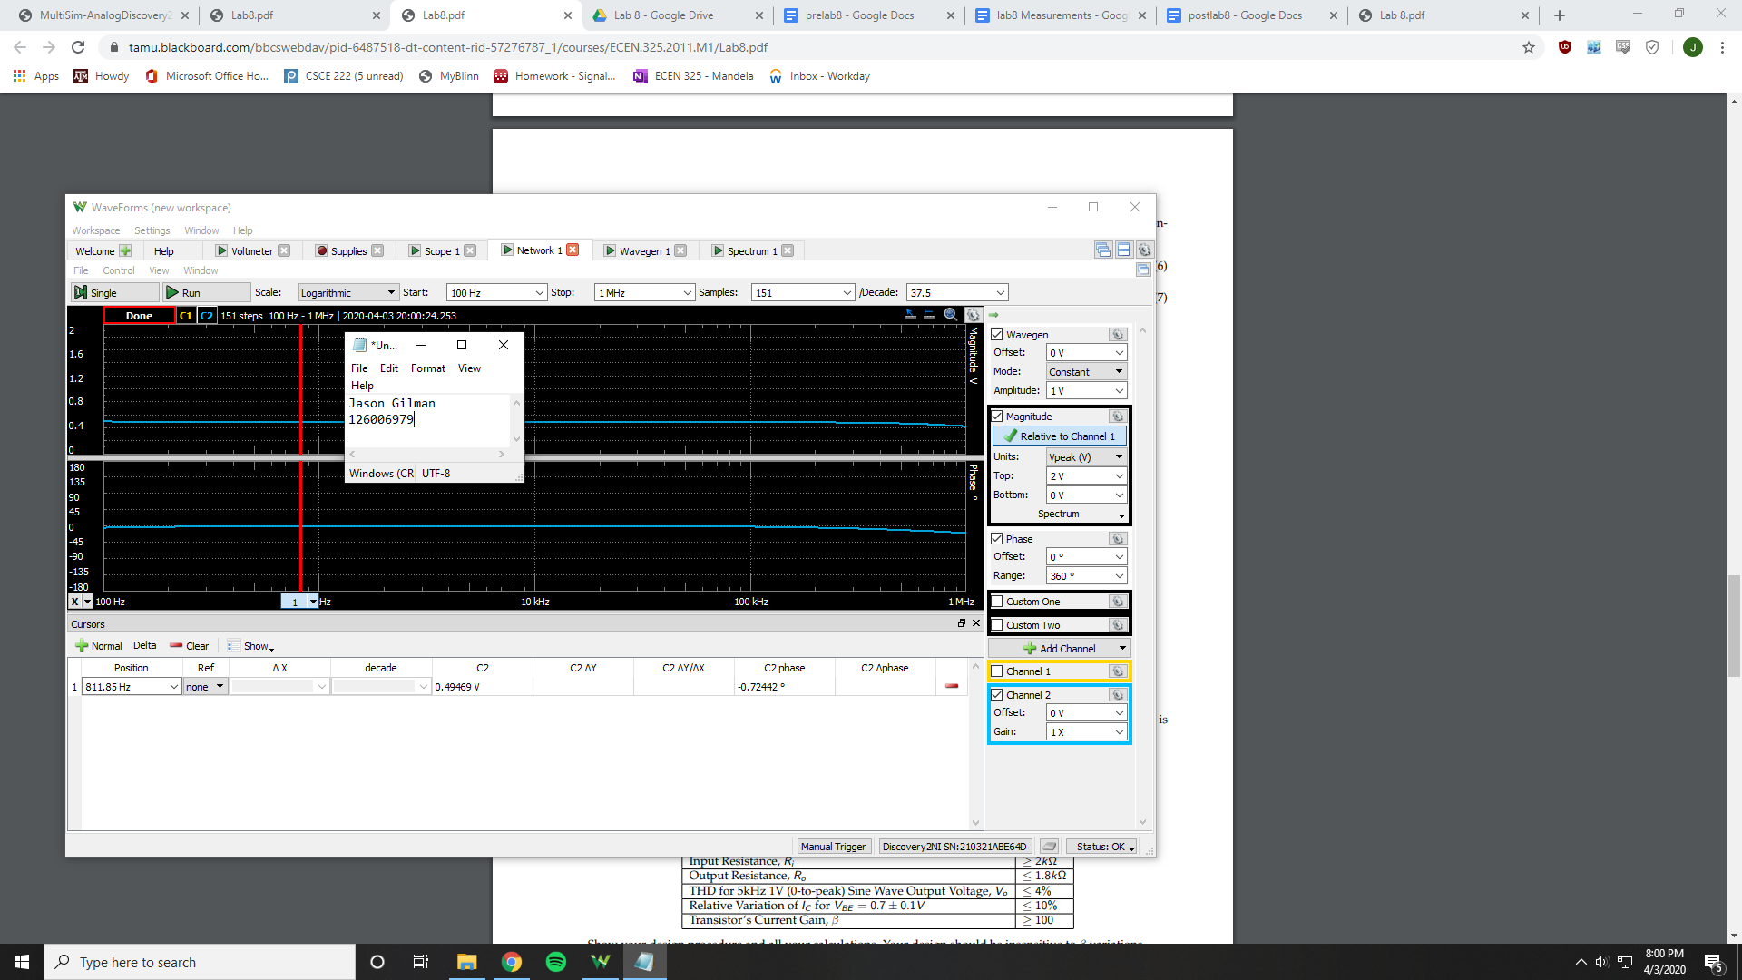

Ri = 26553.77 Ohms

Ro = 978.983 Ohms

Av = .661 V/V

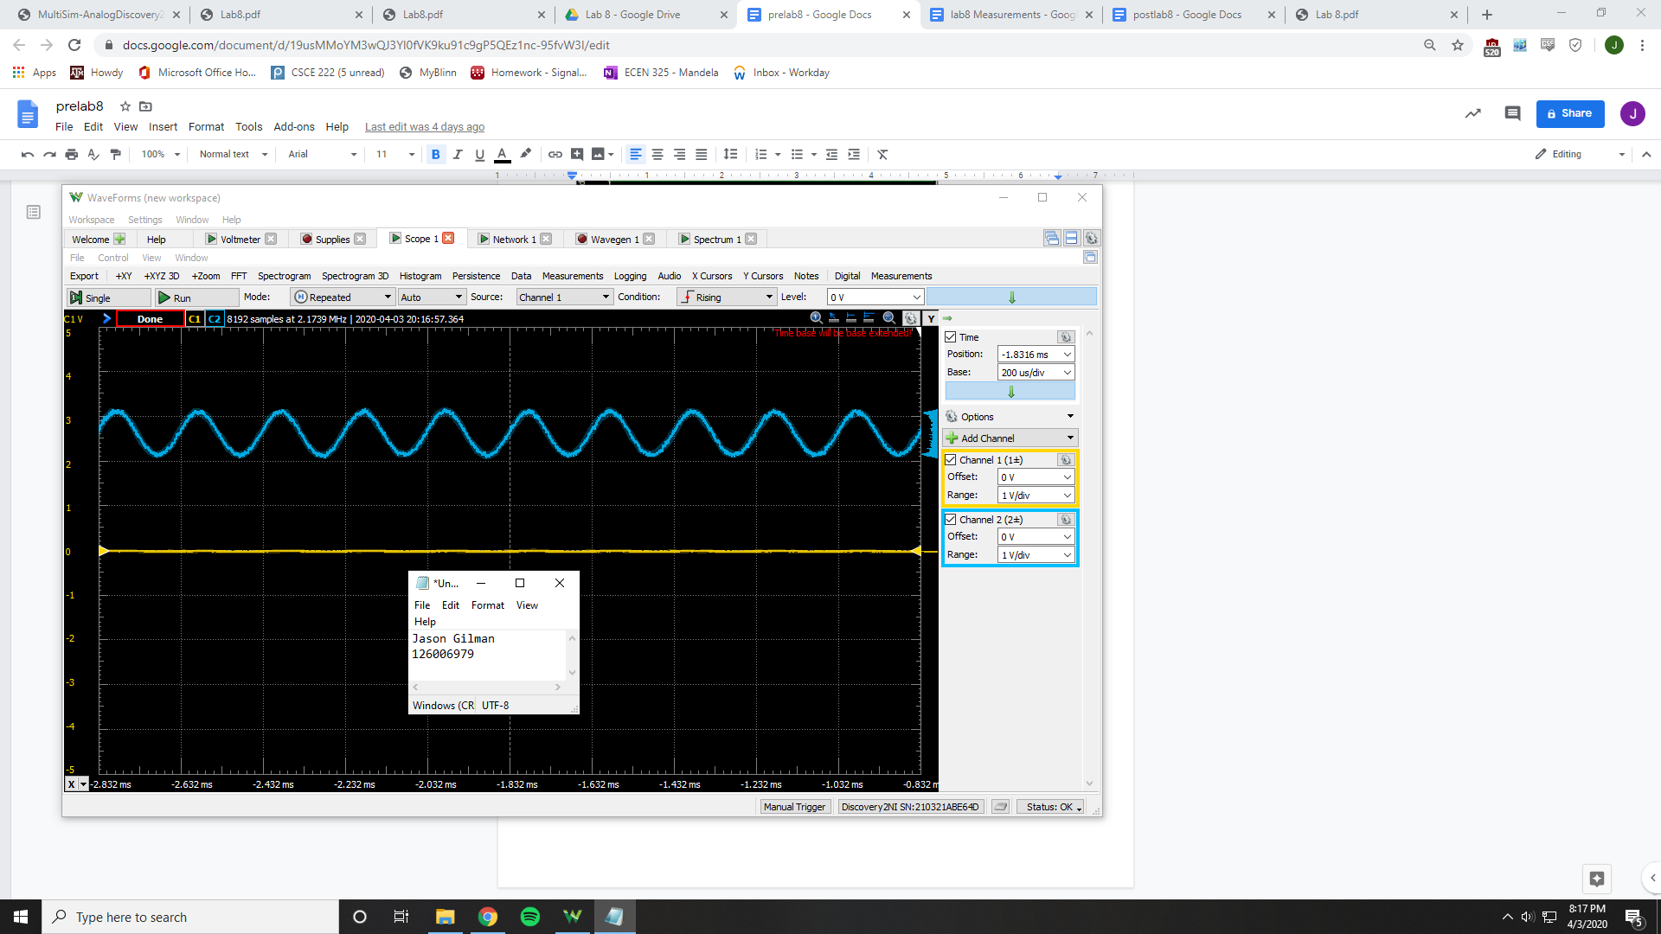

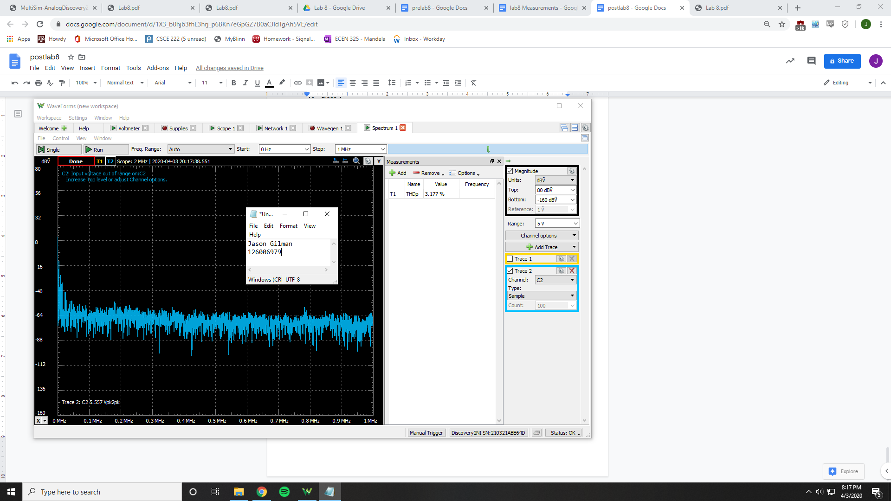

THD = 3.177%

|  |  |  |  |
| --- | --- | --- | --- |
|  | **Calculated** | **Simulated** | **Measured** |
| **NPN Common-Emitter** |  |  |  |
| Vrb2 | 1.2 V | 1.62977 V | 1.607 V |
| Vre | 1 V | 938.72037 mV | .963 V |
| Vrc | 2.8 V | 2.38801 V | 2.356 V |
| Vo |  | 2.38801 V | 2.356 V |
| Ic | 2.8 mV | 2.61199 mA | 2.356 mA |
| Ri | 2000 Ohms | 1 Ohm | 2265.31 Ohms |
| Ro | 1000 Ohms | 1000 Ohms | 986.255 Ohms |
| Av | 25 V/V | 2.89 V/V | .715733 V/V |
| THD |  | 3207040% | 0.60% |
| Clipping Point |  | .3 V | .310 V |
| **PNP Common-Emitter** |  |  |  |
| Vrb2 | 1.2 V | 3.35599 V | 3.33 V |
| Vre | 1 V | 4.08577 V | 3.988 V |
| Vrc | 2.8 V | 2.54694 V | 2.599 V |
| Vo |  | 2.54694 V | 2.599 V |
| Ic | 2.8 mV | 2.54 mA | 1.8683 mA |
| Ri | 2000 Ohms | 1 Ohm | 2632.66 Ohms |
| Ro | 1800 Ohms | 1000 Ohms | 982.278 Ohms |
| Av | 25 V/V | 2.89 V/V | .683754 V/V |
| THD |  | 277.49% | 52.03% |
| Clipping Point |  | .3 V | .35 V |
| **NPN Common-Collector** |  |  |  |
| Vrb2 |  | 1.63171 V | 1.646 V |
| Vre |  | .9415 mV | 1.079 V |
| Ic |  | 2.62026 mA | 3.7366 mA |
| Ri | 3614.603 Ohms | 1 Ohm | 3386.35 Ohms |
| Ro | 8.7101 Ohms | 357 Ohm | 29.98 Ohms |
| Av | .9756 V/V | 1 V/V | .037706 V/V |
| THD |  | 1.339E7 % | 6.86% |
| **PNP Common-Collector** |  |  |  |
| Vrb2 |  | 3.34993 V | 3.28 V |
| Vre |  | 4.076 V | 3.93 V |
| Ic |  | 2.57383 mA | 0 A |
| Ri | 3614.603 Ohms | 1 Ohm | 3857.67 Ohms |
| Ro | 8.7101 Ohms | 357 Ohm | 24.4327 Ohms |
| Av | .9756 V/V | 1 V/V | .030032 V/V |
| THD |  | 4.48306E6 % | 0.66% |
| **NPN Common-Base** |  |  |  |
| Vrb2 |  | 1.62977 V | 1.56 V |
| Vre |  | .938 V | 941 mV |
| Ic |  | 2.61199 mA | 3.7366 mA |
| Vrc |  | 2.38801 V | 2.585 V |
| Vo |  | 2.38801 V | 2.585 V |
| Ri | 8.7101 Ohms | 1 Ohm | 31.385 Ohms |
| Ro | 1000 Ohms | 1000 Ohms | 991.794 Ohms |
| Av | 112 V/V | 100 V/V | 16.3635 V/V |
| THD |  | 2.45937E7 % | 2.80% |
| **PNP Common-base** |  |  |  |
| Vrb2 |  | 3.35599 V | 3.246 V |
| Vre |  | 4.08577 V | 3.98 V |
| Ic |  | 2.54694 mA | 1.8683 mA |
| Vrc |  | 2.54694 V | 2.585 V |
| Vo |  | 2.54694 V | 2.585 V |
| Ri | 8.7101 Ohms | 1 Ohm | 26553.77 Ohms |
| Ro | 1000 Ohms | 1000 Ohms | 978.983 Ohms |
| Av | 112 V/V | 100 V/V | .661 V/V |
| THD |  | 1.17706E7 % | 3.18% |

**Conclusion**

Almost all of the measurements taken are similar between the forms of which they were recorded, whether that was calculated, simulated, or measured. The only disparity is in the input and output resistances, which could have been attributed to including the capacitors in the circuits when simulating for the values.